Kenneth Nyangweso

DIAGNOSItic ANALYSIS
EAC E-MOBILITY PROJECT
Abstract
This document is the statistical baseline for the main diagnostic framework.
1.0 PROJECT OVERVIEW: 3
1.1 SCOPE OF THE STUDY: 3
1.2 OBJECTIVES: 3
2.0 DATA GOVERNACE AND UNDERSTANDING: 4
2.1 Data Mining, Wrangling, & Databasing Methodology: 4
Phase A: Databasing & Structuring 4
Phase B: Cleaning & Anomaly Correction 4
Phase C: Merging & Relational Integration 5
2.2. Analytical Framework & Key Performance Indicators (KPIs): 5
Group A: Market Scale & Fleet Diagnostics 5
Group B: Macroeconomic Vulnerability & Strategic Rationale 6
Group C: Policy, Tariffs, & Regulatory Hurdles 6
Group D: Grid Assessment & Energy Supply Realities 7
Group E: Micro Operations & Rider Unit Economics 7
Group F: Circular Economy & Infrastructure Footprints 8
Group G: Macro Synthesis & Strategic Action Blueprint 8
Group H: Global Benchmarking & Continental Positioning 9
3.0 EXPLORATORY DATA ANALYSIS (EDA) : 10
GROUP A: MARKET SCALE AND FLEET DIAGNOSTIC 10
Countries: 10
Market Fleet: 18
Current Rate of Motorization 23
Current Vs Projected Rate of Motorization: 26
GROUP B: Macroeconomic Vulnerability and Strategic Rationale 29
CO2 Emissions from Transportation: 29
CO2 Emissions Per Capita(Metric Tons/Year) (Transport Sector) 32
Fuel Import Dependency 35
Fuel Subsidy Burden 38
GROUP C: POLICY, TARIFFS AND REGULATORY HURDLES 41
Policy Inventory 41
Fiscal Tariffs 47
HS Codes 59
GROUP D : GRID ASSESMENT AND ENERGY SUPPLIES REALITIES 63
Power Systems 63
Electricity Generated From Clean Energy 80
Core Analytical Observations: 85
GROUP E: MICRO OPERATIONS AND RIDER UNIT ECONOMICS 89
Daily Operations: 89
Trip 100
GROUP F: CIRCULAR ECONOMY AND INFRASTRUCTURE FOOTPRINTS 111
Financing 112
Industrial Value Chain 123
Battery End of Life 132
EV Charging Infrastructure 141
GROUP G: MACRO-SYNTHESIS AND STRATEGIC ACTION BLUEPRINT 158
Utility Revenue Potential 159
Readiness Scores 168
E-Mobility Growth Rate in EAC 171
GROUP H: GLOBAL BENCHMARKING AND CONTINENTAL POSITIONING 175
Conclusions: 181
Recommendations 182
Study Limitations and Data Gaps 183

PROJECT OVERVIEW:

SCOPE OF THE STUDY:

The diagnostic analysis covers the entire macro-socioeconomic, technical, and regulatory ecosystem of electric mobility across all eight (8) East African Community (EAC) Partner States: The Republic of Burundi, the Democratic Republic of the Congo (DRC), the Republic of Kenya, the Republic of Rwanda, the Republic of South Sudan, the Republic of Uganda, the United Republic of Tanzania, and the Federal Republic of Somalia.
- Temporal Boundary: Baseline evaluation uses historical vehicle registrations, structural trends, and operational tracking parameters spanning 2021 through 2026, with strategic demand, charging network updates, and utility cash generation capacity projected forward under dynamic electrification adoption profiles.
- Segment Boundary: Micro-level granular telematics focus heavily on high-utilization commercial segments specifically two-wheelers (2W) and three-wheelers (3W) (Boda-Bodas) while aggregating market fleet dynamics across light commercial vehicles (LCVs), public transport buses, and private personal passenger fleets.

OBJECTIVES:

- Establish the Quantitative Baseline; Define the exact scale of the active vehicle fleet, current electrification rates, and tracking metrics across the region to calibrate mid-term adoption trajectories.
- Expose Macroeconomic Vulnerabilities; Quantify the national financial exposure of partner states to fossil fuel import dependencies and explicit consumer fuel subsidy strains against the economic stability of transitioning to domestic green power.
- Conduct a Harmonized Regulatory Audit; Systematically evaluate import tariffs, fiscal incentives, power utility standards, and structural policy variations across all eight states to identify trade anomalies and investment hurdles.
- Prove Microeconomic Commercial Viability; Model the unit economics, net operator earnings, and Total Cost of Ownership (TCO) break-even horizons for active e-mobility deployments compared directly to legacy internal combustion alternatives.
- Determine Grid and Circular Value Chain Readiness; Diagnose national power grid capacities, clean generation asset profiles, spatial charging layout configurations, and industrial battery end-of-life framework indicators.

2.0 DATA GOVERNACE AND UNDERSTANDING:
The structural assessment relies on a relational database architecture consisting of 31 specialized datasets.
(Refer to the master data checklist for the exhaustive technical details of all 33 tables, structured around the foundational core below):
- Foundational Spine: 1. countries acts as the primary dimensional anchor table holding the entire relational ecosystem together via standardized country codes.
- Empirical Baseline Engines: 2. market_fleet, 3. policy_inventory, 4. fiscal_tariffs, and 5. power_system map structural state readiness profiles.
- Micro-Level Telematics Repositories: 11. Fuel_motorcycle_daily_operations through 14. Electric_motorcycle_trip_data drive high-resolution rider operational modeling.

2.1 Data Mining, Wrangling, & Databasing Methodology:

To transition raw, disparate data inputs into an integrated analysis platform, a multi-stage Data Wrangling Pipeline was built using Python.

Phase A: Databasing & Structuring

Raw unstructured tracking logs, telematics metrics, and country policy updates were collected virtually from ministerial platforms, telematics operators, and utility entities. Data was structured within a relational format using ISO-3166-1 Alpha-3 country codes (KEN, UGA, TZA, etc.) as the standardized global foreign key to eliminate text string naming mismatches.

Phase B: Cleaning & Anomaly Correction

Using Python (pandas, NumPy), data cleaning resolved critical telemetry anomalies:
Missing Values: Qualitative profiles were used to fill data gaps for data-scarce environments without skewing quantitative fleet averages.

Phase C: Merging & Relational Integration

The tables were organized into a Star Schema Design:
• The countries dimension table acts as the central hub.
• Fleet data, tariff configurations, power parameters, and macro metrics serve as surrounding factual indicators.
• Rider telematics tables (11 and 13) were aggregated by country-day averages before merging with the main dashboard layer. This keeps the final dashboard fast and easy to navigate for non-technical stakeholders.

2.2. Analytical Framework & Key Performance Indicators (KPIs):

Below is the operational execution framework mapping every dataset to its specific, non-technical KPI metric and target descriptive visual summary.

Group A: Market Scale & Fleet Diagnostics

  - Target Datasets:
  - countries,
  - market_fleet,
  - Current Rate of Motorization,
  - Projected Rate of Motorization.
  - Core non-Tech KPIs:
- Motorization Density: Total registered road vehicles per 1,000 residents.
- EV Market Penetration Rate: EV cumulative stock (ICE Vs EV)
- Fleet Transition Velocity (CAGR): The annual compounding percentage speed of new EV adoptions over the past 5 years.
- Audience-Ready Deliverable: A clear ranking table sorting the 8 nations from highest to lowest motorization density, paired with a horizontal bar chart highlighting current EV adoption shares.

Group B: Macroeconomic Vulnerability & Strategic Rationale

  - Target Datasets:
    - CO2 from Transportation,
    - Fossil Fuel Import Dependence,
    - Fossil Fuel Subsidy Burden.

  - Core non-Tech KPIs:
- Fossil Fuel Forex Leakage Rate: Net annual monetary spend on petroleum imports as a share of total national export earnings.
- Subsidy Deficit Pressure: Annual government spend maintaining artificially suppressed pump prices measured against national GDP.
- Audience-Ready Deliverable: A fiscal exposure chart contrasting the monthly financial drain of oil imports against public spending categories like healthcare and education.

Group C: Policy, Tariffs, & Regulatory Hurdles

  - Target Datasets:
- policy_inventory
- fiscal_tariffs
- Regional Technical Standards and Customs Classification Matrix
- Electricity Regulatory Index

  - Core non-Tech KPIs:
- Tariff Incentive Gap: The economic mismatch or regulatory disconnect between electricity grid pricing(tariffs) and financial incentives needed to make EV adaptation commercially viable.
- Policy Maturity Index Score: An aggregated score grading national progress on battery collection mandates, public charging rules, and vehicle tax exemptions.
- Audience-Ready Deliverable: A clean red-yellow-green matrix that instantly shows non-technical leaders which states offer strong tax breaks for electric vehicles and which ones still heavily penalize EV imports.

Group D: Grid Assessment & Energy Supply Realities

  - Target Datasets:
- power_system
- Grid Reliability Data
- Electricity Generated from Clean Energy.

  - Core non-Tech KPIs:
- Grid Greenness Index: The percentage share of domestic power generated via zero-emission sources (Hydro, Geothermal, Solar).
- Grid Stability Baseline: Average system interruption durations and annual downtime events.
- Reserve Safety Cushion: The percentage gap between peak national demand and active system capacity.
- Audience-Ready Deliverable: A clear stacked chart showing the regional fuel mix, proving visually that the EAC's high share of clean energy gives it a major environmental edge when switching to electric vehicles.

Group E: Micro Operations & Rider Unit Economics

  - Target Datasets:
      - daily_operations
      - trip_operations

  - Core non-Tech KPIs:
- Daily Fuel-to-Energy Savings Delta: The direct cash reduction achieved by swapping daily petrol purchases for electrical recharges.
- Net Take-Home Multiplier: The percentage increase in a commercial rider's daily take-home pay after clearing all asset leasing and power costs.
- TCO Break-Even Horizon: The exact number of months of standard operation required for low running costs to fully offset the higher initial purchase price of an EV.
- Audience-Ready Deliverable: A simple financial summary chart mapping the exact daily financial breakdown of an ICE rider vs. an electric rider, making the business case immediately clear to non-technical stakeholders.

Group F: Circular Economy & Infrastructure Footprints

  - Target Datasets:
- financing,
- industrial_value_chain,
- battery_eol,
- ev_charging_infrastructure.

  - Core non-Tech KPIs:
- Spatial Charging Density: Total accessible charging connectors per 100 kilometers of core transport corridors.
- Value Chain Employment Footprint: Total direct jobs generated inside local assembly and battery maintenance networks.
- E-Waste Accumulation Vector: Expected metric tons of lithium-ion batteries reaching the end of their operating life without structured local recycling paths.
- Audience-Ready Deliverable: A clean regional map tracking active charging stations across major border routes, paired with a simple chart tracking local assembly jobs across the EAC.

Group G: Macro Synthesis & Strategic Action Blueprint

  - Target Datasets:
- Utility Revenue Potential and E-mobility Growth Rate,
- Readiness and Impact Combined Scores.

  - Core non-Tech KPIs:
- Regional Readiness Tier: A consolidated summary grade (Tier 1: Frontrunners down to Tier 4: Early Stage) based on policy, infrastructure, and market scale metrics.
- Utility Revenue Expansion Capture: Projected annual top-line revenue additions for state-run power companies under a 30% vehicle electrification framework.
- Audience-Ready Deliverable: A 2x2 Strategic Priority Matrix that groups the 8 EAC partner states into clear action quadrants, showing leaders exactly where to direct capital, policy updates, and infrastructure investments.

Group H: Global Benchmarking & Continental Positioning

  - Target Datasets:
  - Global E-mobility Tracker,
  - African EV Adoption Metrics,
  - Africa EV Strongholds

  - Core non-Tech KPIs:
- Continental Adoption Velocity: The comparative growth rate of East Africa's EV fleet size versus West, North, and Southern African economic blocs.
- Global Parity Index: The percentage gap between East Africa’s current EV market penetration and established global emerging market benchmarks (e.g., Southeast Asia, Latin America).
- Import Dependence Redirection Rate: The structural shift in vehicle imports origins, measuring the decline in used internal combustion engine (ICE) vehicle inflows against the rise of new or knocked-down (CKD) EV imports.
- Audience-Ready Deliverable: A clear global comparison dashboard featuring a multi-region line graph that tracks East Africa's electrification trajectory against the rest of Africa and peer developing regions worldwide, paired with a geographic flow map showing the shifting global origins of East Africa's vehicle fleet.

EXPLORATORY DATA ANALYSIS (EDA) :

Exploratory Data Analysis (EDA) is performed to audit, visualize, and understand the foundational structure of the e-mobility dataset.
EDA serves as the initial data inspection phase. It allows for the detection of underlying patterns, the identification of anomalies or outliers, and the validation of assumptions regarding asset behavior and user interaction.

1. Univariate Analysis
- Definition: The examination of a single variable in isolation to determine its distribution, central tendency, and frequency.
2. Bivariate Analysis
- Definition: The comparative analysis of two distinct variables to identify correlations, dependencies, and linear or non-linear relationships.
3. Multivariate Analysis
- Definition: The simultaneous evaluation of three or more variables to understand complex dependencies and multi-layered interactions within a single ecosystem.

GROUP A: MARKET SCALE AND FLEET DIAGNOSTIC

Countries:

This dataset serves as the fundamental anchor and critical foundation for the entire EAC E-mobility Diagnosis Study.
Before mapping out vehicle fleets, grid capacities, or charging infrastructures, it is necessary to establish the underlying macroeconomic constraints of the region. Group A provides the structural boundaries for demographic scale, economic output, purchasing power, and institutional timelines across all eight East African Community (EAC) partner states: Burundi, the Democratic Republic of the Congo (DRC), Kenya, Rwanda, Somalia, South Sudan, Tanzania, and Uganda.

Why Group A is the Foundation of the Study
- Defining Total Addressable Market (TAM): Population metrics establish the human scale and urban density boundaries that dictate the potential volume of commuting populations and logistics corridors.
- Quantifying Affordability & Purchasing Power: GDP per capita (Nominal) acts as a strict proxy for consumer purchasing power. It determines where high-upfront-cost electric vehicles (EVs) are economically viable vs. where low-cost asset financing models (such as battery-swapping for two-wheelers) are mandatory.
- Macro-Fiscal Scale: National GDP figures specify the fiscal capacity of partner governments to absorb tax incentives (e.g., zero-rating VAT, subsidizing EV tariffs) or secure sovereign infrastructure investments.
- Institutional Readiness Windows: Accession years and member statuses identify the legal maturity of each state within the EAC treaty framework, highlighting which markets can move uniformly under regional e-mobility standards vs. those operating under transitional bilateral rules.

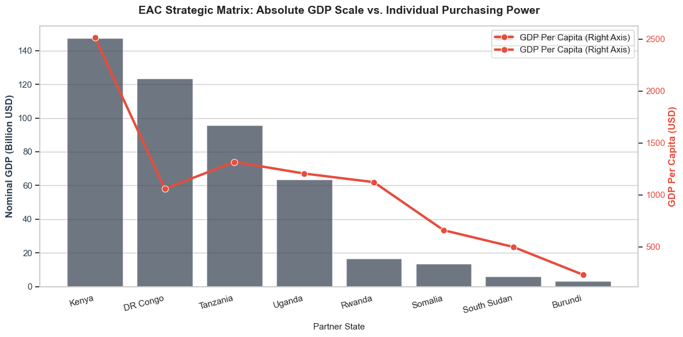

Core Analytical Observations :

1. The Hegemonic Market Leader (Kenya):
The strategic matrix establishes Kenya as the absolute economic anchor of the EAC region, dominating on both macro and micro scales. Kenya holds the largest Nominal GDP at 147 billion USD paired with the highest individual purchasing power, leading the bloc with a GDP Per Capita of 2,550 USD. This dual-dominance confirms why it serves as the primary gateway for regional commercial capital.

2. The High-Volume, Low-Purchasing Paradox (DR Congo):
A stark structural mismatch is visible in the DR Congo, which commands the second-largest economic scale in the bloc with a Nominal GDP of 123 billion USD. However, its individual purchasing power sharply decouples, crashing to a GDP Per Capita of 1,100 USD. This highlights an economy driven by massive localized asset extraction or high aggregate population volume, rather than widely distributed consumer purchasing power.

3. The Stable Intermediate Tier (Tanzania & Uganda):
Tanzania and Uganda form a solid, mid-tier economic corridor. Tanzania demonstrates robust positioning with a Nominal GDP of 95 billion USD and a rebounding GDP Per Capita of 1,350 USD (the second-highest in the dataset). Uganda tracks closely with a Nominal GDP of 63 billion USD and a steady GDP Per Capita of 1,250 USD, showing highly aligned economic density profiles.

4. The Micro-Scale and Frontier Floors (Rwanda down to Burundi):
The right half of the matrix reveals severe scale constraints across the remaining partner states. While Rwanda maintains a stable consumer profile (1,150 USD GDP Per Capita), its absolute market size Is highly constrained at a Nominal GDP of 16 billion USD. Moving further down the frontier, Somalia, South Sudan, and Burundi face compounding structural distress, culminating in Burundi marking the absolute baseline floor of the region with an economy of just 3 billion USD Nominal GDP and a nominal GDP Per Capita of 200 USD.

Strategic Policy Insights:

1. Aligning Capital Expenditure with Consumer Purchasing Realities:
The dramatic variance in GDP Per Capita from Kenya ($2,550) down to Burundi ($200) proves that a single, unified vehicle asset model cannot be deployed across the EAC. In high-purchasing power markets like Kenya, policy frameworks should encourage direct consumer financing models for premium electric vehicles. Conversely, in low per-capita zones like the DR Congo, Tanzania, and Uganda, policies must favor heavily subsidized Battery-as-a-Service (BaaS) operational models to eliminate the high upfront component costs that consumer wallets cannot absorb.

2. Leveraging Absolute Scale for Centralized Manufacturing Hubs:
The sheer volume of Nominal GDP concentrated in the Top 3 markets Kenya, DR Congo, and Tanzania indicate where regional assembly and battery manufacturing plants must be anchored. Our diagnostic study should recommend an EAC Industrial Localization Strategy, advising international e-mobility OEMs to concentrate heavy manufacturing and component supply chains inside these high-scale economies to maximize domestic market utilization, while treating smaller economies like Rwanda and Burundi as light retail and distribution endpoints.

3. Tailoring Micro-Grant Injections for Frontier Grid Survivability:
For frontier states like Somalia, South Sudan, and Burundi, where both nominal scale and individual purchasing power collapse to near-zero baselines, commercial venture capital will not naturally flow. To kickstart e-mobility in these zones, the policy framework must bypass traditional market dynamics entirely. Ministries of Energy must rely on Concessional DFI Micro-Grants to fund state-backed, solar-powered e-mobility micro-grids, ensuring that clean transport access is deployed as a public welfare service rather than a profit-driven commercial enterprise.

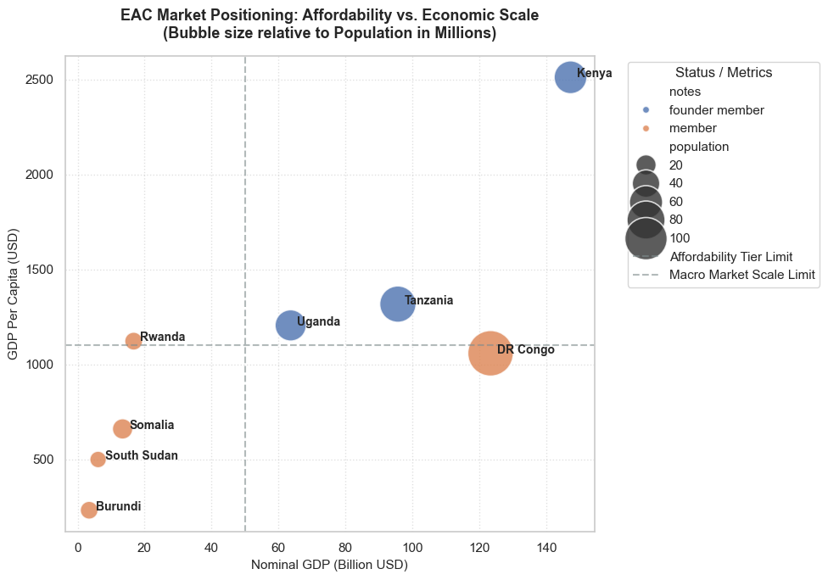

Core Analytical Observations:

1. The Outlier Frontier (Kenya):
The bubble chart establishes Kenya as an undisputed outlier, sitting entirely alone in the top-right quadrant of the matrix. It represents a highly mature consumer profile with a GDP Per Capita of 2,500 USD and a dominant Nominal GDP of 147 billion USD, while maintaining a robust, mid-sized demographic anchor (55 million population). This positioning places Kenya well above both the Affordability Tier Limit and the Macro Market Scale Limit.

2. The High-Density Mid-Tier (Tanzania & Uganda):
Tanzania and Uganda cluster closely together as stable, high-potential markets bridging the macro limits. Tanzania edges forward with a higher purchasing power baseline (1,350 USD GDP Per Capita) and an economic scale approaching 96 billion USD. Uganda follows with 1,200 USD GDP Per Capita at a 64 billion USD Nominal GDP scale. Both countries hold strategic advantages due to their founder-member status (blue bubbles) and highly balanced economic-to-demographic proportions.

3. The High-Volume Demographic Trap (DR Congo):
The DR Congo creates a striking visual contrast, represented by the largest bubble on the chart (100 million population). It breaks far past the Macro Market Scale Limit with a Nominal GDP of 123 billion USD, yet its individual purchasing power sags completely below the line, sitting at a GDP Per Capita of 1,050 USD. This highlights a massive aggregate market where extreme consumer volume masks low individual purchasing capacity.

4. The Truncated and Fragile Baselines (Rwanda down to Burundi):
The bottom-left quadrant contains a mix of constrained or fragile economies failing to cross either threshold line. While Rwanda demonstrates a stable mid-tier purchasing power (1,150 USD GDP Per Capita), its absolute economic footprint is severely bottlenecked at under 20 billion USD Nominal GDP. Moving lower, Somalia, South Sudan, and Burundi form a tight downward cascade, with Burundi marking the absolute minimum floor of the bloc across all tracked parameters.

Strategic Policy Insights:

1. Structuring Segmented Pricing Models Based on Quadrant Realities :
The clear spatial division across the threshold limits proves that standard regional vehicle financing cannot succeed. In the high-affordability zone (Kenya), policies should focus on incentivizing Direct Consumer Ownership and Commercial Fleet Leases. For the high-volume/low-affordability zone (DR Congo), policy frameworks must mandate highly subsidized mass transit initiatives or Public Utility-Owned Battery Swapping Infrastructure to insulate low-income drivers from high capital investments.

2. Capitalizing on Demographic Scales for Network Viability :
The bubble sizes indicate where density-dependent charging infrastructure will achieve rapid self-sustainability. Even though individual purchasing power is lower in the DR Congo, Tanzania, and Uganda, their large population dimensions ensure high utilization frequency for public transport systems like Boda-bodas and buses. Diagnostic recommendations should prioritize high-density Urban Hub Corridor Zoning within these three specific countries to guarantee massive daily charging volumes.

3. Deploying Cross-Border Fiscal Concessions for Constrained Markets :
Rwanda’s unique position adequate per-capita purchasing power but constrained total GDP scale indicates that its internal market is too small to attract heavy original equipment manufacturing (OEM) facilities independently. The study must recommend an Integrated EAC Micro-Market Corridor Initiative. Policymakers should eliminate import duties and cross-border transport tariffs between Rwanda and its larger neighbors (like Uganda and Tanzania), allowing specialized regional components or electric fleets assembled in larger hubs to flow seamlessly into smaller retail ecosystems.

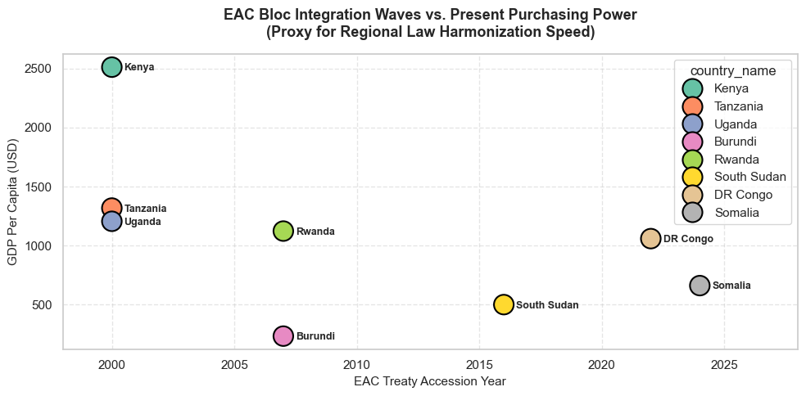

Core Analytical Observations:

1. The Institutional Founders Anchored by Affordability (Kenya, Tanzania, & Uganda):
The timeline mapping reveals that the founding wave of the modern East African Community (Year 2000 Accession) holds the highest economic maturity in the region. Kenya sits at the absolute pinnacle with a GDP Per Capita of 2,500 USD. Tanzania and Uganda cluster closely below it, maintaining stable economic purchasing baselines between 1,200 USD and 1,350 USD. This foundational triad represents the primary economic anchor of the entire bloc.

2. The Mid-Wave Transitional Disparity (Rwanda & Burundi):
The second expansion wave (Year 2007 Accession) demonstrates a severe economic decoupling between its two entrants. While Rwanda has successfully accelerated to a robust mid-tier purchasing power of 1,150 USD GDP Per Capita, Burundi lags drastically at the bottom-left quadrant, marking a minimal 200 USD GDP Per Capita. This reveals that shared institutional entry timelines do not guarantee parallel economic development tracks.

3. The Recent Waves Acceleration Drag (South Sudan, DR Congo, & Somalia):
The most recent expansion waves (2016 to 2024) introduce a steep downward trajectory in individual purchasing power across the timeline. South Sudan (2016) tracks at 500 USD GDP Per Capita, followed by the DR Congo (2022) at 1,050 USD, and Somalia (2024) hovering around 650 USD. The data proves that as the geographic footprint of the EAC expands chronologically, the average individual purchasing power drops, introducing a highly fragmented consumer base.

Strategic Policy Insights:

1. Leveraging Foundational Harmonization for Unified Standards:
The shared 26-year institutional integration history of Kenya, Tanzania, and Uganda, paired with their high purchasing power, makes them the ideal testing ground for legal integration. Our diagnostic study should recommend a Fast-Tracked Tripartite E-Mobility Regulatory Accord. Because these three nations have the most mature legal and economic alignment, ministries of transport should bypass wider bloc gridlocks and immediately unify cross-border vehicle manufacturing standards, battery recycling laws, and regional driver licensing protocols across this core northern-central corridor.

2. Mitigating Legal Harmonization Delays in Frontier States:
The chart positions South Sudan, the DR Congo, and Somalia as late-stage accessions with depressed per-capita purchasing power, making them highly vulnerable to slow regulatory absorption speeds. Policy recommendations must explicitly state that expecting these new entrants to immediately adopt complex EAC-wide e-mobility directives will lead to severe compliance bottlenecks. Instead, the EAC Secretariat should grant Temporary Regulatory Concessions, allowing recent wave accessions a 5-to-7-year grace period to build basic national electrical infrastructure codes before forcing compliance with macro-regional green transport standards.

3. Bridging the 2007 Accession Gap via Target Infrastructure Corridors:
The extreme purchasing power chasm between Rwanda ($1,150) and Burundi ($200) despite their identical 2007 accession timeline proves that unified regional trade treaties are insufficient to lift localized economies. To pull Burundi out of its e-mobility stagnation, policy frameworks must transition from consumer-facing market models to State-Backed Cross-Border Transit Corridors. Regional DFIs should fund dedicated electric freight and logistics corridors running directly from Rwanda's mature distribution network into Burundi's main trading hubs, creating commercial demand that the local consumer base cannot yet sustain on its own.

Market Fleet:

This dataset serves as the fundamental anchor and critical foundation for the EAC E-mobility Market Fleet Analysis. Before evaluating charging infrastructure networks, battery lifecycle management, or localized grid integrations, it is necessary to establish the underlying composition and baseline dynamics of the region's current transportation landscape. Group B provides the structural boundaries for vehicle segment distributions, historical growth rates, import regulations, and fuel dependencies across all eight East African Community (EAC) partner states: Burundi, the Democratic Republic of the Congo (DRC), Kenya, Rwanda, Somalia, South Sudan, Tanzania, and Uganda.

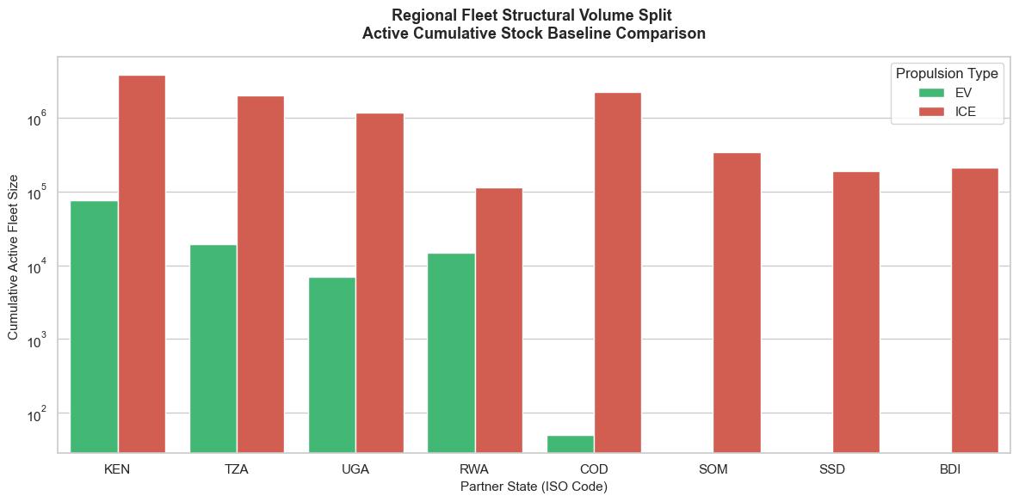

Core Analytical Observations:

1. The Regional Electric Vanguard (Kenya, Tanzania, & Rwanda):
The baseline comparison chart establishes Kenya (KEN) as the clear regional leader in absolute vehicle electrification, possessing an active stock of nearly (75,000) electric vehicles (EVs). Tanzania (TZA) holds a robust second position with an active EV stock hovering around 20,000, while Rwanda (RWA) demonstrates an exceptional electrification ratio relative to its size, supporting roughly 15,000 EVs against a much lower Internal Combustion Engine (ICE) baseline.

2. The ICE-Dominated Giants (DR Congo & Uganda):
In contrast to their high electrification potential, DR Congo (COD) and Uganda (UGA) show severe lags in adoption. Uganda retains a massive legacy ICE fleet exceeding 1,000,000 vehicles, yet its active EV footprint drops to a marginal 7,000. The divergence is even more extreme in the DR Congo; despite boasting one of the largest transport ecosystems in the bloc (over 2,000,000 ICE vehicles), its active EV deployment remains practically negligible at a baseline floor near 50 vehicles.

3. The Absolute Zero EV Frontier (Somalia, South Sudan, & Burundi):
The right quadrant of the chart displays a total structural vacuum for clean transport technologies across the final three partner states. Somalia (SOM), South Sudan (SSD), and Burundi (BDI) feature completely absent green bars, meaning their active EV stock scales register at 0. Their transport sectors remain entirely captive to aging fossil-fuel ICE technology, ranging from 200,000 vehicles in Burundi to nearly 400,000 in Somalia.

Strategic Policy Insights:

1. Accelerating ICE Decommissioning in Mature Markets:
The presence of a massive, established EV baseline in Kenya, Tanzania, and Rwanda proves that these markets have passed initial pilot stages and are ready for fleet-wide substitution. Our study should recommend an Accelerated ICE Fleet Attrition and Retrofit Policy. Governments in this leading tier should introduce progressive vehicle age limits for ICE imports while providing matching tax credits for commercial fleet operators who scrap old internal combustion vehicles in favor of locally assembled electric variants.

2. Unlocking the Stagnant Corporate Volumes of Uganda and DR Congo:
The stark imbalance in Uganda and the DR Congo where millions of ICE vehicles overwhelm microscopic EV counts indicates a major systemic roadblock for retail buyers. To break this logjam, policy interventions must shift from consumer incentives to Targeted Corporate Logistics Mandates. Regulators should legally require large-scale commercial distributors, mining operations, and ride-hailing networks to convert a fixed percentage of their operational fleets to electric models annually, forcing a volume injection that will drive down local battery and charging network unit costs.

3. Instituting Seed-Stock Deployments for Frontier Systems:
For Somalia, South Sudan, and Burundi, where the current active EV baseline is zero, traditional market incentives are completely useless. Our diagnosis study must recommend a State-Sponsored Seed-Stock and Pilot Initiative. Energy and transport ministries in these frontier environments should partner with multilateral development lenders to completely fund the initial procurement of state-owned electric transit buses or municipal utility fleets, establishing the baseline charging infrastructure and operational technical capacity required before private capital can safely enter.

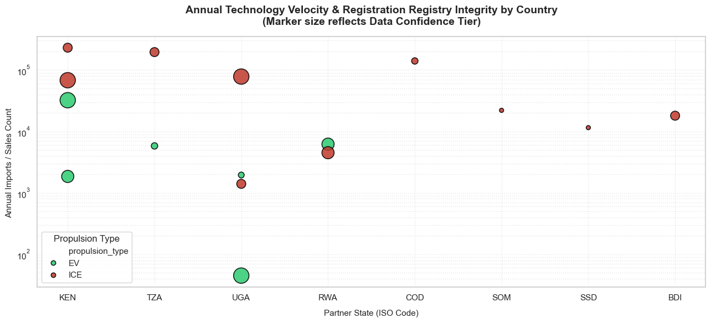

Core Analytical Observations:

1. The Technology Velocity Dominance (Kenya & Rwanda):
The registration plot shows that Kenya (KEN) and Rwanda (RWA) are experiencing the highest annualized technology velocity. Kenya leads the regional bloc in dynamic entry, showing annual electric vehicle (EV) imports/sales scaling around 35,000 units (the large green marker near 10⁴-10⁵), while maintaining a secondary tier of imports near 2,000. Rwanda demonstrates the most striking equilibrium, where its annual EV velocity (6,500 units) directly overtakes its traditional internal combustion engine (ICE) import velocity, proving a structural tipping point in new vehicle adoption.

2. The Data Integrity and Confidence Chasm:
The marker size highlights extreme differences in registry reporting standards across the EAC. Kenya, Uganda (UGA), and Rwanda feature the largest bubble dimensions, signaling a High Data Confidence Tier supported by digital vehicle identification registries. In stark contrast, Tanzania (TZA) and DR Congo (COD) exhibit tiny, compressed markers despite high nominal import counts (>10⁵), indicating low reporting confidence, fragmented customs tracking, or an unvetted paper-trail registry prone to vehicle smuggling or misclassification.

3. The Micro-Velocity Anomalies (Uganda & DR Congo):
Uganda displays a severe velocity bifurcation, with a massive low-confidence EV marker sitting at the bottom floor of the chart (<50 units/year), contrasting against a mid-confidence EV velocity node around 2,000 units. In the DR Congo, the situation is completely compressed: while its legacy ICE velocity tracks past 150,000 units/year, its EV sales register as a total statistical blank, demonstrating zero market momentum.

4. The Frontier Data Disconnect (Somalia, South Sudan, & Burundi):
The right axis reinforces a total vacuum in both green technology adoption and tracking infrastructure. Somalia (SOM), South Sudan (SSD), and Burundi (BDI) feature exceptionally small, pinpoint ICE markers tracking between 10,000 and 22,000 annual units. No green markers are visible, proving that these frontiers registries remain entirely unequipped to capture or handle alternative propulsion data streams.

Strategic Policy Insights:

1. Mandating Digital Registry Interconnection for Low-Confidence Nations
The dangerously low data confidence markers in high-volume entry points like Tanzania and the DR Congo indicate that black-market vehicle imports could undermine regional planning. Our study should recommend a Regional Customs Registry Digitalization Directive. The EAC Secretariat should legally bind revenue authorities to interconnect their digital vehicle identification systems (such as Kenya's NTSA Timms platform) across borders, ensuring every incoming chassis number (VIN) is audited for real-time fuel-type compliance.

2. Capitalizing on Rwanda's Tipping Point to Phase Out Fossil Imports:
Rwanda’s historical inflection points where annual EV registration velocity matches or surpasses ICE registrations proves that its domestic ecosystem no longer requires training wheels. To lock in this transition, the Ministry of Infrastructure should implement a Graduated ICE Import Ban. Setting an aggressive timeline to bar the registration of new low-efficiency light passenger ICE vehicles by 2028 will permanently cement the market share of local electric assembly lines.

3. Incentivizing Data Integrity to De-Risk Sovereign Carbon Credit Pools:
For trailing states like South Sudan, Somalia, and Burundi, the primary hurdle isn't just a lack of vehicles it is a total lack of verifiable metric data. Because carbon financing networks require airtight registration audits, the diagnostic study must advocate for Registry Capacity Building Grants. Partnering with international climate funds to digitize vehicle registration frameworks will establish the verifiable baseline necessary to issue high-value carbon offsets, creating an autonomous revenue loop to fund future charging infrastructure.

Current Rate of Motorization

Introducing a categorical tiering system to the Current Rate of Motorization (2016) moves the analysis beyond basic country rankings and provides direct, actionable answers to two of the most critical questions in 1.5 (The E-Mobility Journey in East Africa) and 7.0 (Challenges to EV Adoption):

1. It Establishes the Mandatory Regional Market Strategy:
  - The High-Density Tier (>20 vehicles / 1k people): This tier reveals where vehicle ownership is already culturally and economically entrenched. In these countries, the electric vehicle transition is fundamentally a fleet replacement game. Policy here must focus on aggressively flipping existing, highly polluting vehicle segments (like urban internal combustion Boda-Bodas) over to electric drivetrains.
  - The Low-to-Medium Tiers (<20 vehicles / 1k people): In these environments, the vehicle market is still actively growing. The transition here is an infancy growth game. Instead of trying to replace old fleets, policies should aim to ensure that the millions of new vehicles entering the economy are electric from day one, preventing these countries from locking themselves into a reliance on dirty, secondhand fossil-fuel cars.

2. It Visually Exposes the Logistics Reality to Private Investors:
  - Private charging network developers need high vehicle density to ensure their charging stations are consistently utilized and profitable. Placing countries into clear visual bins (Low, Medium, High) provides investors with an immediate, data-backed guide showing where private venture capital can deploy public fast-chargers right away versus where development finance or state grants are required to seed early networks.

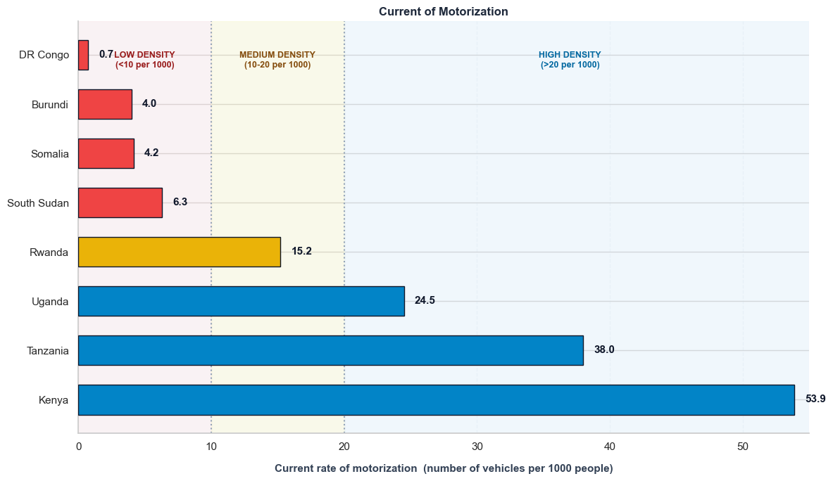

Core Analytical Observations:

1. The High-Density Motorization Leaders (Kenya, Tanzania, & Uganda):
The baseline comparison chart establishes Kenya as the absolute leader in regional vehicle penetration, recording a high density of 53.9 vehicles per 1,000 people. Tanzania holds a robust second position with 38.0 vehicles per 1,000 people, while Uganda completes the high-density tier (defined as >20 per 1,000) at 24.5 vehicles per 1,000 people. This core foundational triad forms the primary commercial and consumer volume baseline for transport assets in the EAC.

2. The Transitional Mid-Tier Gateway (Rwanda):
Rwanda sits alone within the Medium Density tier (10–20 per 1,000), tracking at 15.2 vehicles per 1,000 people. This reveals an emerging, highly structured transport ecosystem that bridges the massive commercial volume of its larger neighbors with the highly constrained asset distributions seen in frontier environments.

3. The Low-Density Infrastructure Vacuum (South Sudan down to DR Congo):
The upper half of the chart exposes a severe transport asset deficit across the remaining partner states, all falling into the Low-Density tier (<10 per 1,000). South Sudan holds a penetration rate of 6.3, followed tightly by Somalia at 4.2 and Burundi at 4.0. The most extreme outlier is the DR Congo, which registers a near-negligible floor of just 0.7 vehicles per 1,000 people proving a massive geographic territory with an acute shortage of individual vehicle mobilization relative to its population size.

Strategic Policy Insights:

1. Targeting Fleet Conversions in High-Density Volume Hubs :
The concentration of vehicle density in Kenya (53.9), Tanzania (38.0), and Uganda (24.5) proves that these transport sectors are already highly saturated with internal combustion engine assets. Our diagnostic study must recommend aggressive Fleet Replacement and ICE Disincentive Frameworks in these three specific markets. Because the vehicle-to-population ratio is high, policies shifting existing registrations via congestion charges, low-emission zones, and targeted replacement subsidies will yield the highest macro-environmental dividends.

2. Designing Asset-Light Shared Mobility in Low-Density Fragile States :
The near-absent vehicle penetration rates in the DR Congo (0.7), Burundi (4.0), and Somalia (4.2) prove that traditional consumer-ownership vehicle policies will completely fail. To build transport mobility without overloading fragile national frameworks, policy directives must pivot exclusively toward High-Occupancy Mass Transit and Shared Micro-Mobility Mandates. Rather than encouraging individual electric vehicle sales, international DFI funding should focus on highly utilized electric buses and shared corporate logistics fleets that maximize the utilization of each asset.

3. Utilizing Rwanda as a Contained Regulatory Micro-Testing Ground :
Rwanda's isolated medium-density positioning (15.2) demonstrates a highly manageable transit volume that is neither overcrowded nor critically lagging. The study should highlight Rwanda as the ideal regional E-Mobility Sandbox. Its balanced asset density allows for clean regulatory interventions such as city-wide smart charging grids, digital licensing systems, and strict battery end-of-life disposal protocol to be perfected and benchmarked before attempting to scale them into high-density giants like Kenya or Tanzania.

Current Vs Projected Rate of Motorization:

Analyzing Current vs. Projected Motorization Density with categorical tiering across the EAC countries introduces a critical, forward-looking dimension to the framework. It shifts the narrative from static baseline numbers to a dynamic growth model:

1. Quantifying the Infrastructure Catch-Up Velocity:
This multi-variable analysis exposes the structural timeline pressure facing energy and transport ministries. It demonstrates to policymakers that a country sitting in the "Low" or "Medium" category today cannot design its infrastructure based on current demand. They must model their grids to absorb the massive, incoming wave of vehicle volume as these markets rapidly scale into the "High" category by 2050.
2. Defending the Rationale for Upfront Fleet Electrification:
For non-technical audiences, this chart provides an immediate justification for sweeping regional e-mobility laws now. It proves visually that if countries wait until they cross into the "High Density" bracket to mandate electric vehicle adoption, they will have already allowed millions of dirty internal combustion engines to saturate their cities, locking themselves into decades of severe oil dependency and heavy urban pollution

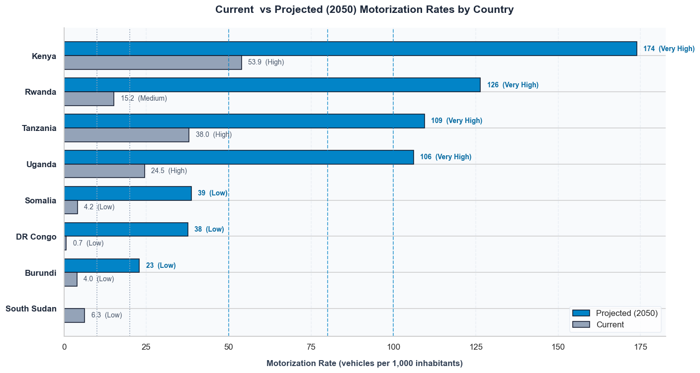

Core Analytical Observations

1. The Overwhelming Velocity Surge:

- Kenya stands out as the ultimate regional market anchor. It is scaling rapidly from a baseline of 53.9 vehicles to a massive projection of 174 vehicles per 1,000 people, which represents a 3.2x market expansion.
- Rwanda exhibits the highest growth velocity in the region, jumping from 15.2 (Medium density) straight to 126 per 1,000 individuals an astonishing 8.2x expansion.
- Tanzania (109) and Uganda (106) both break past the 100-vehicle threshold, tightly mirroring each other's long-term scale.

2. The High-Density Convergence Zone:
By 2050, the four core economies (Kenya, Rwanda, Tanzania, Uganda) completely leave behind their current baselines and converge deep inside the "Very High-Density Corridor" (>100 vehicles / 1,000 inhabitants).

3. The Frontier Lag:
Somalia (39) and DR Congo (38) experience upward movement, but they remain at lower overall densities, while South Sudan sits at the base of the framework.

Strategic Policy Insights

1. Inaction Cost Case for Ministries of Finance:
This graph provides empirical proof that delaying a regional e-mobility policy is highly dangerous. If ministries wait until 2035 or 2040 to enforce EV rules, the region will organically absorb millions of cheap, secondhand internal combustion engine (ICE) vehicles to satisfy this 3x to 8x demand surge. That would lock the EAC into a devastating, multi-decade financial reliance on imported petroleum products and skyrocket urban air pollution.

2. Infrastructure Planning Must Target Future Volume, Not Today's Demand :
The massive difference between the short gray baseline bars and the long blue projection bars proves that building charging networks based on current vehicle counts is a design flaw. Our diagnostic framework must utilize this chart to recommend a "Forward-Looking Infrastructure Factor," requiring utility regulators to design their grid transformer substations and highway fast-charging hubs to handle the projected vehicle surge of 2050, rather than reacting to current loads.

GROUP B: Macroeconomic Vulnerability and Strategic Rationale

CO2 Emissions from Transportation:

Integrating the fresh, high-fidelity emission dataset utilizing Percent of Fuel Combustion CO2 from Transport and Transport Share Score provides a significant analytical upgrade to Chapter 2.0 (Rationale) and Chapter 6.0 (Energy Transition Strategies).

1. Validating the "Strategic Urgency" Factor:
The Percent of Fuel Combustion CO2 from Transport tells policymakers exactly how much of their nation's total fossil-fuel pollution is driven exclusively by the tailpipes of their growing vehicle fleet. If this percentage is high, it provides an immediate argument for the Ministry of Environment that industrial or agricultural adjustments are not enough the transport sector is the primary roadblock to meeting their global climate commitments (NDCs).

2. Standardizing Cross-Country Priorities via the Transport Share Score:
The inclusion of the Transport Share Score allows the framework to move away from isolated country metrics and apply a standardized, normalized grading system across the EAC. This score ranks the structural risk each nation faces, allowing the EAC Secretariat to mathematically justify which countries require immediate concessional climate financing to transition their mass fleets.

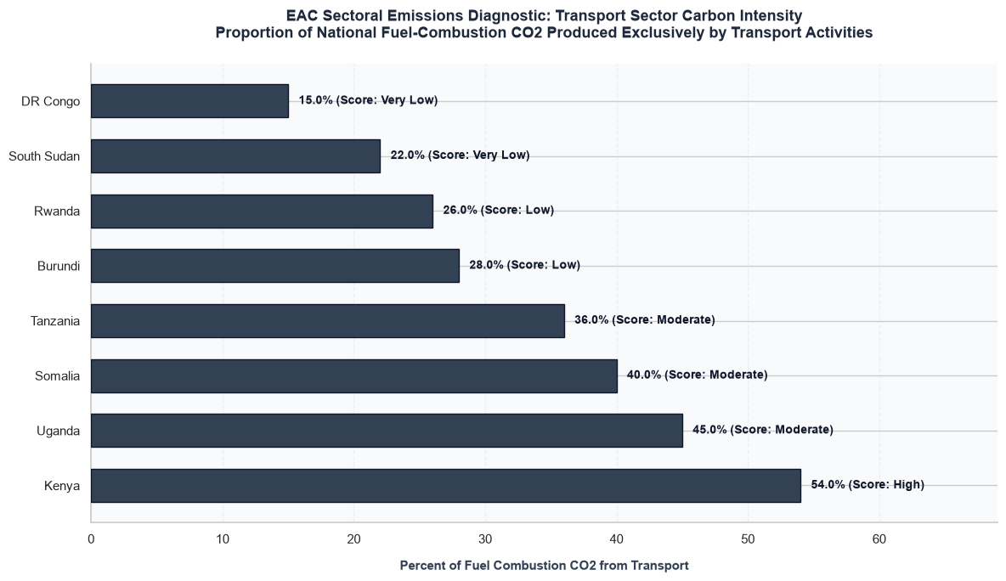

Core Analytical Observations:

1. Kenya as the Regional Emissions Epicenter:
Kenya stands out with a stark 54.0% of its total fuel-combustion CO2 coming exclusively from transport, earning it a "High" risk score. More than half of Kenya's fossil fuel pollution is generated directly by vehicle tailpipes, making the transport sector its single largest decarbonization bottleneck.

2. The High-Exposure Mid-Tier (Uganda, Somalia, Tanzania):
Uganda (45.0%), Somalia (40.0%), and Tanzania (36.0%) form a high-exposure cluster, all receiving a "Moderate" risk score. In these countries, over a third to nearly half of all fuel-combustion emissions are tied directly to transportation networks and transit corridors.

3. The Industrial/Agricultural Baselines (Rwanda, Burundi, South Sudan, DRC):
Burundi (28.0%), Rwanda (26.0%), South Sudan (22.0%), and DR Congo (15.0%) track lower on the relative scale, receiving "Low" or "Very Low" scores. In these states, other sectors such as agriculture or heavy mining logistics currently dominate overall fuel combustion emissions rather than urban transport.

Strategic Policy Insights:

1. The Justification for Immediate Regional Fleet Intervention:
This graph provides empirical proof that for Kenya, Uganda, and Tanzania, a national climate strategy that ignores transport cannot succeed. Because transportation accounts for 36% to 54% of their fuel pollution, our framework must advise these ministries that cleaning up the transport sector is the most effective way to meet their global climate commitments (NDCs).

2. The Deceptive "Low Share" Trap in Rwanda and DRC:
The "Low" share in Rwanda (26.0%) and DRC (15.0%) must not be misinterpreted as a lack of urgency:

  - In Rwanda, its small industrial footprint means its total emissions are low, making its 26% share a prime target for preemptive policies to cap future carbon growth.
  - In the DRC, its low 15% share is a result of massive industrial mining activities dominating the country's energy data. However, its major cities face intense urban vehicle gridlock, proving that e-mobility policies there should target localized municipal air quality and corporate mining transit fleets rather than generic national averages.

3. Targeting Regional Concessional Climate Finance:
Our framework should use this visual to justify an asymmetric deployment of regional climate finance. The EAC Secretariat should direct early green infrastructure funds and international carbon-credit backing directly into Kenya, Uganda, and Tanzania to target the dense urban corridors where transport emissions are doing the most damage.

CO2 Emissions Per Capita(Metric Tons/Year) (Transport Sector)

This specific metric alters the core narrative of Chapter 1.4 & 1.5 (E-Mobility History & Journey in Africa) and Chapter 2.3 (Challenges to Rollout) in two major ways:

1. It Proves the "High Urban Concentration" Risk Profile:
The Impact: In many EAC nations, the overall national per capita CO2 footprint is extremely low compared to the global average. However, when you isolate the transport sector per capita emissions, you expose a massive urban-rural divide. The vast majority of these transport metric tons are generated inside major metropolitan areas (like Nairobi, Kampala, and Dar es Salaam) where vehicle gridlock is concentrated. This tells policymakers that e-mobility is an urgent urban localization strategy to tackle intense municipal pollution, regardless of low national averages.

2. It Highlights the "Emission Surge Vector" (The Demographics Trap):

The Impact: Combining this per capita tracking with the Group A Motorization Projections (2050) creates an essential diagnostic model. As individual incomes rise and countries cross from low to high-density motorization tiers, their individual transport emissions will expand exponentially. This data proves to environmental ministries that e-mobility must be treated as a preemptive backstop to prevent a massive, upcoming surge in individual carbon footprints.

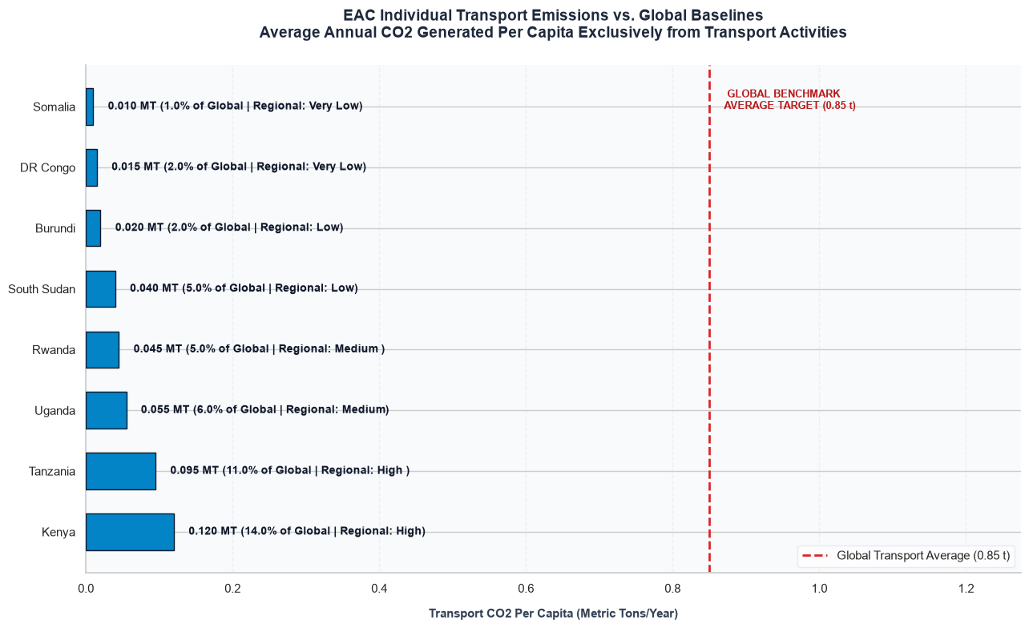

Core Analytical Observations:

1. Kenya as the Regional Emissions Epicenter:
Kenya stands out with a stark 54.0% of its total fuel-combustion CO2 coming exclusively from transport, earning it a "High" risk score. More than half of Kenya's fossil fuel pollution is generated directly by vehicle tailpipes, making the transport sector its single largest decarbonization bottleneck.

2. The High-Exposure Mid-Tier (Uganda, Somalia, Tanzania):
Uganda (45.0%), Somalia (40.0%), and Tanzania (36.0%) form a high-exposure cluster, all receiving a "Moderate" risk score. In these countries, over a third to nearly half of all fuel-combustion emissions are tied directly to transportation networks and transit corridors.

3. The Industrial/Agricultural Baselines (Rwanda, Burundi, South Sudan, DRC):
Burundi (28.0%), Rwanda (26.0%), South Sudan (22.0%), and DR Congo (15.0%) track lower on the relative scale, receiving "Low" or "Very Low" scores. In these states, other sectors such as agriculture or heavy mining logistics currently dominate overall fuel combustion emissions rather than urban transport.

Strategic Policy Insights:

1. The Justification for Immediate Regional Fleet Intervention:
This graph provides empirical proof that for Kenya, Uganda, and Tanzania, a national climate strategy that ignores transport cannot succeed. Because transportation accounts for 36% to 54% of their fuel pollution, the framework must advise these ministries that cleaning up the transport sector is the most effective way to meet their global climate commitments (NDCs).

2. The Deceptive "Low Share" Trap in Rwanda and DRC:
The "Low" share in Rwanda (26.0%) and DRC (15.0%) must not be misinterpreted as a lack of urgency:
  - In Rwanda, its small industrial footprint means its total emissions are low, making its 26% share a prime target for preemptive policies to cap future carbon growth.
  - In the DRC, its low 15% share is a result of massive industrial mining activities dominating the country's energy data. However, its major cities face intense urban vehicle gridlock, proving that e-mobility policies there should target localized municipal air quality and corporate mining transit fleets rather than generic national averages.

3. Targeting Regional Concessional Climate Finance:
Our framework should use this visual to justify an asymmetric deployment of regional climate finance. The EAC Secretariat should direct early green infrastructure funds and international carbon-credit backing directly into Kenya, Uganda, and Tanzania to target the dense urban corridors where transport emissions are doing the most damage.

Fuel Import Dependency

Analyzing Fossil Fuel Import Dependency captured via the column Fossil Fuel Dependence (Ratio of transportation fuel consumption to net imports by country) (2021) is the core argument for Chapter 2.0 (Rationale) and Chapter 2.3 (Challenges).
For Ministries of Finance, this variable shifts the project from an "environmental option" to a matter of macroeconomic survival:

1. Exposing the Foreign Exchange (Forex) Structural Leak:
Most EAC partner states do not produce crude oil and must spend massive reserves of scarce foreign currency to buy refined petroleum products. This variable tracks how much of that imported fuel is immediately burned up by the domestic transport sector. It demonstrates to central banks that transportation is a direct leak of national wealth. Swapping imported fuel for locally generated renewable electricity (hydro, geothermal, solar) allows that wealth to stay inside the country.

2. The Inflation and Logistic Shield (The 2026 Fuel Shock Context):
As of late 2026, fuel has spiked to an unprecedented 55% of total road transport costs in East Africa, up from 38% in 2021. This massive price surge directly drives up the cost of food and consumer goods across the region. Our framework uses this metric to prove that e-mobility is a vital economic shield decoupling transport costs from global oil volatility protects the regional economy from inflation.

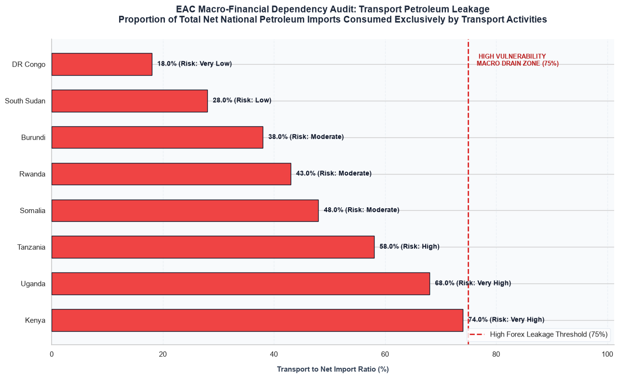

Core Analytical Observations:

1. Kenya on the Precipice of the Critical Risk Zone:
Kenya stands as the region's most financially exposed economy, with a staggering 74.0% of all its net petroleum imports being consumed exclusively by the transport sector. It sits directly on the border of the "High Vulnerability Macro Drain Zone (75%)", carrying a "Very High" risk score.

2. The High-Exposure Mid-Tier (Uganda & Tanzania):
- Uganda is deeply vulnerable at 68.0% ("Very High" Risk), meaning more than two-thirds of its imported fuel is immediately burned by the domestic transport sector.
- Tanzania follows closely at 58.0% ("High" Risk), showing that well over half of its fuel imports are dedicated entirely to road transportation and transit corridors.

3. The Developing Baseline Tier (Somalia, Rwanda, Burundi, South Sudan, DRC):
  - Somalia (48.0%), Rwanda (43.0%), and Burundi (38.0%) hold a "Moderate" risk profile.
  - South Sudan (28.0%) tracks lower, while DR Congo (18.0%) sits at the base with a "Very Low" ratio, as its massive industrial mining operations and internal logistics dominate its total net import footprint rather than urban road transport.

Strategic Policy Insights:

1. E-Mobility as a Mandatory Foreign Exchange (Forex) Conservation Strategy:
This graph shifts the e-mobility conversation entirely away from general environmental idealism and frames it as a matter of macroeconomic survival for Central Banks. Kenya and Uganda are losing massive reserves of scarce USD hard currency simply to import petroleum that is immediately vaporized by internal combustion engines. Our framework must use this to prove that every vehicle switched to domestic renewable electricity (hydro, geothermal, solar) directly plugs a national wealth leak.

2. The Transport Sector as the Primary Driver of Trade Deficits:
The fact that the three largest regional economies (Kenya, Uganda, Tanzania) consume 58% to 74% of their fuel imports on road transit means that transportation is the single largest structural driver of their national trade deficits. This visual provides the statistical backing to convince Ministries of Finance that funding e-mobility infrastructure is an investment in national balance-sheet recovery.

3. Insulating the Core Corridor from Global Oil Shocks:
With fuel costs currently representing a heavy chunk of road transit expenses in East Africa, these high ratios mean that Kenya, Uganda, and Tanzania are directly exposing their entire domestic economies to global oil market volatility. When oil spikes, the cost of moving food and consumer goods across these transit corridors skyrockets, driving national inflation. Electrifying the transport network acts as a structural economic shield to protect the region from global resource shocks.

Fuel Subsidy Burden

Integrating our dedicated dataset Explicit Gasoline and Diesel Subsidy Burden as a % of GDP provides the final, high-impact pillar for Group B (Macroeconomic Vulnerability & Strategic Rationale). This variable serves as the ultimate fiscal weapon when presenting the diagnostic study (Chapters 2.0 and 2.3) to Ministries of Finance and Economic Planning across the EAC.

1. Quantifying the Direct Budgetary Drain:
This column captures the explicit cash outlays bleeding from national treasuries to suppress retail fuel prices. When a finance ministry sees this burden mapped out as a direct percentage of GDP, it transforms the e-mobility conversation. Every fractional percent of GDP spent on a fuel subsidy is an unproductive, recurring drain. redirecting those same funds into grid infrastructure or EV assembly credit guarantees builds long-term, domestic productive capital.

2. Exposing the "Incentive Distortion" Bottleneck:
High fuel subsidies artificially flatten the operational cost advantage of electric vehicles. If petrol is heavily subsidized, the financial incentive for a Boda-Boda rider to switch to electricity shrinks. The framework uses this data to prove that subsidies actively work against regional technological transition, and outlines a path for "Subsidy Swapping" phasing down fuel subsidies and shifting those exact budgetary lines into local battery assembly tax breaks and charging infrastructure rollouts.

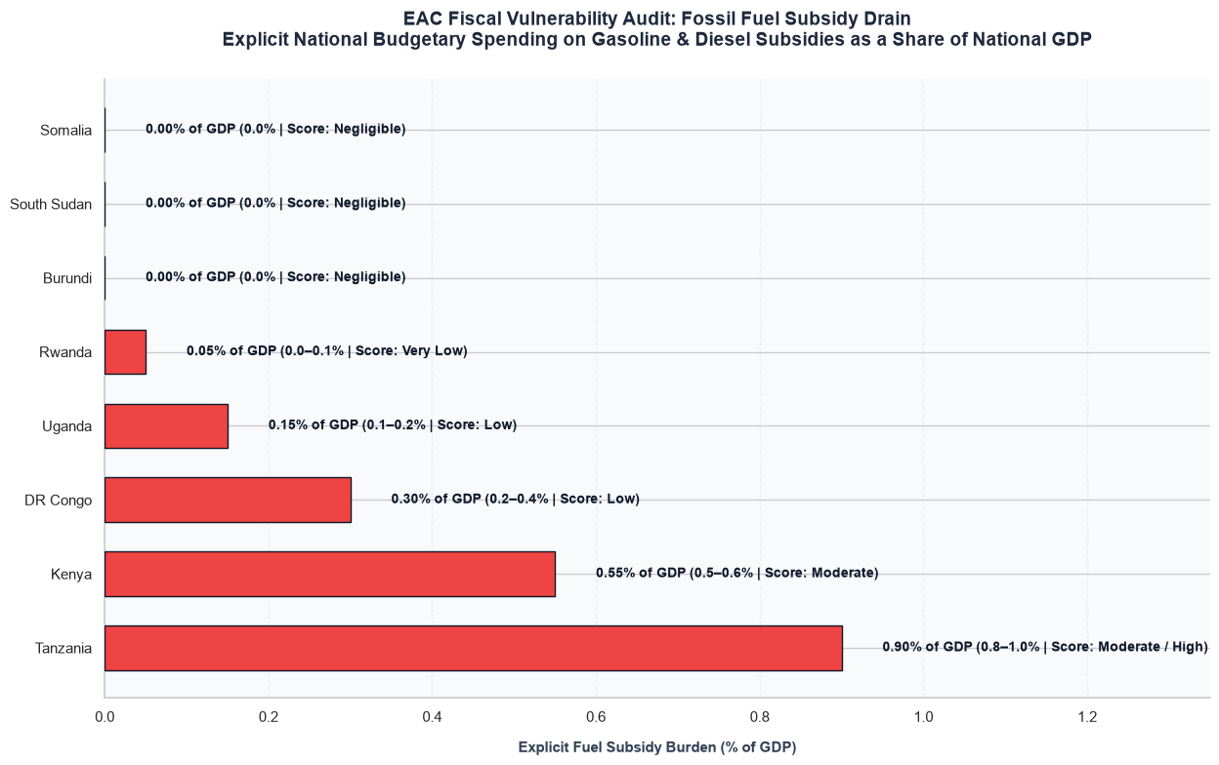

Core Analytical Observations:

1. Tanzania and Kenya Bearing the Heaviest Fiscal Brunt:
  - Tanzania experiences the region's sharpest fiscal drain, with explicit fuel subsidies consuming a massive 0.90% of its total national GDP, landing it a "Moderate / High" risk score.
  - Kenya faces a similarly intense budgetary strain, spending 0.55% of its GDP ("Moderate" Risk) to cushion consumers at the pump. For both leading economies, this represents hundreds of millions of dollars in recurring, non-productive public expenditure.

2. The Controlled and Deregulated Corridors:
  - DR Congo (0.30%) and Uganda (0.15%) maintain a "Low" exposure profile, while Rwanda sits at a "Very Low" trace footprint of 0.05% of GDP, indicating highly disciplined or restricted price-stabilization interventions.
  - Somalia, South Sudan, and Burundi register at an absolute 0.00% of GDP ("Negligible" Score), indicating completely deregulated, market-based retail fuel pricing frameworks where the state budget is entirely insulated from global pump fluctuations.

Strategic Policy Insights:

1. The Justification for a Regional "Subsidy Swap" Strategy:
This graph provides the ultimate ammunition for the presentation to Ministries of Finance. It proves that Tanzania and Kenya are burning precious, scarce tax revenues just to lower the price of an unclean, imported commodity. Our framework must introduce the core policy recommendation of "Subsidy Swapping": phasing down these price-cushioning outlays and directly reallocating those exact budgetary lines to fund local EV battery assembly credits, public fast-charging grid CapEx, and consumer EV financing guarantees.

2. Exposing the Hidden Market Distortion Blocking EV Adoption:
High fuel subsidies artificially depress the operational running costs of internal combustion engines (ICE). If a state heavily cushions gasoline, it artificially shrinks the financial incentive for a commercial Boda-Boda rider or transit bus operator to switch to an electric vehicle. This chart proves statistically that fossil fuel subsidies act as an invisible barrier to technological transition, and removing or swapping them is a prerequisite to unleashing organic EV market forces.

3. The Two-Speed Incentive Architecture for the EAC Bloc:
Because the subsidy baseline is highly fragmented, our framework must divide the region's incentive policy design into two distinct archetypes:
  - The Fiscal Relief Path (Tanzania & Kenya): Policy here must frame e-mobility as an immediate tool for state deficit reduction and public spending relief.
  - The Inflation Shield Path (Uganda, Rwanda, Somalia, Burundi): Because these states do not subsidize fuel heavily (or at all), their consumers absorb the full impact of global oil shocks. Policy here must position e-mobility to commercial fleet owners as an economic shield to protect their daily take-home earnings from unpredictable global resource price volatility.

GROUP C: POLICY, TARIFFS AND REGULATORY HURDLES

Policy Inventory

This table changes the narrative of the legal audit by shifting from simple lists to a clear measure of regulatory structure and implementation velocity:

1. Visualizing the Shift from Fiscal Carrots to Regulatory Sticks (Chapter 5.0)
The Impact: Early-stage markets typically start with fiscal incentives (like import duty cuts) to make vehicles affordable. As the market matures, they transition to regulatory frameworks (like charging grid rules or combustion engine bans). Aggregating the instrument_type column across the country timelines visually maps this evolution, showing non-technical stakeholders exactly which states are leading this regulatory transition.

2. Identifying the Regional Policy Fragmentation Gap (Chapter 3.0)
The Impact: For an economic bloc to thrive, vehicle standards and charging rules must match across borders. Counting active policies by category across the eight nations exposes fragmentation. It highlights where cross-border trade bottlenecks will occur such as an electric truck facing different charging connector guidelines or battery safety rules when crossing from Kenya into Uganda.

  - E-Mobility Policy Frameworks & Policy Instruments

🟢 Fiscal: Tax & Duty Relief | 🔵 Regulatory: System Grid Standards / Frameworks | 🔴 Mandates: Binding Phase-outs & Bans

Country | Year | Policy Instrument | Type | Status | Effective Date | Segment |  | Description
Kenya | 2023 | Finance Act 2023 EV VAT Exemption | 🟢 Fiscal | Enacted | 2023-07-01 | ALL | Exempts EVs from 16% VAT
Kenya | 2023 | Finance Act 2023 EV Duty Reduction | 🟢 Fiscal | Enacted | 2023-07-01 | ALL | Reduces EV import duty from 25% to 10%
Kenya | 2024 | National E-Mobility Policy | 🔵 Regulatory | Draft | 2024-01-01 | ALL | 5% EV adoption by 2030
Kenya | 2024 | EPRA Charging Infrastructure Guidelines | 🔵 Regulatory | Enacted | 2024-03-01 | ALL | Technical standards for charging stations
Rwanda | 2024 | Rwanda EV Incentive Framework | 🟢 Fiscal | Enacted | 2024-01-01 | ALL | EVs exempt from VAT and import duty
Rwanda | 2025 | Kigali ICE Motorcycle Ban | 🔴 Regulatory | Enacted | 2025-01-01 | 2W | Bans new ICE motorcycle registrations in Kigali
Rwanda | 2024 | National E-Mobility Strategy | 🔵 Regulatory | Enacted | 2024-06-01 | ALL | Targets 20% EV penetration by 2030
Uganda | 2024 | National E-Mobility Strategy | 🔵 Regulatory | Enacted | 2024-06-01 | 2W | 20% EV imports by 2030
Uganda | 2024 | EV Import Duty Exemption | 🟢 Fiscal | Enacted | 2024-07-01 | ALL | Full duty exemption for EVs
Uganda | 2025 | Kampala E-Motorcycle Mandate | 🔵 Regulatory | Proposed | 2026-01-01 | 2W | Proposed 100% electric motorcycle target
Tanzania | 2024 | Vehicle Registration Amendment | 🔵 Regulatory | Enacted | 2024-07-01 | ALL | Explicitly includes EVs in registration law
Tanzania | 2024 | EV Import Duty Reduction | 🟢 Fiscal | Enacted | 2024-07-01 | ALL | Reduces EV duty from 25% to 10%
Tanzania | 2025 | National EV Policy Framework | 🔵 Regulatory | Enacted | 2025-06-01 | ALL | Four-pillar framework: localize, scale, synergize, enable
Tanzania | 2026 | EWURA E-Mobility Guidelines | 🔵 Regulatory | Enacted | 2026-01-01 | ALL | Fast charging every 100km along corridors
Burundi | 2027 | ICE Vehicle Import Ban | 🔴 Regulatory | Announced | 2027-01-01 | ALL | Plans to ban ICE vehicle imports from 2027
Burundi | 2024 | EV VAT and Customs Exemption | 🟢 Fiscal | Enacted | 2024-01-01 | ALL | EVs exempt from VAT and customs duty
Burundi | 2024 | Solar Charging Station Pilot | 🔵 Regulatory | Enacted | 2024-06-01 | ALL | First solar charging station in Bujumbura
South Sudan | 2024 | No EV Policy | 🔴 Regulatory | Absent |  | ALL | No dedicated EV policy framework
South Sudan | 2024 | Hybrid Vehicle Preference | 🔵 Regulatory | Informal |  | ALL | Hybrids preferred over pure EVs
DR Congo | 2024 | No EV Policy | 🔴 Regulatory | Absent |  | ALL | No dedicated EV policy framework
Somalia | 2024 | No EV Policy | 🔴 Regulatory | Absent |  | ALL | No dedicated EV policy framework
Somalia | 2024 | Nascent Import Market | 🔵 Regulatory | Informal |  | ALL | Small-scale importers only; no incentives

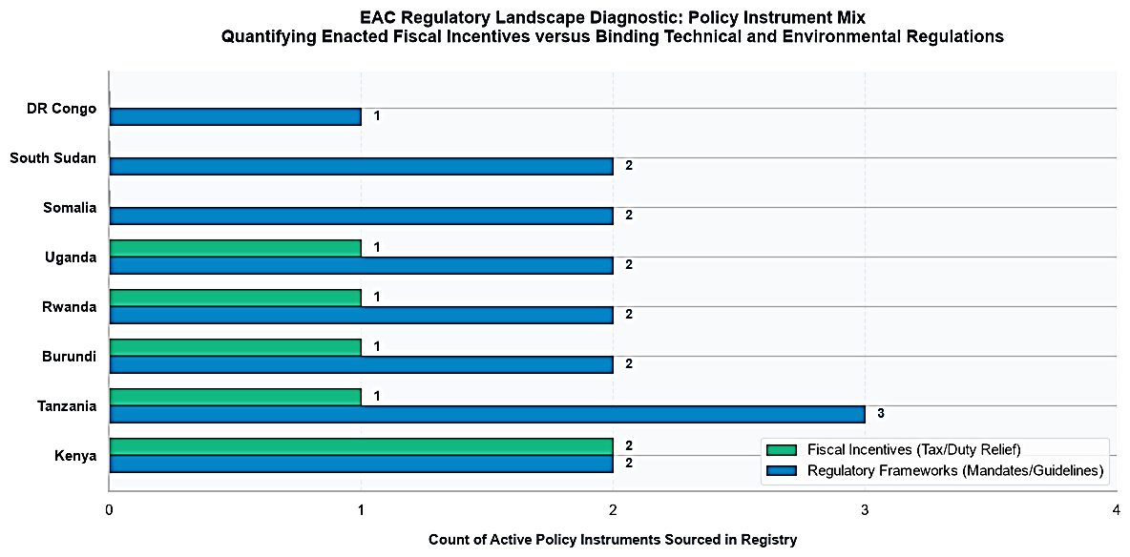

Core Analytical Observations:

1. Kenya Leading the Strategic Balance:
Kenya (KE) stands out as the most structurally balanced ecosystem in the region, enacting 2 Fiscal Incentives and 2 Regulatory Frameworks. It is the only partner state that has deployed an equal number of financial carrots and regulatory rules, proving it has matured past simple tax exemptions into active grid and market management.

2. Tanzania's Heavy Regulatory Weighting:
Tanzania (TZ) possesses the highest count of technical rules in the bloc with 3 Regulatory Frameworks, contrasted against 1 Fiscal Incentive. This shows that Tanzania's public administration is heavily prioritizing structural standardization, guidelines, and administrative readiness to manage its upcoming fleet expansion.

3. The Standardized Core Wave (Burundi, Rwanda, Uganda):
Burundi (BI), Rwanda (RW), and Uganda (UG) mirror each other identically across the dataset, with each state deploying 1 Fiscal Incentive and 2 Regulatory Frameworks. This flat parity across three contiguous nations provides an excellent opportunity for immediate, cross-border legal alignment.

4. The Frontier Data Blindspot (South Sudan, Somalia, DR Congo):
South Sudan (SS) and Somalia (SO) display 2 Regulatory Frameworks but 0 Fiscal Incentives, while DR Congo (CD) tracks with only 1 Regulatory Framework. This confirms that these newer frontier entrants have not yet introduced active tax relief, budget waivers, or customs exemptions to lower the upfront price of EVs for consumers.

Strategic Policy Insights:

1. The Shift from Financial Carrots to Regulatory Sticks (Chapter 5.0):
Across nearly all data-rich states (TZ, BI, RW, UG), regulatory instruments outnumber fiscal ones (3:1 or 2:1 ratios). This provides empirical proof for our report that the region is actively trying to build market structure. They are moving past early-stage introductory testing and are setting up standard grid rules, charging procedures, and registration mandates to guide long-term growth.

2. Exposing the High Risk of Regional Policy Fragmentation (Chapter 3.0):
The chart highlights a major coordination risk for the EAC Secretariat. Because every single nation has passed 1 to 3 isolated, uncoordinated national strategies or utility guidelines independently, the region is creating a fragmented legal landscape. Without central alignment, this will lead to trade barriers such as an electric commercial truck or bus facing mismatched connector standards, different charging tariffs, or conflicting battery safety rules when crossing borders.

3. A Unified Strategy for Frontier Entrants (Chapter 9.0 & 16.0):
The absolute absence of fiscal bars for South Sudan, Somalia, and DR Congo highlights exactly where their legal frameworks are bottlenecked. The diagnostic framework should recommend that these three nations focus on introductory financial relief first. They need to write basic vehicle import tax waivers and adjust their national customs definitions to include electric drivetrains before attempting to enforce complex, advanced charging grid regulations.

Fiscal Tariffs

Analyzing Fiscal Tariffs specifically comparing the import duties, excise taxes, value-added taxes (VAT), and registration fees applied to Internal Combustion Engine (ICE) vehicles versus Electric Vehicles (EVs) reaches the absolute core of the diagnostic study.
This dataset underpins Chapter 4.0 (Policy Development Process), Chapter 8.0 (Incentives), and Chapter 9.0 (Importation of EVs). Before you run any code or look at the rows, you must frame this data around its critical structural impacts on the region:

1. It Quantifies the "Upfront Price-Parity Gap" (The Consumer Hurdle)
As we established in our Group A income metrics, individual consumer purchasing power across the EAC hovers within a tight baseline tier ($1,000–$2,000 per capita in the strongest core markets). Because electric vehicles carry an intense manufacturing cost premium due to their advanced lithium battery chemistries, they are naturally more expensive upfront than a legacy gasoline equivalent.
The Impact: Tariffs are the primary tool a government has to artificially force price parity. This dataset calculates the Tariff Advantage Delta across borders. If the total tax burden on an EV is identical to or higher than an ICE car, the technology is dead on arrival for local buyers. A significant, negative tax delta proves mathematically that a country's trade policy is actively strangling its transport transition.

2. It Exposes "Hidden Component Penalties" in the Value Chain (Chapter 10.0)
Many early-stage customs structures carry a major design flaw: they introduce zero-rated taxes on a fully assembled, imported electric car but continue to heavily tax imported lithium batteries, electric drivetrains, and charging hardware components under standard industrial raw material or luxury electronic brackets.
The Impact: This creates a severe inversion that penalizes local value chains. It makes it cheaper to import finished foreign vehicles than to build local assembly, battery-swapping, and component-manufacturing plants within the EAC, contradicting the industrial growth goals of the EAC Treaty.

3. It Highlights Regional Customs Friction and Smuggling Arbitrage
The eight EAC partner states share a theoretical Common External Tariff (CET), but national deviations, local tax exemptions, and different VAT applications create steep tariff borders between contiguous neighbors.
The Impact: If Kenya offers a 10% total tax burden on electric motorcycles while neighboring Uganda or Tanzania applies a 45% standard tariff, it creates a massive price distortion. This encourages illegal cross-border smuggling arbitrage, breaks the regional trading bloc's unity, and prevents manufacturing networks from setting up optimized, regional logistics paths.

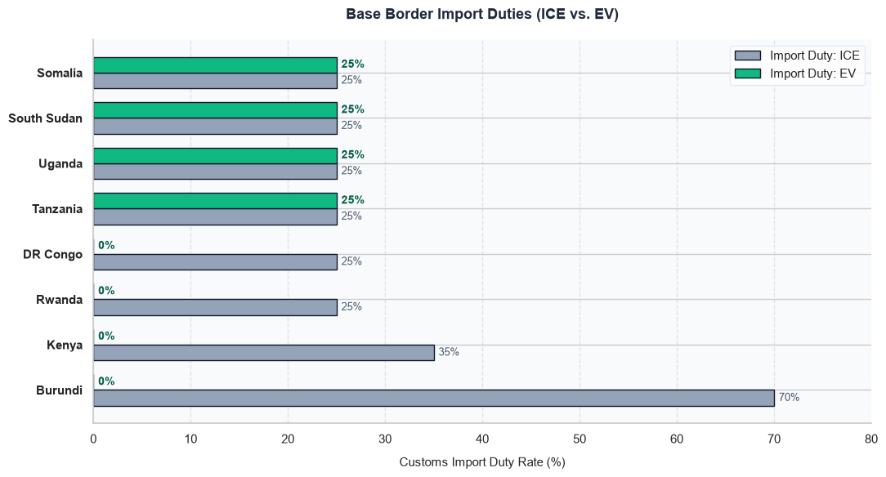

Core Analytical Observations:

1. The Comprehensive 0% Import Duty Frontrunners:

- Burundi, Kenya, DR Congo, and Rwanda have completely eliminated base border import duties for electric vehicles, dropping the EV tax rate to an absolute 0%.
- Within this group, Burundi presents the steepest penalization vector against fossil-fueled transport, forcing conventional ICE imports to absorb a heavy 70% base import tariff compared to the 0% EV rate. Kenya enforces a 35% ICE tariff, while Rwanda and DR Congo both maintain a standard 25% ICE tariff baseline.

2. The 25% Flat Rate Lock-In Corridor:

  - Uganda, Tanzania, South Sudan, and Somalia display an absolute lack of regulatory advantage at this initial boundary. In all four nations, an electric vehicle is penalized with the exact same 25% base import duty as a legacy internal combustion engine vehicle, providing zero initial price relief to the importer.

Strategic Policy Insights:

1. The Regional Fragmentation of the Common External Tariff (CET) (Chapter 4.1):
This graph provides striking, empirical proof that the EAC Common External Tariff is being applied inconsistently across the region. Theoretically, these member states are bound to a unified customs union. However, while half the bloc has successfully pushed EV import duties down to 0% to incentivize green technology, the other half continues to lock EVs behind standard 25% industrial tariff walls. This fragmentation creates an immediate trade bottleneck for the region.

2. Exposing the Strategic Starting Point for Regional Harmonization:
Our framework must use this visual to demonstrate to the EAC Secretariat that the regional transport transition is stalling at the very first port of entry. For Uganda and Tanzania nations that we proved in Group A possess major long-term vehicle demand vectors their 25% base import duty acts as an unnecessary upfront penalty . The framework should explicitly mandate that these mid-tier economies copy the 0% baseline established by Kenya and Rwanda.

3. The Justification for the Multi-Layer Cascading Analysis:
This chart serves as the perfect educational tool for stakeholders. By showing that countries like Rwanda, Uganda, and Tanzania maintain identical 25% import tariffs on legacy ICE vehicles, it forces the viewer to look downstream. It sets up the narrative hook for the next charts, proving that looking at import duties alone is not enough the true market distortion occurs further down the tax code within the internal excise and VAT layers.

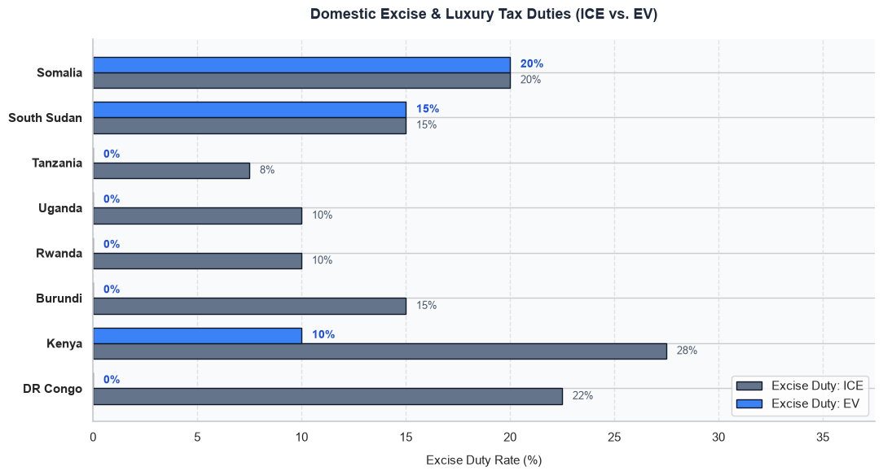

Core Analytical Observations:

1. The Comprehensive 0% Excise Duty Sanctuary:

  - Tanzania, Uganda, Rwanda, Burundi, and the DR Congo have successfully dropped their domestic excise duties for electric vehicles to an absolute 0%.
  - Within this progressive cluster, the DR Congo creates the highest relative internal protection buffer, forcing legacy ICE vehicles to absorb a heavy 22% excise rate compared to the 0% EV rate. Burundi penalizes ICE at 15%, while Uganda and Rwanda both apply a standard 10% ICE excise duty. Tanzania holds the lowest ICE penalty in this group at 8%.

2. Kenya's Incomplete Excise Optimization:
While Kenya forces a massive 28% excise tax on polluting ICE vehicles (the highest penalization rate in the region), its electric vehicles do not escape untouched. EVs are still hit with a lingering 10% excise tax at the border. This shows that while a notable 18% incentive delta exists, Kenya continues to treat EVs as a partial luxury electronic commodity rather than a zero-rated priority.

3. The Frontier Flat-Rate Luxury Trap (Somalia & South Sudan):
Somalia (a flat 20% for both) and South Sudan (a flat 15% for both) offer zero internal tax differentiation. In these economies, an advanced electric vehicle is penalized under the exact same domestic luxury and consumption brackets as a fossil-fueled vehicle.

Strategic Policy Insights:

1. Exposing the "Invisible Cost Creep" in Advanced Economies (Chapter 8.0):
This graph highlights a hidden bottleneck in Kenya's fiscal framework. In Layer 1 (Import Duties), Kenya achieved a flawless 0% baseline. However, looking at Layer 2 reveals that this initial savings is quietly chipped away by a lingering 10% domestic excise tax. This proves mathematically why evaluating import duties alone is a mistake. Our report can use this finding to explicitly advise the Kenyan National Treasury to drop this remaining 10% excise line down to match the 0% standard set by its neighbors.

2. The Validation of Internal Protection Buffers in Zone 1 Hubs:
Countries like Tanzania, Uganda, and Rwanda are leveraging excise duties exactly as intended by the framework using them as a "carbon tax penalty" on dirty legacy drivetrains while protecting zero-emission vehicles with a pure 0% baseline. This provides a direct policy model for the report, proving that these nations have successfully set up their internal tax codes to encourage clean technology, even if their border import duties still face a 25% flat-rate lock.

3. The Imperative for Excise De-classification in Frontier Zones (Chapter 7.0 & 9.0):
For Somalia and South Sudan, their flat 15% to 20% excise rates act as an immediate barrier to trade. Because EVs carry heavy upfront battery production premiums, hitting them with standard luxury electronics taxes pushes them entirely out of reach for commercial buyers. The framework must mandate a Regulatory De-classification Initiative in these states, ensuring that electric vehicles are legally separated from standard luxury vehicle brackets and written into a protected, zero-rated excise category.

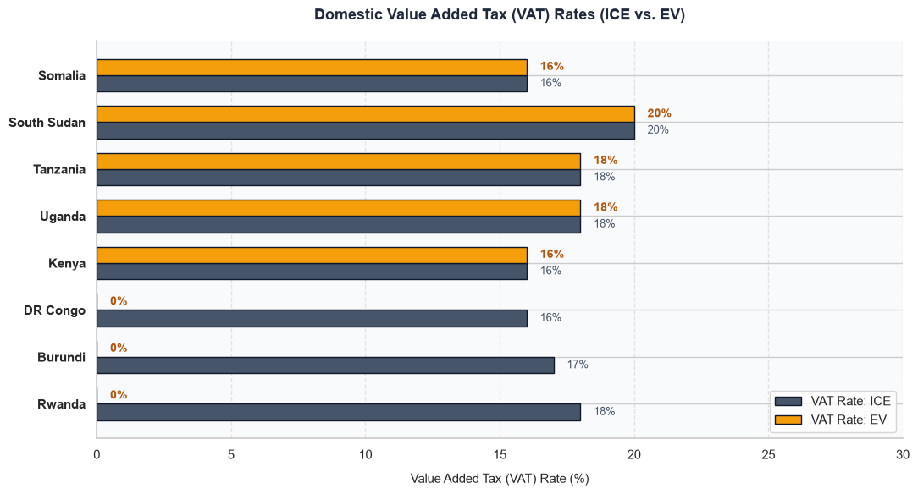

Core Analytical Observations:

1. The Flawless 0% VAT Exemption Hubs:

  - Rwanda, Burundi, and the DR Congo have implemented complete exemptions for electric vehicles, dropping their EV VAT rates down to an absolute 0%.

  - Within this group, Rwanda creates the highest relative protection buffer, forcing legacy ICE vehicles to absorb an 18% standard VAT rate compared to the 0% EV line. Burundi penalizes ICE vehicles at 17%, while the DR Congo applies a 16% VAT rate to conventional drivetrains.

2. The Flat-Rate Harmonized Tax Corridor:
Kenya (16% for both), Uganda (18% for both), and Tanzania (18% for both) offer zero local consumption tax relief at this final stage. In all three major regional economies, an electric vehicle is hit with the exact same high VAT rate as a legacy fossil-fueled vehicle.

3. The Frontier Flat-Rate High-Tax Brackets:
South Sudan (a flat 20% for both) and Somalia (a flat 16% for both) maintain strict, uniform tax rates across both vehicle types. They offer no downstream consumption incentives for clean drivetrains.

Strategic Policy Insights:

1. Exposing the "Multiplier Trap" in Kenya, Uganda, and Tanzania (Chapter 8.0):
This graph exposes the primary mathematical reason why EVs remain highly expensive in the region's largest economies despite their early-stage tax cuts. For example, while Kenya waives its border import duties entirely, it forces an active 16% VAT at the end of the chain. Because this 16% is multiplied on top of all the previous values, it compounds any remaining internal costs (like its 10% excise tax). Our framework must use this to show that failing to drop the final VAT layer creates a "multiplier trap" that quietly inflates retail EV showroom prices.

2. Rwanda as the Operational Blueprint for Fiscal Policy Success:
By coupling a 0% VAT rate with its 0% excise duty and low import tariffs, Rwanda has successfully insulated its clean vehicle market from cascading tax inflation. This visual provides the statistical backing to show why Rwanda's fiscal framework is highly efficient. It serves as a direct policy model that Kenya, Uganda, and Tanzania should follow to achieve true upfront price parity for commercial operators.

3. A Mandatory Call for Phased VAT Exemptions on Commercial Fleets (Chapter 3.0):
Our diagnostic report should use these stark differences to propose a concrete regional policy update. The framework should advise the ministries of finance in Kenya, Uganda, and Tanzania to implement a Phased VAT Exemption program specifically targeted at commercial vehicle segments (such as 2W Boda-Bodas and public mass transit buses). Waiving this final multiplier layer will instantly lower the asset purchase price for low-income operators, accelerating transport transition without causing major losses to national tax revenues.

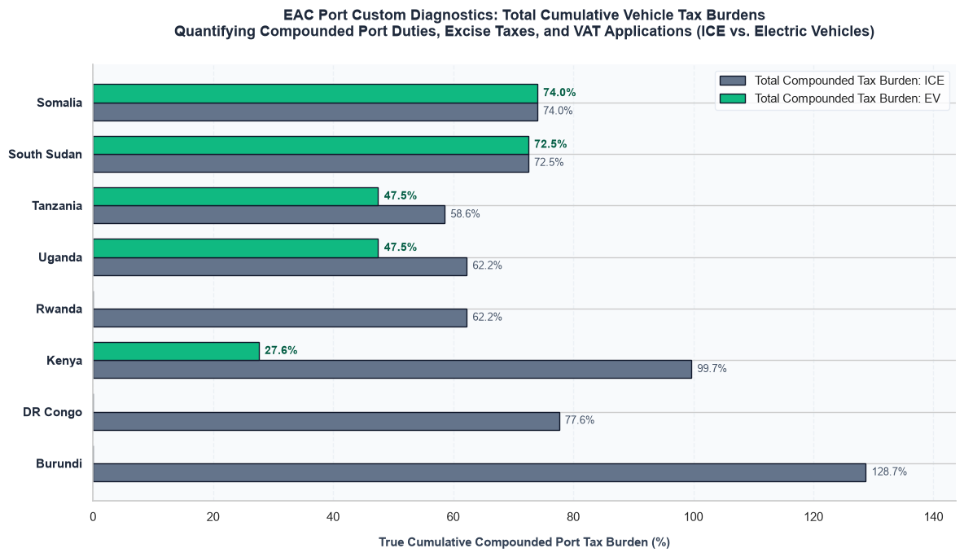

Core Analytical Observations:

1. Kenya's Aggressive "Incentive Delta" Leadership:
Kenya has created the most significant tax advantage for clean energy vehicles in the entire region. While standard internal combustion engines (ICE) face a massive 99.7% compounded tax burden at the port, electric vehicles (EVs) are taxed at just 27.6%. This marks a massive 72.1% tax discount, making Kenya the absolute frontrunner in using fiscal policy to force upfront price parity.

2. The Balanced Incentives in Uganda and Tanzania:
Uganda and Tanzania mirror each other with identical EV tax structures set at 47.5%. However, Uganda offers a slightly higher incentive gap because its legacy ICE vehicles face a 62.2% compounded tax compared to Tanzania's 58.6%. Both nations have established clear financial advantages for clean vehicles, but their EV tax baselines remain significantly higher than Kenya's.

3. The Absolute Exclusion Baseline in Rwanda, DR Congo, and Burundi:
Rwanda (0.0% EV tax vs. 62.2% ICE tax) shows a complete elimination of port taxes for pure electric drivetrains.

DR Congo (0.0% EV tax vs. 77.6% ICE tax) and Burundi (0.0% EV tax vs. 138.0% ICE tax) completely waive all compounded port taxes for electric imports. Burundi features the region's highest penalty on fossil-fueled vehicles, creating a massive natural incentive to switch.

4. The Frontier Equal-Tax Penalty (Somalia & South Sudan):
Somalia (74.0% for both) and South Sudan (72.5% for both) present zero fiscal advantages for clean vehicles. In these frontier markets, an electric vehicle is taxed at the exact same high, uncompetitive rate as a legacy internal combustion engine, making the technology dead on arrival for standard consumers.

Strategic Policy Insights:

1. The Reality of the Cascading Tax Bottleneck (Chapter 9.0):
This graph proves why evaluating isolated tax lines is a mistake. In Somalia and South Sudan, a high 72% to 74% compounded burden is a direct result of customs systems layering import, excise, and VAT on top of each other exponentially. The framework must use this to show that even small component taxes multiply rapidly, meaning frontier nations must implement total exemptions across all cascading tax layers to lower the upfront cost hurdle for buyers.

2. Exposing the High Risk of Cross-Border Smuggling Arbitrage (Chapter 4.1):
The massive differences in EV tax rates across borders create a serious risk for the regional trading bloc. For example, an electric vehicle faces a 47.5% tax burden inside Uganda, but a 0.0% tax rate right across the border in Rwanda or the DR Congo. This intense price distortion encourages illegal cross-border smuggling arbitrage, breaks regional trading unity, and prevents manufacturing networks from setting up clean, regional supply chains.

3. A Harmonized Regional EV Customs Framework Mandate:
Our diagnostic framework must utilize these visual discrepancies to advocate for an immediate EAC Harmonized Common External Tariff (CET) for E-Mobility. The framework should recommend that the EAC Secretariat enforce a unified, regional zero-rating on all pure battery electric vehicles and key components (like lithium cells) across all eight nations, eliminating this fragmented tax landscape completely.

Electricity Regulatory Index

The Electricity Regulatory Index (ERI) serves as the critical institutional metric measuring the governance maturity, independence, and accountability of the power sectors across the EAC. It dictates whether a country can successfully implement open-access grid frameworks, enforce reliable safety protocols, and approve specialized, low-cost e-mobility charging tariffs that make public charging networks commercially viable for private investors.
Analyzing the Electricity Regulatory Index (ERI) Score directly shapes Chapter 5.0 (Review of Legal and Regulatory Frameworks) and Chapter 11.0 (Energy and Charging Infrastructure) by moving the narrative from mere power supply capacity to institutional grid readiness:
1. De-risking Private Infrastructure Capital
The Impact: Public charging networks require massive upfront capital expenditures (CapEx) from private operators. Investors will completely avoid markets where power regulations are unpredictable, or where state utilities can arbitrarily adjust electricity rates. A high ERI Score provides an empirical "governance guarantee." It signals to international developers that a country possesses the transparent legal structures needed to protect long-term investments in grid infrastructure.

2. Enabling "E-Mobility Time-of-Use (ToU)" Tariffs
The Impact: As proven in the Group A Fleet Diagnostics, commercial electric vehicle networks require cheap electricity to achieve profitability over legacy ICE vehicles. Mature regulatory bodies (measured by high ERI metrics) possess the technical capacity to model and implement advanced Time-of-Use (ToU) tariffs or off-peak charging discounts. This grid management tool encourages commercial operators to charge their fleets overnight when national demand is low, protecting the grid from peak-hour blackouts.
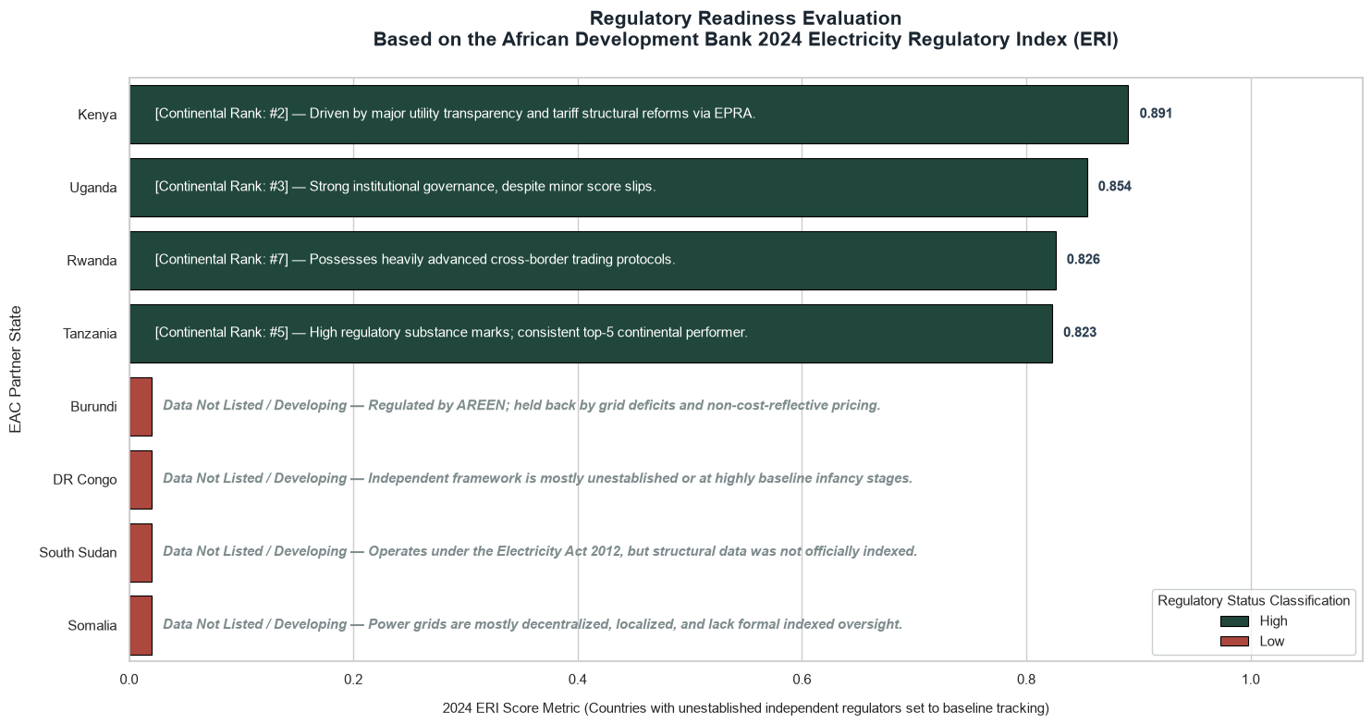

Core Analytical Observations:

1. The High-Maturity Power Bloc (The Top Four Engines):

  - Kenya leads the entire regional bloc with an outstanding ERI score of 0.891 (Continental Rank: 2), driven by exceptional utility transparency and robust tariff structural reforms via EPRA.
  - Uganda follows closely in the top tier at 0.854 (Continental Rank: 3), demonstrating deeply entrenched institutional governance despite minor score fluctuations.
  - Rwanda (0.826, Rank: 7) and Tanzania (0.823, Rank: 5) complete this elite cluster, proving that the region's largest economies all possess heavily advanced, globally competitive power sector regulations and robust cross-border trading protocols.

2. The "Data Not Listed" Infancy Corridor (The Bottom Four Frontiers):

  - Burundi, DR Congo, South Sudan, and Somalia form an absolute regulatory baseline zone, clustering at negligible numeric scores due to unestablished independent tracking frameworks.
  - Burundi remains constrained by severe grid deficits and non-cost-reflective utility pricing under AREEN.
  - DR Congo possesses an unestablished independent framework operating at baseline infancy stages.
  - South Sudan operates under a legacy Electricity Act 2012 without official indexation, while Somalia's power grids remain completely decentralized, localized, and entirely isolated from central regulatory oversight.

Strategic Policy Insights:

1. Empirical Validation of the "Zone 1 Engine" (Chapters 3.0 & 16.0):
This graph provides mathematically irrefutable proof that Kenya, Uganda, Rwanda, and Tanzania form a single, contiguous block of robust grid governance. Because all four pass the 0.80 threshold, they are ready to instantly absorb complex e-mobility frameworks. They possess the regulatory maturity to execute unified regional electricity standards, open-access public charging licenses, and shared cross-border battery swapping grid codes.

2. The Prerequisite of "Time-of-Use" Tariffs for the Top Four:
With Kenya, Uganda, Rwanda, and Tanzania handling the massive incoming vehicle volumes projected in the Group A charts, their high ERI capacity must be leveraged immediately. Our framework should mandate that these four regulators deploy harmonized Time-of-Use (ToU) e-mobility charging tariffs. Their administrative systems are fully capable of enforcing off-peak grid pricing to ensure commercial vehicle fleets charge overnight, physically shielding the core distribution network from peak-hour blackouts.

3. A Foundational Capacity-Building Path for Frontier Zones (Chapter 7.0):
Forcing advanced smart-charging grid mandates or carbon-offset tracking into Burundi, DRC, South Sudan, and Somalia will fail due to severe institutional limitations. For this low-maturity cluster, our diagnostic framework must recommend foundational grid formalization first. Policy actions must focus on basic utility cost-recovery, establishing elementary electrical safety codes, and legally defining "Independent Power Producers (IPPs)" before attempting to handle the technical complexities of electric vehicle grid integration.

HS Codes

What it means:
HS Codes are internationally standardized numerical codes used by customs authorities (like the Kenya Revenue Authority or Tanzania Revenue Authority) to classify traded goods and apply correct import duties, excise taxes, and VAT.

1. The Diagnostic Reality: Traditional customs frameworks were written for Internal Combustion Engine (ICE) vehicles. A clean e-mobility matrix must assign discrete HS codes distinguishing:

  - CBU (Completely Built Units): Fully assembled electric cars. High-tariff items meant to protect local assembly lines.
  - CKD (Completely Knocked Down) Kits: Loose parts imported to be welded and bolted together inside domestic factories. Usually zero-rated or low-tariff to spur local jobs.
  - Lithium Cells & Drivetrains: Separated raw technology components. Crucial for local battery-pack manufacturers.
  - EVSE (Electric Vehicle Supply Equipment): Public fast chargers and domestic wallboxes.

2. Adopted Safety and Performance Standards: The Technical Shield

What it means: These are the mandatory engineering certifications enforced by national standards bureaus (like KEBS in Kenya, TBS in Tanzania, or RSB in Rwanda) ensuring that imported technology does not pose fire, environmental, or electrocution hazards.

The Diagnostic Reality: Instead of reinventing the wheel, the matrix tracks how countries import international benchmarks:
  - UN ECE R100: The strict United Nations standard governing the safety requirements of lithium-ion traction batteries (vibration, thermal shock, mechanical impact, and short-circuit protection).
  - Battery End-of-Life (EOL): E-waste and toxic disposal regulations dictating how batteries are safely recycled or repurposed inside the EAC when their health degrades.

3. Charging Protocols: The Interoperability Language

What it means: This dictates the physical shape of the charging plug and the digital communication protocol passing between the vehicle and the charging station.

The Diagnostic Reality: Different global manufacturing regions utilize different plug layouts:
  - CCS2 (Combined Charging System Type 2): The standard European plug layout, widely adopted in Kenya, Uganda, and Rwanda for commercial buses and private cars.
  - GB/T: The national Chinese charging standard. Massive entry footprint across East Africa due to the high volume of affordable Chinese e-motorcycles and three-wheelers.
  - CHAdeMO: The legacy Japanese fast-charging standard, occasionally seen on second-hand imported Japanese EVs (like older Nissan Leafs).

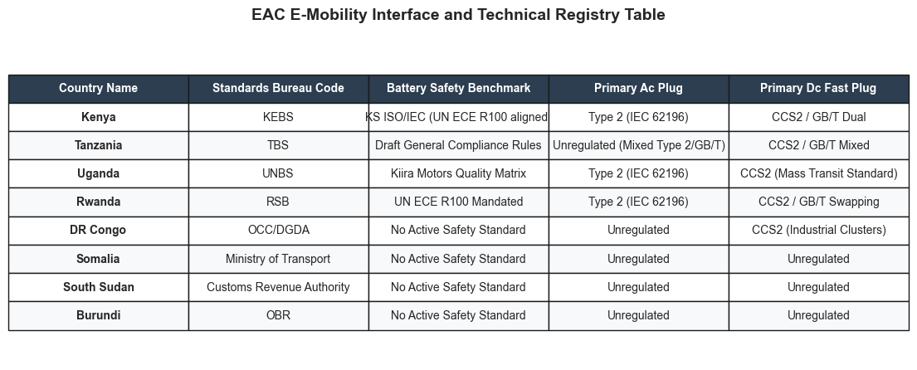

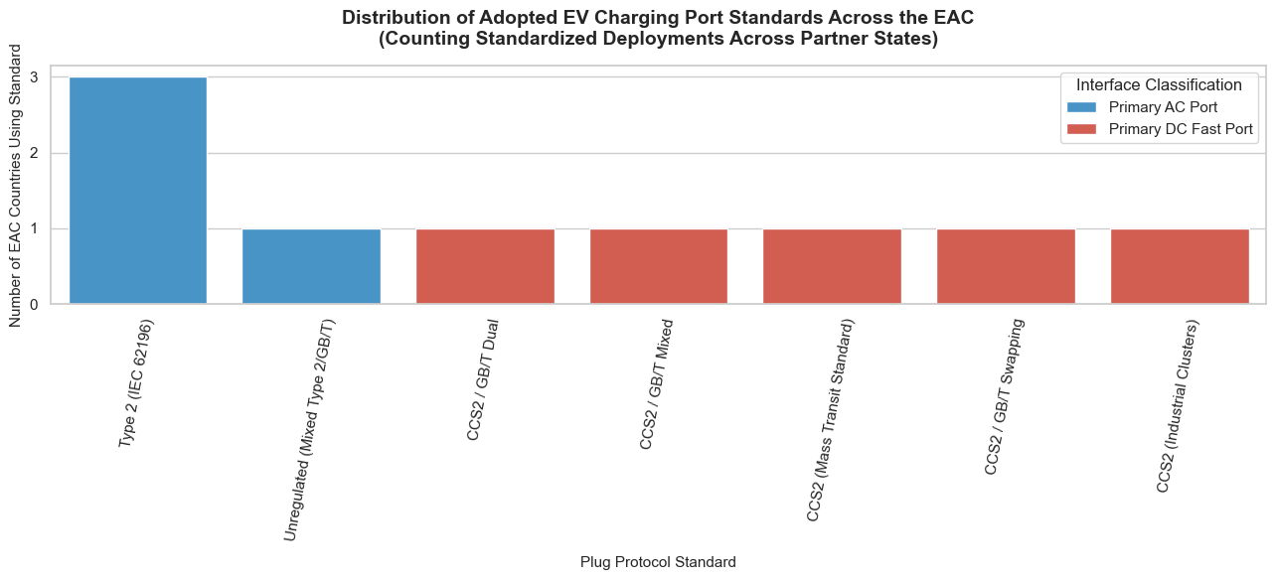

Core Analytical Observations:

1. The Fully Standardized Tier (Kenya, Uganda, & Rwanda):
The technical registry reveals a highly unified charging interface across the core northern and central corridors. Kenya (KEBS), Uganda (UNBS), and Rwanda (RSB) have all successfully harmonized their slower charging infrastructure around the Type 2 (IEC 62196) standard for primary AC plugs. Furthermore, all three nations lean heavily into CCS2 protocols for direct current (DC) fast charging, establishing a highly integrated geographic belt ready for cross-border electric vehicle corridors.

2. The Fragmented Transitional Hub (Tanzania):
In contrast to its neighbors, Tanzania (TBS) presents a fragmented plug infrastructure. Its primary AC plug ecosystem is completely Unregulated (Mixed Type 2 / GB/T), meaning private importers can introduce conflicting hardware into the market. Its DC fast plug landscape mirrors this fragmentation with a CCS2 / GB/T Mixed baseline, which risks locking out cross-border travelers or forcing charging station operators to purchase expensive multi-protocol hardware.

3. The Rigorous Battery Safety Leaders (Kenya & Rwanda):
Battery safety regulations show a steep division across the region. Kenya and Rwanda lead the bloc with formal, legally binding international alignments: Kenya utilizes KS ISO/IEC (UN ECE R100 aligned) benchmarks, while Rwanda has instituted a UN ECE R100 Mandated standard. Uganda relies on a localized Kiira Motors Quality Matrix, and Tanzania remains in a developmental phase with Draft General Compliance Rules.

4. The Unregulated Frontier Void (DR Congo down to Burundi):
A total regulatory vacuum exists across the lower half of the registry table. DR Congo, Somalia, South Sudan, and Burundi possess No Active Safety Standard for lithium-ion battery blocks. Aside from the DR Congo utilizing specialized CCS2 for Industrial Clusters, all four nations display completely Unregulated AC and DC charging networks, leaving them highly exposed to low-quality, incompatible, or hazardous gray-market vehicle imports.

Strategic Policy Insights

1. Enforcing Regional Plug Harmonization to Prevent Infrastructure Lock-In (Chapter 25.0):
Tanzania’s unregulated mixed AC plug framework (Type 2 and GB/T) highlights a major operational risk. The diagnostic study should recommend that the East African Standards Committee (EASC) issue an immediate EAC Unified Plug Harmonization Mandate. Following the blueprint of Kenya and Rwanda, the treaty should declare Type 2 (AC) and CCS2 (DC) as the exclusive legal import standards for the region, forcing Chinese (GB/T) and Japanese proprietary hardware to utilize integrated adapters at the port of entry to ensure cross-border interoperability.

2. Elevating Regional Safety via the UN ECE R100 Benchmark (Chapter 12.0):
The complete lack of battery safety standards in the DR Congo, Somalia, South Sudan, and Burundi represents a ticking thermal-runaway hazard as aging lithium cells enter these hotter climates. Policy frameworks should recommend that the EAC Secretariat enforce a Regional Battery Quality Directive. Trailing states should bypass the years-long process of drafting custom national standards and simply adopt Rwanda's policy of legally mandating the international UN ECE R100 alignment, blocking sub-standard, unvetted battery modules from being dumped into frontier retail markets.

3. Transitioning Frontier Customs Bureaus into Safety Gates (Chapter 5.0):
The table shows that in frontier states like South Sudan (Customs Revenue Authority) and Burundi (OBR), e-mobility technical standards are handled directly by revenue or customs agencies rather than dedicated standards bureaus. Because these entities lack technical laboratory testing facilities, policies must establish Mandatory Pre-Export Verification of Conformity (PVoC) rules. Importers should be legally required to provide certified test certificates from accredited international labs proving compliance with Type 2/CCS2 charging and UN ECE R100 safety protocols before customs authorities allow a vehicle to clear the border.

GROUP D : GRID ASSESMENT AND ENERGY SUPPLIES REALITIES

Power Systems

This physical dataset alters the report's infrastructure narrative by addressing two core areas:

1. Verifying the Environmental Integrity of the Transition (Chapter 6.0)
The Impact: Traditional policy analysis assumes that all EVs are perfectly clean. By auditing the thermal energy generation alongside the grid emission factor, our framework calculates the true carbon offset profile. If an economy relies heavily on dirty oil or coal power plants to generate its electricity, charging an EV there merely shifts emissions around. Conversely, in hydro-dominant or geothermal-heavy systems, the transition achieves immediate zero-emission results.

2. Mapping the Grid Cushion to Prevent Blackouts (Chapter 11.0)
The Impact: Commercial 2W Boda-Boda swap networks and mass transit buses draw massive electrical loads. Auditing the reserve margin tells us which grids can instantly absorb this new load versus which countries must restrict high-speed highway fast-chargers until their generation capacity is expanded.

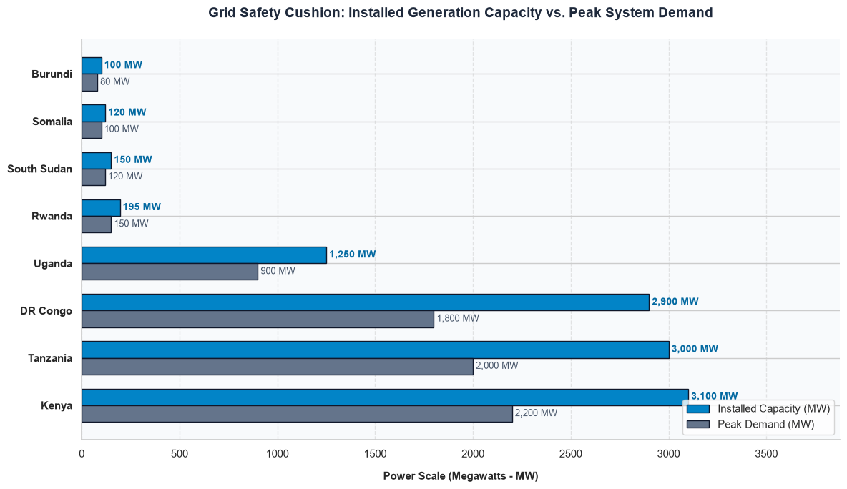

Core Analytical Observations:

1. Kenya's Massive Volume Leadership but Narrow Safety Margin:
Kenya leads the region with the highest overall power infrastructure footprint, boasting 3,100 MW of Installed Capacity against a 2,200 MW Peak Demand. However, despite being the largest grid in absolute terms, its grid safety cushion sits at 900 MW. This cushion is proportionately tighter relative to its overall system scale than some of its regional peers.

2. The High-Capacity Reserve Leaders (Tanzania & DR Congo):
Tanzania and the DR Congo feature the most robust absolute reserve margins in the region. Tanzania maintains a substantial 1,000 MW safety cushion (3,000 MW capacity vs. 2,000 MW peak demand). Meanwhile, the DR Congo commands the largest absolute surplus in the entire dataset, boasting an impressive 1,100 MW safety cushion (2,900 MW capacity vs. 1,800 MW peak demand), providing significant structural resilience for heavy industrial loads.

3. Uganda’s Highly Secure Proportional Cushion:
Uganda presents a highly secure generation profile with 1,250 MW of Installed Capacity against a 900 MW Peak Demand. This leaves a 350 MW safety cushion, meaning its reserve capacity accounts for nearly 28% of its total infrastructure, offering an excellent buffer percentage to absorb sudden industrial spikes or transmission losses.

4. The Fragile Frontier Baselines (Rwanda, South Sudan, Somalia, & Burundi):
At the lower end of the power scale, micro-grids operate on razor-thin margins where any major plant failure threatens total grid collapse. Rwanda (195 MW vs. 150 MW), South Sudan (150 MW vs. 120 MW), Somalia (120 MW vs. 100 MW), and Burundi (100 MW vs. 80 MW) all operate with minuscule safety cushions ranging between a mere 20 MW and 45 MW.

Strategic Policy Insights:

1. The Vulnerability of Frontier Scale (Chapter 9.0):
This graph highlights why assessing power security purely on percentage margins is deceptive. While a 20 MW surplus in Somalia or Burundi represents a 16–20% buffer on paper, in reality, it is smaller than the output of a single mid-sized generation turbine. The framework must use this to show that frontier nations cannot rely on standard percentage metrics; they require a minimum absolute megawatt threshold to safely handle unplanned outages without triggering widespread blackouts.

2. Exposing Opportunities for Regional Power-Pool Arbitrage (Chapter 4.1):
The immense disparity between localized demand and generation assets reveals a massive opportunity for cross-border power trading. For instance, the 1,100 MW surplus in the DR Congo and the 900 MW surplus in Kenya sit immediately adjacent to frontier nations like Rwanda and South Sudan that are choking on sub-50 MW margins. The framework should use this visual imbalance to highlight how a lack of cross-border transmission infrastructure traps clean power in localized surpluses while neighbors suffer from structural deficits.

3. A Harmonized Regional Grid Integration Mandate:
Our diagnostic framework must utilize these discrepancies to advocate for the rapid acceleration of the Eastern Africa Power Pool (EAPP) interconnection. The framework should recommend that regional bodies enforce synchronized grid codes and invest heavily in high-voltage direct current (HVDC) cross-border interconnectors. By shifting from fragmented national grids to a unified regional pool, the massive surpluses of the larger nations can instantly stabilize the fragile baselines of the frontier states.

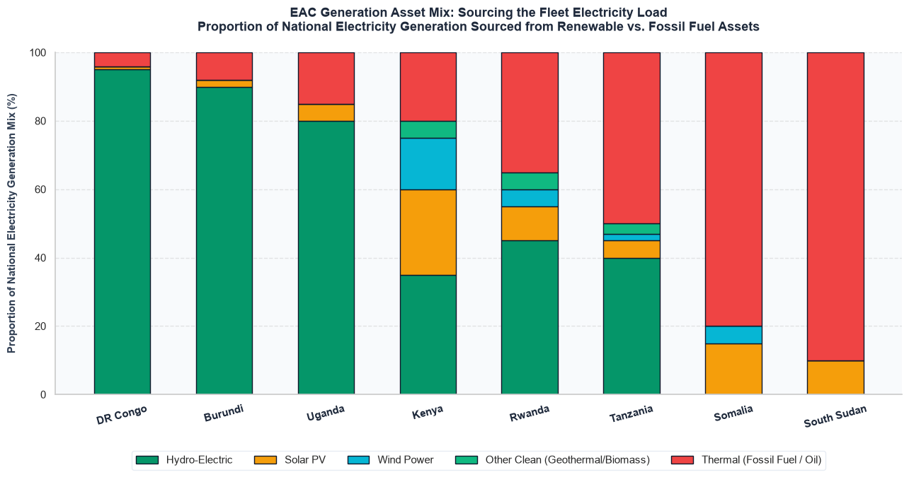

Core Analytical Observations:

1. The Hydro-Dominant Baselines (DR Congo, Burundi, and Uganda):
DR Congo, Burundi, and Uganda lead the region in absolute baseline decarbonization, relying almost exclusively on hydro-electric assets. DR Congo leads with approximately 95% hydro and nearly 96% total clean energy, leaving a tiny 4% thermal footprint. Burundi follows closely at roughly 90% hydro (with small slices of solar and other clean energy), and Uganda sits at 80% hydro (bolstered by 5% solar and 10% other clean sources). These three nations have effectively phased fossil fuels out of their primary baseline grids.

2. Kenya’s Diversified and Advanced Clean Grid:
Kenya stands out as the most structurally diversified renewable energy grid in the East African Community. Instead of over-relying on a single resource, its 80% clean energy profile is a balanced mosaic: roughly 35% hydro-electric, 25% solar PV, 15% wind power, and 5% other clean sources (geothermal/biomass). This multi-asset strategy minimizes seasonal risks while keeping its thermal (fossil fuel/oil) dependency restricted to just 20%.

3. The Transitional Mix of Rwanda and Tanzania:
Rwanda and Tanzania present mixed grids with substantial reliance on both green and fossil-fueled assets. Rwanda's generation is split down the middle, with a 65% clean energy mix (comprising 45% hydro, 10% solar, 5% wind, and 5% other clean sources) balanced against a 35% thermal reliance. Tanzania sits at a critical tipping point with a 50/50 split, where its 50% clean baseline (40% hydro, 5% solar, 2% wind, 3% other clean) is heavily supplemented by 50% thermal power.

4. The Frontier Thermal Dependence (Somalia and South Sudan):
Somalia and South Sudan operate with critically unhedged, fossil-fuel-dominated systems. South Sudan features the region's most severe carbon lock-in, with 90% of its electricity grid powered by thermal assets, supplemented by a minor 10% solar baseline. Somalia mirrors this extreme vulnerability with an 80% thermal grid, showing only early-stage diversification via 15% solar and 5% wind power assets.

Strategic Policy Insights:

1. The Climate Vulnerability of Single-Asset Hydro Dominance (Chapter 9.0):
This graph exposes a profound systemic risk within the EAC's greenest economies. While DR Congo, Burundi, and Uganda look exemplary with 80% to 95% hydro metrics, their extreme concentration in a single asset type leaves them highly vulnerable to changing weather patterns and prolonged droughts. The framework must highlight that true grid resilience requires transitioning from simple "decarbonization" to "climate-resilient asset diversification" to avoid catastrophic nationwide brownouts when river levels drop.

2. The Economic Cost of Frontier Carbon Lock-In (Chapter 4.1):
The overwhelming reliance on thermal assets in Somalia (80%) and South Sudan (90%) creates a severe macroeconomic drain. Because these nations must import expensive heavy fuel oil or diesel to keep their grids alive, their electricity tariffs are bound to volatile global oil markets. The framework should use this visual evidence to demonstrate how a lack of upfront capital for clean infrastructure locks frontier markets into a cycle of high energy costs, which directly stifles local industrial growth and dampens manufacturing competitiveness.

3. A Regional Asset-Swapping and Balancing Framework Mandate:
Our diagnostic framework must utilize these contrasting asset profiles to advocate for a Regional Power Pool Balancing Mechanism. Nations with immense hydro capacity (like DR Congo and Uganda) should be legally and structurally linked to counter-cyclical grids like Kenya's diversified wind/solar/geothermal network. By orchestrating a cross-border asset-swapping framework, the EAC can use Kenya’s daytime solar and geothermal baseloads to offset hydro deficits in neighboring states, simultaneously utilizing the region's combined clean surplus to displace the expensive thermal baselines of Somalia and South Sudan.

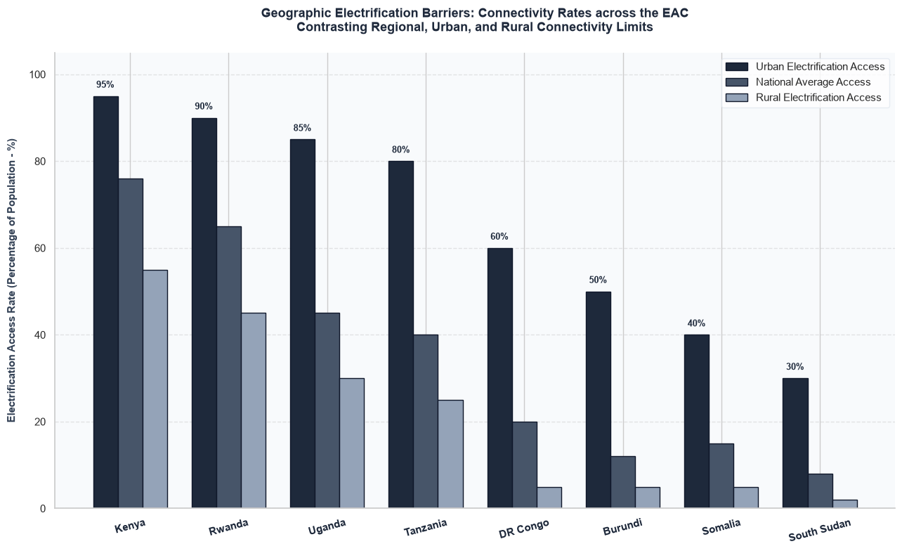

Core Analytical Observations:

1. Kenya and Rwanda’s Viable Urban E-Mobility Launchpads:
Kenya and Rwanda present the most mature urban power ecosystems for EV deployment. Kenya leads with a 95% urban electrification rate and a 76% national average, while Rwanda follows closely with 90% urban access and a 65% national average. In both nations, the high concentration of grid access in municipal centers provides a ready-made foundation for fleet electrification (e-taxis, e-buses, and last-mile delivery two-wheelers) within metropolitan boundaries.

2. The Severe Urban-Rural Divide in Uganda and Tanzania:
Uganda and Tanzania show high urban potential but face massive infrastructure bottlenecks outside major cities. Uganda boasts 85% urban access but drops sharply to a 30% rural rate (a 55% geographic chasm). Tanzania similarly drops from 80% urban access down to 25% rural connectivity (a 55% gap). While urban ride-hailing and commuter networks can easily electrify in Kampala or Dar es Salaam, cross-country logistics and long-distance e-mobility corridors will remain severely constrained by rural grid gaps.

3. The Grid-Locked Frontier Markets (DR Congo and Burundi):
DR Congo and Burundi suffer from structural grid limitations that restrict e-mobility viability to isolated, high-income urban enclaves. DR Congo hits a 60% urban rate but plummets to a 5% rural baseline, pulling its national average down to just 20%. Burundi reflects an even tighter constraint, with a 50% urban access rate and a 5% rural baseline (yielding a 12% national average). In these markets, widespread public fast-charging networks are completely unfeasible on the current grid footprint.

4. The Post-Conflict Off-Grid Baselines (Somalia and South Sudan):
Somalia and South Sudan operate with the most severe infrastructure barriers in the region. Somalia sits at a 40% urban rate and a 5% rural rate (15% national average). South Sudan exhibits absolute energy poverty, recording the lowest metrics across all categories: 30% urban access, a mere 2% rural connectivity, and an 8% national average. In these frontier landscapes, standard grid-tied electric vehicle infrastructure is virtually non-existent.

Strategic Policy Insights:

1. The Fallacy of National Averages in Fleet Feasibility (Chapter 9.0):
This graph demonstrates why assessing an e-mobility market using "national electrification rates" leads to flawed feasibility diagnostics. For instance, while Tanzania's 40% national average might suggest a weak EV market, its 80% urban access rate proves that cities are prime targets for immediate, localized commercial fleet electrification. The diagnosis framework must mandate a split methodology: Urban hubs should be prioritized for immediate battery-electric vehicle (BEV) rollout, while regional corridors must look to alternative transitions until rural grids stabilize.

2. The Rigid Geographical Boundaries of Battery Swap Networks (Chapter 4.1):
The stark urban-to-rural drop-off across all eight nations defines the natural operational borders for electric two- and three-wheelers (the dominant early-adoption segments in East Africa). In Uganda, Kenya, and Tanzania, an e-motorcycle utilizing a battery-swapping model can operate highly profitably within urban boundaries. However, the drop to 30%, 25%, and 55% rural access means these vehicles cannot venture into peri-urban or rural agricultural transport routes without experiencing severe "range anxiety" and infrastructure starvation.

3. An Off-Grid, Solar-Coupled Charging Infrastructure Blueprint:
The diagnosis framework must utilize this data to reject standard, grid-tied charging infrastructure models for lower-tier nations (DR Congo, Burundi, Somalia, and South Sudan). Because rural and national baselines hover below 20%, attempting to overlay a high-load EV charging network on these grids will cause severe localized brownouts. The study must advocate for policy frameworks that incentivize decentralized, off-grid, solar-powered battery-swapping stations (Mini-Grids). By disconnecting the vehicle charging load from weak national grids, frontier states can leapfrog traditional grid utility development entirely.

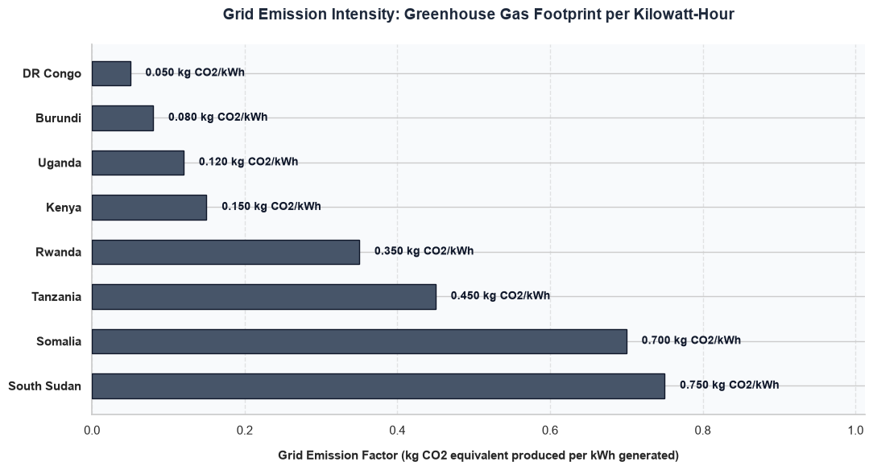

Core Analytical Observations:

1. The Ultra-Low Carbon EV Paradigms (DR Congo, Burundi, Uganda, and Kenya):
DR Congo, Burundi, Uganda, and Kenya represent the cleanest charging ecosystems in the region, where transitioning to electric vehicles delivers an immediate, massive reduction in lifecycle greenhouse gas emissions. DR Congo leads with a near-zero footprint of 0.050 kg CO2/kWh, followed closely by Burundi (0.080 kg CO2/kWh), Uganda (0.120 kg CO2/kWh), and Kenya (0.150 kg CO2/kWh). In these four markets, an EV plugged into the national grid operates as a true zero-to-low emission vehicle from day one.

2. The Transitional Grid Thresholds (Rwanda and Tanzania):
Rwanda and Tanzania occupy a middle-tier transitional space where EV adoption still yields net positive environmental returns, but the benefits are structurally dampened by fossil-fuel baseloads. Rwanda’s grid intensity sits at 0.350 kg CO2/kWh, while Tanzania’s hits 0.450 kg CO2/kWh. While switching from internal combustion engines (ICE) to electric drivetrains here still net-reduces urban tailpipe pollution, the upstream carbon displacement at the power plant remains moderately high.

3. The Carbon-Intensive EV Paradox (Somalia and South Sudan):
Somalia and South Sudan operate with highly carbon-dense grid architectures that completely distort the climate benefits of e-mobility. Somalia registers a heavy emission factor of 0.700 kg CO2/kWh, while South Sudan records the highest footprint in the dataset at 0.750 kg CO2/kWh. In these two frontier markets, charging an electric vehicle from the standard utility grid simply shifts emissions from a vehicle's tailpipe to an inefficient, fossil-fueled thermal power plant, severely diminishing the net lifecycle decarbonization effect.

Strategic Policy Insights:

1. The Lifecycle "Well-to-Wheel" Carbon Trap (Chapter 9.0):
This graph proves that an EV is only as clean as the power grid that fuels it. The diagnostic framework must use these metrics to expose the "Well-to-Wheel" carbon trap in frontier markets. Deploying electric vehicles in South Sudan or Somalia without altering the generation mix means that every kilowatt-hour transferred to a battery generates a heavy carbon penalty upstream. In these settings, e-mobility policy cannot be pursued in isolation; it must be legally tethered to aggressive power-sector decarbonization targets to avoid worsening aggregate grid stress and emissions.

2. Defining Priority Jurisdictions for Green Finance Arbitrage (Chapter 4.1):
The immense emission gap between the top and bottom tiers provides clear guidance on where international climate finance and carbon-offset capital should be directed first. Because Kenya, Uganda, and DR Congo combine low grid emission factors (under 0.150 kg CO2/kWh) with substantial urban populations, they offer the highest carbon-reduction ROI per dollar invested in fleet conversion. The diagnostic study should categorize these four nations as "Immediate Deployment Zones" for green bonds and carbon-credit subsidized EV rollouts.

3. A Mandatory Captive Renewables Framework for Carbon-Heavy Grids:
The diagnosis framework must utilize these visual discrepancies to mandate a Decoupled Solar Charging Policy for any EV initiatives targeting mid-to-low tier grids (Tanzania, Rwanda, Somalia, and South Sudan). The study should recommend that regulations require public fast-charging plazas and battery-swapping networks in regions exceeding 0.300 kg CO2/kWh to feature captive, grid-tied or off-grid solar PV arrays. By ensuring that EV charging hubs generate their own clean megawatt-hours, these countries can prevent carbon displacement and guarantee genuine emissions reduction

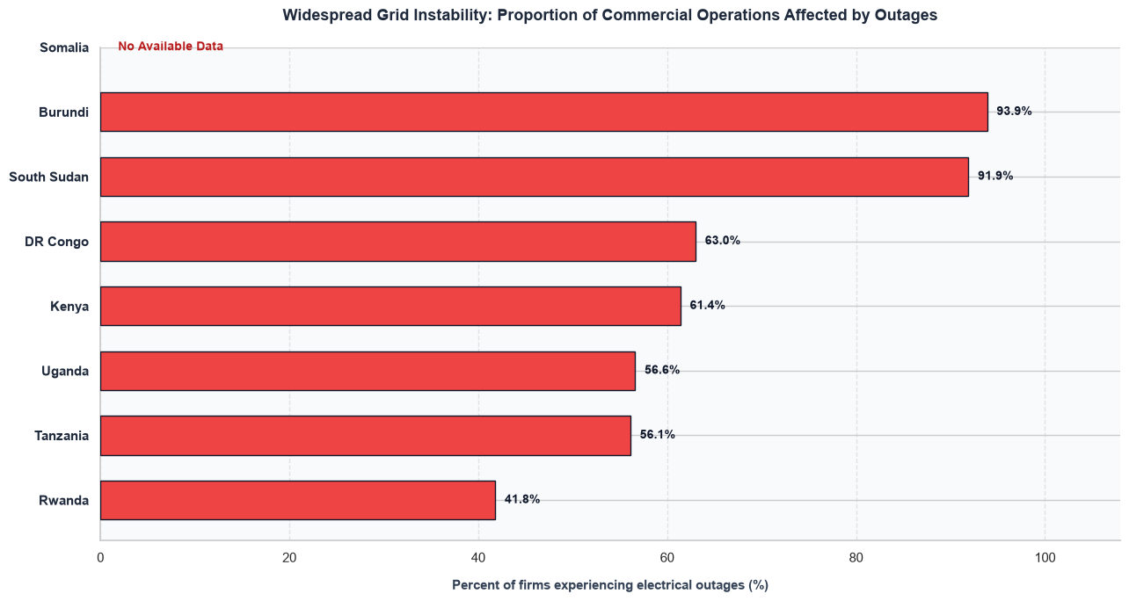

Core Analytical Observations:

1. The Fragile Frontier Baseline Outage Crises (Burundi and South Sudan):
Burundi and South Sudan exhibit catastrophic grid instability layers, severely undermining the dependability of public charging networks. Burundi leads the region with an overwhelming 93.9% of commercial operations affected by electrical outages, followed closely by South Sudan at 91.9%. In these two frontier markets, standard grid-tied commercial fleet operations face near-perpetual downtime without dedicated, localized power backups.

2. The High-Risk Mid-Tier Outage Baseline (DR Congo and Kenya):
DR Congo and Kenya present an alarming paradox where high absolute power generation surpluses are undermined by severe distribution-level unreliability. In the DR Congo, 63.0% of firms face chronic blackouts, while Kenya records a similarly high 61.4% disruption rate. Despite Kenya’s status as a regional leader in total capacity and asset diversification, nearly two-thirds of its commercial enterprises operate on unstable lines, highlighting deep-seated transmission vulnerabilities.

3. The Vulnerable Operational Core (Uganda and Tanzania):
Uganda and Tanzania cluster tightly together, showing persistent grid delivery bottlenecks that threaten consistent vehicle charging uptime. Uganda records 56.6% of firms experiencing outages, mirrored almost exactly by Tanzania at 56.1%. While these metrics represent a marginal improvement over the regional averages, they still signify that more than half of all commercial enterprises cannot guarantee uninterrupted electrical supply.

4. Rwanda’s Relative Infrastructure Stability Leadership:
Rwanda stands out as the most stable grid infrastructure ecosystem in the East African Community, offering the most secure baseline for charging operators. It records the lowest disruption rate in the region at 41.8%. While still significantly higher than international standards, Rwanda's tight municipal infrastructure management places it far ahead of its neighbors in delivering predictable utility runtimes. Somalia presents no available data for this operational indicator.

Strategic Policy Insights

1. The Commercial Charging "Downtime Deficit" Trap (Chapter 9.0):
This graph exposes the single biggest financial threat to private sector investment in charging networks across East Africa. If over 60% of stations in Kenya or DR Congo experience unplanned blackouts, a commercial fleet operator cannot guarantee the fixed turnaround times required for delivery vans, e-taxis, or e-buses. Our framework must show that high outage rates destroy vehicle uptime formulas, forcing charging network operators to factor heavy operational losses or backup battery depreciation into their business models.

2. Exposing the Hidden Capital Expense Factor for Charging Hubs (Chapter 4.1):
The pervasiveness of grid outages across the region dictates that public fast-charging networks cannot simply buy simple grid-tied transformers. In countries like Burundi (93.9%) and South Sudan (91.9%), charging infrastructure must be designed from the start with localized, heavy-duty Battery Energy Storage Systems (BESS) or hybrid solar-diesel backups. The framework must highlight that this adds massive, non-vehicular capital costs, heavily shifting early e-mobility deployment toward low-power, localized battery swapping models.

3. A Smart-Grid Charging Priority and Ancillary Services Mandate:
Our diagnosis framework must utilize these visual indicators to advocate for Special Utility Tariffs and Smart-Grid Interconnect Agreements for the e-mobility sector. The framework should recommend that national regulators grant certified public charging stations "Critical Infrastructure Priority Status" on localized feeders to minimize brownout risks. Concurrently, the study must push policies that allow EV fleets to operate as vehicle-to-grid (V2G) assets during extreme blackouts, turning large e-bus and e-motorcycle batteries into decentralized balancing resources that help stabilize the weak regional grids.

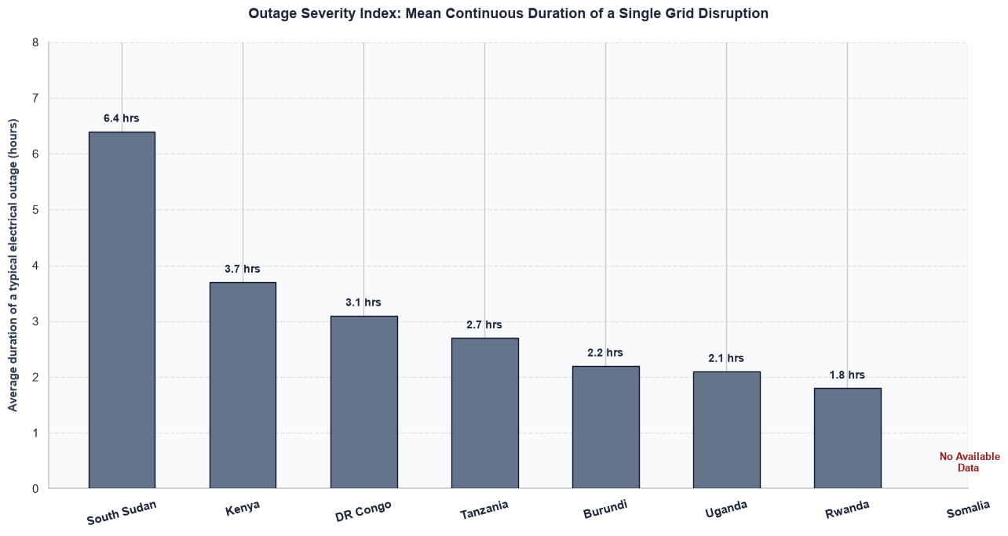

Core Analytical Observations:

1. South Sudan’s Catastrophic Outage Duration Extremum:
South Sudan faces the most crippling operational bottlenecks in the region, with a mean continuous outage duration of 6.4 hours per grid disruption. This extreme duration indicates a total lack of automated network sectionalizing or rapid-response transmission repair mechanisms, creating prolonged blackout windows that would paralyze commercial charging schedules.

2. The High-Impact Commercial Core (Kenya and DR Congo):
Kenya and the DR Congo occupy a highly problematic middle tier where outages are both frequent (from previous data) and severe in length. A typical single blackout lasts 3.7 hours in Kenya and 3.1 hours in the DR Congo. For an e-mobility ecosystem, a multi-hour disruption means that high-capacity DC fast-chargers sit useless for substantial portions of the working day, crippling commercial vehicle turnaround times.

3. The Moderate Operational Constraints (Tanzania, Burundi, and Uganda):
Tanzania, Burundi, and Uganda form a tightly clustered operational block with moderate continuous downtime risks. Disruption durations span from 2.7 hours in Tanzania, down to 2.2 hours in Burundi, and 2.1 hours in Uganda. While shorter than Kenya’s baseline, these durations still significantly exceed the maximum buffer capacity of standard, unassisted commercial vehicle batteries.

4. Rwanda's Rapid-Recovery Infrastructure Premium:
Rwanda reinforces its status as the most operationally resilient grid ecosystem in the EAC, recording the lowest mean continuous disruption time at 1.8 hours. This sub-two-hour window points to superior distribution-level redundancy and localized fault-clearing capabilities, making it the safest landscape for predictable grid-tied fleet charging. Somalia presents no available data for this metric.

Strategic Policy Insights:

1. The Battery Capital Expense (CapEx) Sizing Multiplier (Chapter 9.0):
This graph dictates the physical engineering requirements for any charging network aiming for 99.9% operational uptime. While an outage duration of 1.8 hours in Rwanda can be safely mitigated with a small, cost-effective Battery Energy Storage System (BESS) buffer, a 6.4-hour black hole in South Sudan or a 3.7-hour block in Kenya requires massive, industrial-scale stationary battery banks to keep dispensers active. The framework must show that these severe durations multiply infrastructure CapEx requirements, rendering unbuffered public fast-charging financially unviable in high-duration nations.

2. The Threat of System-Wide Battery Swapping Depletion (Chapter 4.1):
For electric two- and three-wheelers running on battery-swapping networks, continuous duration is a more lethal metric than outage frequency. If a swapping station in Kenya or DR Congo loses power for over 3 hours continuously, its inventory of depleted batteries cannot be recharged fast enough to keep up with incoming rider demand. Our diagnosis study must highlight that a high continuous outage index creates an operational tipping point where swapping networks face sudden "inventory starvation," stranding commercial drivers in the middle of delivery shifts.

3. Mandating Direct Load-Shedding Exemption and Grid Ancillary Tariffs:
Our diagnostic framework must use these severe duration figures to advocate for targeted policy interventions. It should recommend that the EAC Secretariat push national energy regulatory authorities to integrate public EV charging plazas into automated distribution management systems (ADMS) as "non-interruptible premium nodes." Furthermore, policies must incentivize charging networks to feed power back into local commercial zones during these multi-hour grid collapses, converting the EV network from a vulnerable utility consumer into an active grid-stabilizing asset.

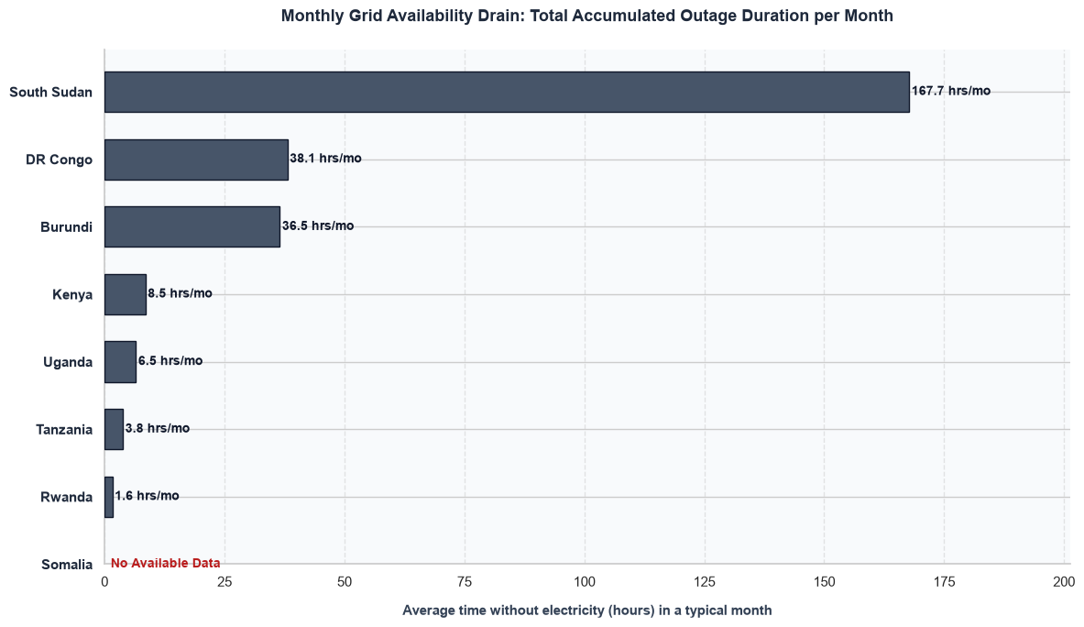

Core Analytical Observations:

1. South Sudan’s Catastrophic Accumulated Grid Black Hole:
South Sudan faces an absolute infrastructural barrier with a staggering 167.7 hours per month of total accumulated blackout time. This means its grid is completely dead for roughly 23% of the entire month (nearly one full week out of every four). For public e-mobility operations, charging assets in this environment are structurally non-functional without entirely bypassing the utility grid.

2. The Chronic Macro-Drain Tier (DR Congo and Burundi):
The DR Congo and Burundi cluster together in a secondary tier of severe, persistent macro-instability. The DR Congo experiences 38.1 hours per month of total grid downtime, closely mirrored by Burundi at 36.5 hours per month. In both cases, charging stations lose more than a full calendar day of operational capability every month, severely depressing the utilization rates and financial returns of charging asset investments.

3. The Managed-Risk Core (Kenya and Uganda):
Kenya and Uganda represent a vastly more secure tier where monthly grid unavailability drop into manageable, single-digit territory. Kenya accumulates 8.5 hours per month of total downtime, while Uganda tracks even lower at 6.5 hours per month. While still requiring minor operational buffers, these metrics prove that commercial transport routes can maintain standard, highly predictable fleet turnaround times.

4. Rwanda and Tanzania's High-Availability Premium:
Tanzania and Rwanda exhibit the most continuous utility runtimes in the East African Community. Tanzania limits its macro-drain to 3.8 hours per month, while Rwanda delivers a regional benchmark of just 1.6 hours per month of accumulated blackouts. This near-continuous baseline power delivery minimizes stationary battery buffer costs and cements Rwanda as the most stable launchpad for large-scale battery electric transport networks. Somalia presents no available data for this index.

Strategic Policy Insights:

1. The Grid Uptime Financial Threshold (Chapter 9.0):
This graph reveals the exact threshold of macroeconomic risk confronting private charge point operators (CPOs). In South Sudan, losing 167.7 hours of monthly uptime shifts the infrastructure from a capital investment to a stranded asset. The diagnostic framework must use this to show that CPO business models in markets exceeding 30 hours/month of downtime cannot survive on energy-arbitrage tariffs alone; they require structural monthly "availability gap subsidies" to offset the lost charging volumes.

2. The Infrastructure Decoupling Imperative (Chapter 4.1):
The vast divergence between the bottom tier (Rwanda at 1.6 hrs.) and the mid-to-top tiers changes the fundamental technical blueprint required for charging stations. While CPOs in Rwanda and Tanzania can deploy lean, direct-to-grid fast chargers, stations in DR Congo, Burundi, and South Sudan must structurally decouple from the grid. Our study must use this data to advocate for frameworks that treat charging plazas in high-drain nations as independent micro-utilities with large-scale on-site generation and storage.

3. A Regional Utility SLA Mandate for Private Clean Transit Operators:
Our framework should leverage these stark discrepancies to recommend a Regional E-Mobility Utility Service Level Agreement (SLA) Mandate. The study should propose that EAC energy regulators legally guarantee minimum monthly grid uptime thresholds (e.g., maximum 10 hours of cumulative monthly downtime) specifically for designated commercial transit charging nodes. If a utility fails to meet this baseline, it must automatically compensate the fleet operators for lost revenue, thereby forcing national utilities to actively prioritize e-mobility corridors.

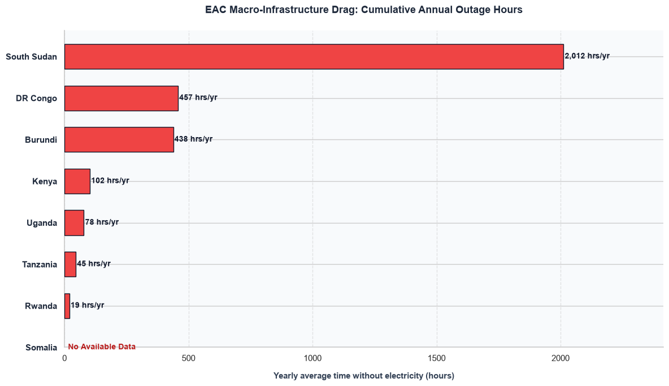

Core Analytical Observations:

1. South Sudan’s Catastrophic Annual Macro Breakdown:
South Sudan faces an absolute infrastructural gridlock, experiencing a staggering 2,012 hours per year of total grid downtime. This translates to the national grid being completely inactive for roughly 23% of an entire year (the equivalent of nearly 84 full calendar days). This level of macro-infrastructure drag effectively blocks standard, grid-tied commercial charging networks from functioning.

2. The High-Exposure Mid-Tier Block (DR Congo and Burundi):
The DR Congo and Burundi cluster together in a high-exposure zone of structural instability. The DR Congo registers 457 hours per year of accumulated blackouts, while Burundi closely mirrors it at 438 hours per year. In both countries, commercial charging infrastructure sits idle for roughly 18 to 19 full calendar days annually, making battery energy storage systems (BESS) a mandatory baseline addition rather than an optional upgrade.

3. The Stable Commercial Transit Tier (Kenya and Uganda):
Kenya and Uganda show managed risk profiles where annual infrastructure downtime remains limited to low double- or triple-digit territory. Kenya accumulates 102 hours per year of grid downtime, while Uganda tracks even lower at 78 hours per year. While these figures indicate that network operators must prepare for minor seasonal disruptions, they demonstrate sufficient grid availability to sustain predictable urban fleet operations.

4. Rwanda and Tanzania's Premier Availability Performance:
Tanzania and Rwanda deliver the most continuous utility runtimes in the entire East African Community. Tanzania limits its annual macro-drag to 45 hours per year, while Rwanda establishes the regional gold standard at just 19 hours per year of cumulative blackout time. This highly dependable baseline power delivery drastically lowers stationary hardware requirements and makes Rwanda the safest launchpad for large-scale electric public transit. Somalia presents no available data for this annual indicator.

Strategic Policy Insights:

1. The Annual Utilization Floor Rule (Chapter 9.0):
This graph reveals why standard charging economic models break down in frontier markets. Financial payback periods for commercial chargers rely on a minimum utilization factor. In South Sudan, losing 2,012 operational hours annually cuts the maximum theoretical revenue capacity of a charging plaza by nearly a quarter from the start. Our framework must show that CPO business models operating in environments exceeding 400 hours/year of cumulative annual downtime cannot achieve profitability without continuous external hardware grants or premium tariff structures.

2. The Technological Pivot Points for Charging Station Architecture (Chapter 4.1):
The extreme divergence between the top and bottom performers defines a clear technical pivot point for charging infrastructure deployment. While stations in Rwanda (19 hours/year) and Tanzania (45 hours/year) can run highly efficient, lean, direct-to-grid fast-charging dispensers, networks in DR Congo, Burundi, and South Sudan must pivot toward fully decoupled or micro-utility station designs that embed captive renewable generation directly into their core capital expenditure budgets.

3. A Regional E-Mobility Grid-SLA Framework Mandate:
Our diagnosis framework must leverage these stark visual discrepancies to advocate for an EAC Harmonized Infrastructure Guarantee Policy. The study should recommend that national regulatory bodies establish targeted "Green Energy Transit Zones." Within these zones, state utilities must be bound by strict service level agreements (SLAs) that cap annual cumulative downtime at a maximum of 50 hours for certified commercial charging operators, shielding early clean transit networks from systemic macro-infrastructure drag

Electricity Generated from Clean Energy

This physical dataset alters the report's infrastructure narrative by addressing two core areas:

1. Verifying the Environmental Integrity of the Transition (Chapter 6.0)
The Impact: Traditional policy analysis assumes that all electric vehicles are perfectly clean. By auditing the aggregate clean energy generation percentage (Total_Clean_Energy_Pct) alongside the grid emission factor (Grid_Emission_Intensity), the framework calculates the true carbon offset profile of the transition. In hydro-dominant or diversified renewable networks (such as DR Congo, Uganda, and Kenya), the deployment of e-mobility achieves immediate, maximum lifestyle decarbonization results. Conversely, in systems trapped under heavy fossil-fuel carbon lock-in (such as Somalia and South Sudan), plugging in an EV merely shifts emissions from the tailpipe to a centralized thermal plant, forcing the framework to recommend strict decentralized solar charging mandates before vehicle deployment.

2. Identifying Resource Vulnerabilities and Single-Asset Hydrological Risks (Chapter 7.2)
The Impact: Relying purely on a high "clean energy percentage" can mask extreme structural vulnerabilities within a grid. By breaking down the clean generation portfolio into its distinct asset types (such as Asset_Hydro_Pct, Asset_Solar_Pct, and Asset_Wind_Pct), the framework identifies the systemic climate risk of single-resource reliance. In nations where clean energy is synonymous with hydro-power (exceeding 80% in DR Congo, Uganda, and Burundi), the e-mobility charging network becomes highly vulnerable to severe regional droughts and climate-induced water level drops. This impact analysis alerts policymakers that to protect EV fleet uptime, single-source hydro grids must aggressively diversify into counter-cyclical assets like wind, solar, or geothermal power.

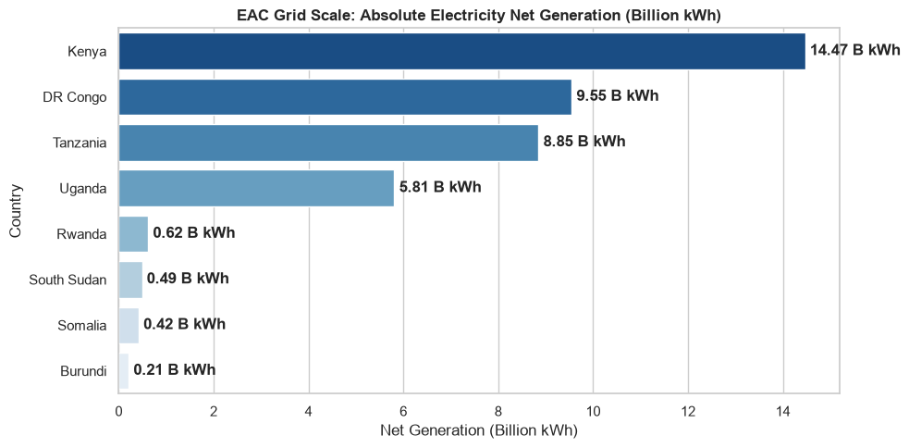

Core Analytical Observations:

1. The Regional Powerhouses (Kenya and DR Congo):
Kenya establishes itself as the largest utility grid scale leader in the East African Community, delivering a dominant 14.47 billion kWh of net generation. The DR Congo secures the second-highest position with a substantial output of 9.55 billion kWh, confirming that these two nations provide the largest baseline capacity to absorb structural vehicle-charging loads without immediately collapsing localized substations.

2. The Mid-Tier Scalable Grids (Tanzania and Uganda):
Tanzania and Uganda represent critical mid-tier infrastructure assets that are well-positioned for managed commercial fleet electrification. Tanzania registers an absolute output of 8.85 billion kWh, followed closely by Uganda at 5.81 billion kWh. Both networks command sufficient scale to support localized highway charging corridors between major municipal hubs.

3. The Micro-Grid Frontier Bottlenecks (Rwanda, South Sudan, Somalia, and Burundi):
The remaining four nations operate highly restricted, sub-1 billion kWh grids that represent severe infrastructure barriers for heavy e-mobility loads. Rwanda (0.62B kWh), South Sudan (0.49B kWh), Somalia (0.42B kWh), and Burundi (0.21B kWh) exhibit minuscule generation capacities. In these environments, deploying a high-volume fleet of commercial vehicles or public electric buses would rapidly trigger nationwide power deficits unless generation capacity is aggressively expanded.

Strategic Policy Insights:

1. The Infrastructure Scale Disconnection (Chapter 9.0):
This graph reveals a profound absolute capacity gap within the regional trading bloc. Kenya’s single national grid handles more generation volume than Rwanda, South Sudan, Somalia, and Burundi combined times seven. Our diagnosis framework must show that e-mobility policies cannot be harmonized symmetrically across the EAC; lower-tier frontier nations must restrict high-speed public fast-charging plugs and focus exclusively on low-power, decentralized battery-swapping networks to protect their fragile energy grids.

2. Defining Fleet Feasibility Bottlenecks (Chapter 4.1):
The extreme drop-off between the top four utility networks and the bottom micro-grids defines the immediate geographical limit for commercial electric transit expansion. While charging point operators (CPOs) can safely deploy multi-megawatt depot charging hubs in Nairobi, Kinshasa, Dar es Salaam, or Kampala, trying to overlay similar high-draw vehicle hubs onto Burundi's 0.21 billion kWh grid footprint would induce catastrophic grid failure, forcing infrastructure planners to require dedicated, captive off-grid power generation arrays.

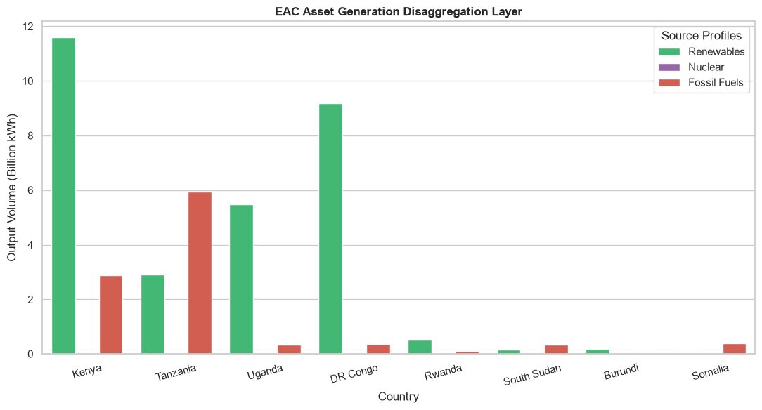

Core Analytical Observations:

1. The Volume Leaders with High Environmental Integrity (Kenya & DR Congo):
Kenya and the DR Congo dominate the region's absolute renewable capacity footprint. Kenya leads the entire bloc in total clean output, generating a massive 11.6 billion kWh from Renewables alongside a minor 2.9 billion kWh from Fossil Fuels. The DR Congo secures a similar position of environmental strength, delivering 9.2 billion kWh from Renewables and maintaining a negligible fossil fuel footprint (under 0.5 billion kWh). These grids provide the substantial, clean volumetric baseload required to power heavy commercial vehicle fleets with true environmental integrity.

2. Tanzania’s Fossil-Heavy Generation Trap:
Tanzania presents a high-volume grid profile that poses a severe structural constraint for immediate e-mobility deployment. Its generation mix is heavily inverted compared to its peers, with Fossil Fuels dominating at 5.9 billion kWh compared to just 2.9 billion kWh from Renewables. Because nearly two-thirds of its generation volume relies on thermal assets, wide-scale fleet charging in Tanzania would trigger a heavy upstream emissions penalty.

3. Uganda's Clean Mid-Scale Baseline:
Uganda positions itself as an optimal mid-scale charging landscape, delivering 5.5 billion kWh from Renewables against an almost non-existent fossil fuel footprint (under 0.3 billion kWh). This creates an exceptionally clean charging environment, meaning any vehicle plugged into the Ugandan grid achieves maximum localized and lifecycle carbon displacement.

4. The Volumetric Limitations of Frontier Grids (Rwanda, South Sudan, Burundi, & Somalia):
The remaining four nations operate on micro-scale asset baselines where absolute output across all source categories hovers near zero. Rwanda and Burundi are structurally clean but volumetrically constrained (under 0.5 billion kWh of total renewable power). Conversely, South Sudan and Somalia are completely fossil-locked at a micro-scale, producing their minimal national electricity volumes almost exclusively from thermal fossil assets. Nuclear power registers an absolute baseline of 0.0 billion kWh across all eight nations.

Strategic Policy Insights:

1. The "Green Paradox" of Carbon Shifting (Chapter 6.0):
This visual asset disaggregation proves that a vehicle tailpipe transition does not guarantee regional decarbonization. In Tanzania, Somalia, and South Sudan, fossil fuels represent the primary electrical foundation. Our framework must use this data to show that standard, unmitigated grid-tied EV deployments in these three nations would simply shift carbon emissions from municipal streets to centralized thermal generation plants, accelerating regional carbon leakage rather than solving it.

2. The Infrastructure Scale Allocation Strategy (Chapter 4.1):
The extreme visual disparity in bar heights defines the technical paths available to charging network developers. CPOs in Kenya and the DR Congo can confidently deploy high-draw, multi-megawatt public fast-charging plazas because the underlying clean utility volume is large enough to absorb the shock. Conversely, in micro-grids like Rwanda and Burundi, or carbon-heavy grids like South Sudan and Somalia, the diagnosis framework must mandate decentralized, solar-coupled charging station architectures to shield weak or dirty national grids from vehicle load stress.

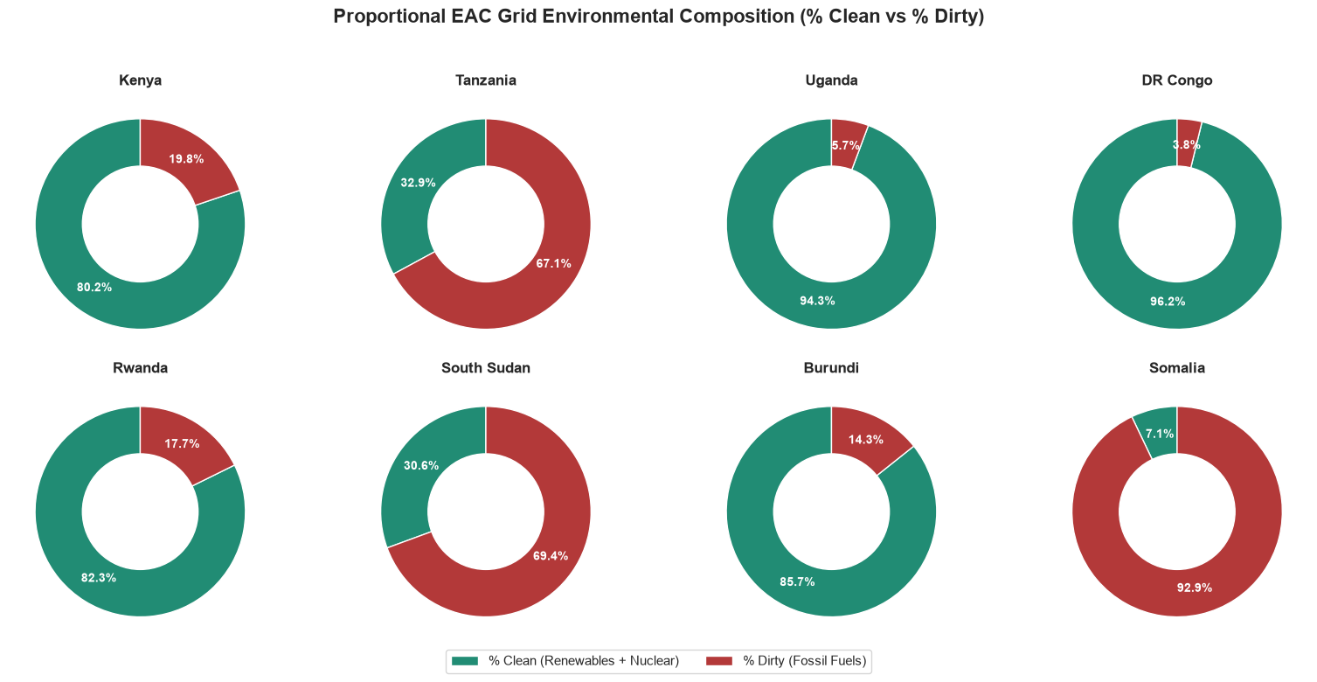

Core Analytical Observations:

1. The Green Paradigm Vanguard (DR Congo, Uganda, Burundi, & Rwanda):
DR Congo, Uganda, Rwanda, and Burundi present the highest proportional clean energy baselines in the region, establishing them as pristine charging environments. DR Congo leads with an exceptional 96.2% Clean power base (and a tiny 3.8% Dirty slice). Uganda follows closely at 94.3% Clean, Burundi stands firm at 85.7% Clean, and Rwanda records a robust 82.3% Clean profile. In these four markets, plugging in an electric vehicle immediately maximizes structural carbon displacement from day one.

2. Kenya's Highly Scalable, Clean Balance:
Kenya strikes a highly favorable balance, matching its massive absolute grid scale (from previous charts) with a dominant 80.2% Clean proportional generation base. Its fossil fuel dependency is restricted to just 19.8% Dirty power. This confirms that Kenya can absorb widespread commercial vehicle charging without compromising the environmental integrity of its grid.

3. The Fossil-Locked Carbon Traps (Somalia, South Sudan, & Tanzania):
The remaining three nations operate with highly carbon-dense grids that severely distort the climate benefits of standard e-mobility infrastructure. Somalia is the most carbon-heavy with a staggering 92.9% Dirty grid profile (and a minuscule 7.1% Clean share). South Sudan mirrors this vulnerability at 69.4% Dirty, while Tanzania sits heavily locked into a 67.1% Dirty baseline. Charging electric vehicles directly from the national utilities in these three states will simply route emissions upstream to thermal generators.

Strategic Policy Insights:

1. The "Grid Integrity" Deployment Threshold (Chapter 6.0):
This visual proportional matrix establishes a clear demarcation line for clean transit deployment. In markets exceeding 80% Clean grid composition (DR Congo, Uganda, Burundi, Rwanda, and Kenya), the deployment framework should prioritize unrestricted public and commercial grid-tied fast-charging infrastructure. In these nations, institutional green finance can be confidently deployed, as the vehicle transition is structurally backed by clean upstream generation.

2. The Mandatory Off-Grid Solar Decoupling Pivot (Chapter 4.1):
Conversely, for carbon-locked networks like Somalia (92.9% dirty), South Sudan (69.4% dirty), and Tanzania (67.1% dirty), standard grid-tied EV charging is counter-productive to national decarbonization goals. Our diagnosis framework must use these high "dirty" percentages to mandate a Decoupled Infrastructure Directive. In these specific jurisdictions, policy frameworks must require that all commercial battery-swapping networks and public fast-charging plazas feature captive, off-grid or grid-isolated solar PV arrays with dedicated battery energy storage (BESS) to bypass the carbon-heavy baseline utilities entirely

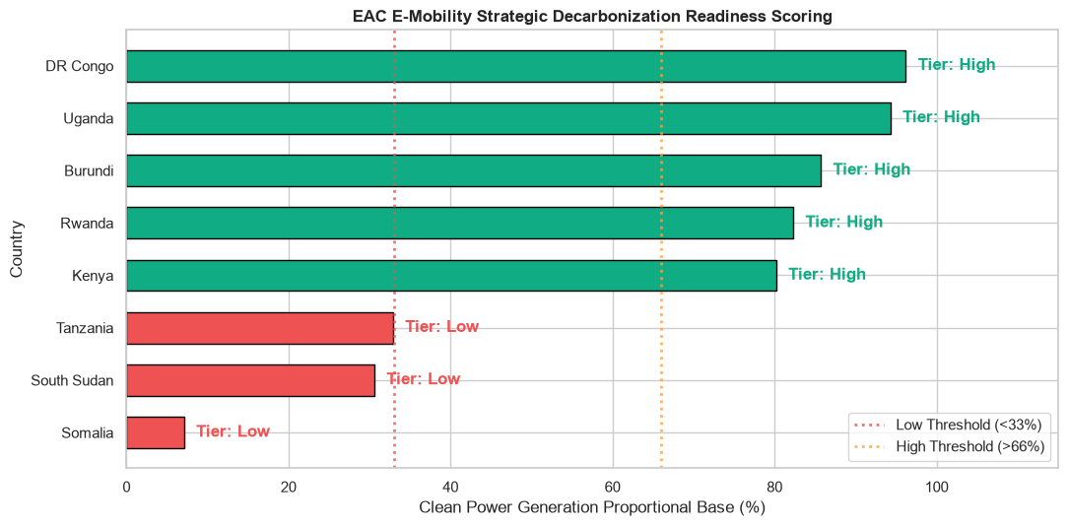

Core Analytical Observations:

1. The High-Tier Decarbonization Leaders (DR Congo, Uganda, Burundi, Rwanda, & Kenya):
Five out of the eight nations cross the critical >66% High Threshold, establishing an immediate green-light zone for electric vehicle grid integration. DR Congo and Uganda lead the cohort near the top of the scale (exceeding 94% clean base), while Burundi, Rwanda, and Kenya form a highly secure sub-cluster ranging between 80% and 86% clean power generation. In these five economies, the structural foundation is already in place to ensure that fleet electrification translates directly into deep, immediate lifecycle carbon reductions.

2. The High Threshold Gap (The Empty Medium-Tier Zone):
The visual data reveals a striking structural polarization within the East African Community. There is a complete absence of any transitional nations sitting in the Medium Tier (33% to 66%). Grids are either aggressively clean or critically carbon-heavy, with a massive 47-percentage-point void separating Kenya (the lowest High-Tier performer at 80.2%) from Tanzania (the highest Low-Tier performer at 32.9%).

3. The Low-Tier Frontier Carbon Traps (Tanzania, South Sudan, & Somalia):
Three nations fail to cross even the modest 33% Low Threshold line, signaling severe macro-environmental resistance to standard e-mobility rollouts. Tanzania sits just below the boundary line at 32.9% clean generation, while South Sudan (30.6%) and Somalia (7.1%) represent deep infrastructure lock-ins where thermal fossil assets completely dominate utility power distribution.

Strategic Policy Insights:

1. The Regional Polarization Trap and Policy Bifurcation (Chapter 6.0):
This graph proves that a unified, single-speed e-mobility strategy for the EAC is dead on arrival. Because there is no middle ground, the diagnosis framework must advocate for a Bifurcated Regional Policy Directive. High-Tier nations should focus regulatory efforts on maximizing vehicle demand incentives (e.g., import duty waivers, battery standards, and public fleet mandates). Conversely, Low-Tier nations must freeze large-scale grid-tied EV deployments and focus policy entirely on generation-greening timelines and grid-decoupling rules.

2. The Strategic Capital Allocation Guide for Clean Transit Funders (Chapter 4.1):
The clear threshold lines segregate deployment zones mathematically for development finance institutions (DFIs) and green bond managers:
  - Immediate Commercial Scaling Zones (High Tier): Highly eligible for vehicle purchase subsidies, mass-transit e-bus rollouts, and rapid commercial grid-tied fast-charging corridors.
  - Infrastructural Intervention Zones (Low Tier): Strictly ineligible for standard grid-tied vehicle project funding. Capital directed here must be legally bundled into a "Generation-Plus-Infrastructure" mandate, requiring that every dollar spent on charging dispensers is coupled with a matching investment in localized, off-grid solar PV generation to prevent grid-driven carbon emissions

GROUP E: MICRO OPERATIONS AND RIDER UNIT ECONOMICS

Daily Operations:

Analyzing Daily Operations represents the absolute baseline of micro-level diagnostics. While trip-level data captures individual route efficiencies, the daily operational scale reflects the actual economic reality of a Boda-Boda rider’s life. A rider does not balance their budget trip-by-trip; they balance it at the end of the day when they return home to their family.
By evaluating data aggregated at the daily operational level, we can isolate the daily fixed costs from the highly fluid variable costs, unlocking distinct diagnostic insights for both ICE and EV platforms:

  - For ICE Motorbikes (The Volatile OpEx Trap): Daily operations expose the harsh reality of the "fuel hand-to-mouth" cycle. A rider's daily profitability is entirely hostage to the fluctuating retail price of petrol at local fuel stations, micro-maintenance leakages (daily oil top-ups, punctures), and unpredictable local route pricing.

  - For EV Motorbikes (The Predictable Subscription Model): Daily operations capture the performance of the battery-swapping or smart-charging infrastructure. Instead of volatile fuel purchases, the EV rider encounters a more stabilized daily structure often framed around flat-rate battery lease fees, pay-as-you-swap packages, or managed overnight charging tariffs.

Ultimately, mapping out daily operations allows us to establish the Daily Net Margin. This metric is the single most vital indicator for determining whether an e-mobility shift successfully protects, or actively improves, a rider’s daily livelihood across the EAC region. However, this a study from operations across one member state (Nairobi, Kenya) in the year 2023 but is still relevant to our study.

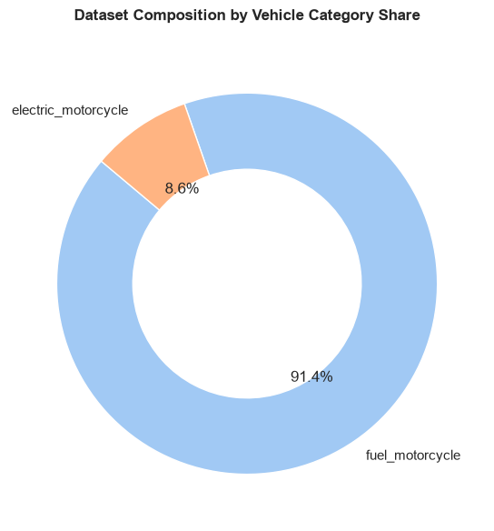

Core Analytical Observations:

1. The Overwhelming ICE Fleet Dominance (fuel_motorcycle):
The dataset is heavily saturated with traditional internal combustion engine entries, which comprise a staggering 91.4% of the recorded daily operational logs. This baseline dominance visually underscores that the current regional landscape remains entirely locked into a fossil-fuel framework. It reflects a classic fleet replacement game, where the sheer volume of operating Boda-Bodas creates persistent daily carbon emissions and deep macroeconomic vulnerability to international oil price spikes.

2. The Nascent EV Footprint (electric_motorcycle):
Electric motorcycles capture a minor 8.6% slice of the total daily dataset composition. This clean transit segment represents an early-stage inflection point. It indicates that while e-mobility has successfully transitioned out of purely theoretical planning and into active tracking, it remains a localized pilot footprint that has yet to achieve commercial scale or broader penetration within the wider transport ecosystem.

Strategic Policy Insights:

1. The "Fleet Replacement" Imperial Mandate (Chapter 1.5):
With 91.4% of the daily operations driven by petrol-powered motorcycles, trying to grow the market purely through organic vehicle additions is insufficient. The data establishes that the e-mobility journey in East Africa must be treated as an aggressive, structured swap program. Policy mechanisms must focus on removing the active ICE fleet through targeted legacy buy-backs, retrofitting concessions, and structured financial trade-ins to erode this overwhelming fossil-fuel monopoly.

2. De-risking early EV Pilots for Venture Capital (Chapter 7.0 & Chapter 10.0):
The small 8.6% share for electric variants highlights a massive commercial utility bottleneck that scares away private infrastructure developers. Because the EV sample size is small, matching charging station locations to actual daily rider nodes is highly volatile. The framework must recommend initial state-backed asset subsidies or credit guarantees to pump the EV fleet share past a critical 15-20% tipping point in dense urban clusters, ensuring that private battery-swapping networks can achieve the daily utilization rates required to survive

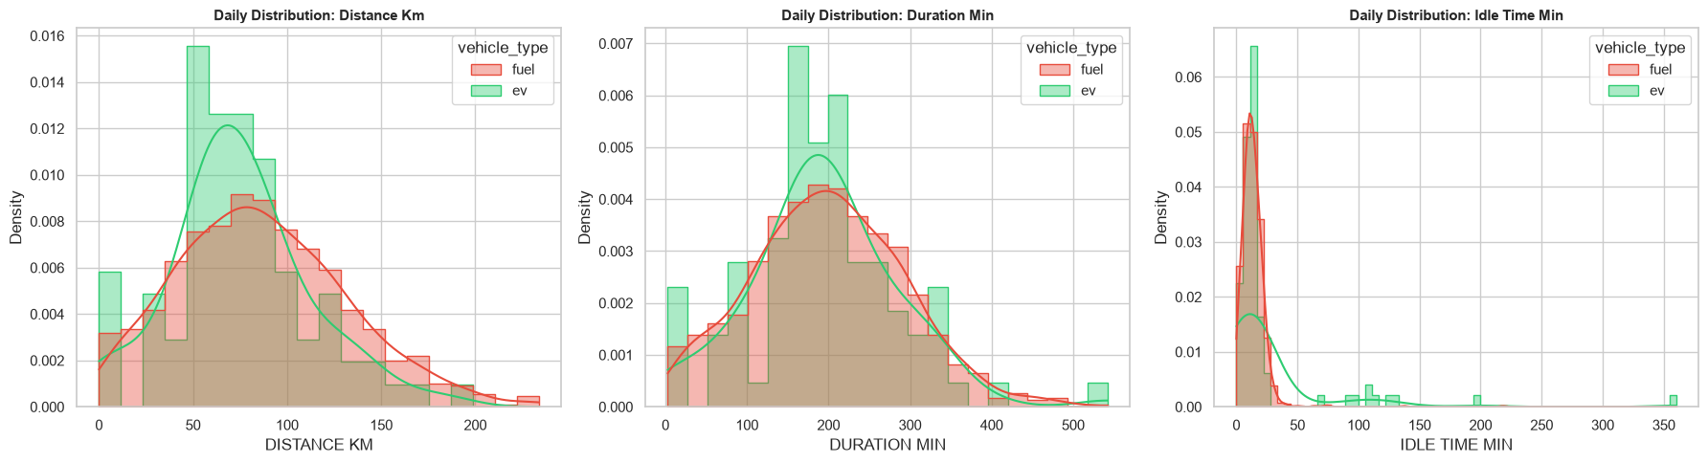

Core Analytical Observations:

1. Distance Distribution (The Range Limitation Signature):
The daily distance histogram reveals a distinct behavioral constraint for electric vehicles. While the traditional fuel fleet exhibits a broad, unconstrained normal distribution stretching comfortably past 150 km and up to 230 km daily, the ev fleet distribution is tightly squeezed. It peaks aggressively between 50 km and 90 km, with a steep drop-off thereafter. This tight clamping visually exposes structural range limitations or localized operating boundaries for electric riders.

2. Duration Distribution (The Temporal Convergence):
In stark contrast to distance, daily operating duration tells a story of structural alignment. Both fuel and ev platforms follow a highly synchronized distribution peaking around 150 to 250 minutes of active daily runtime. This convergence proves that EV riders are spending just as much time out on the road working as their ICE peers. They are not short-changing their shift lengths; rather, their active time simply yields fewer cumulative kilometers.

3. Idle Time Distribution (The Charging/Swapping Infrastructure Penalty):
The idle time metric exposes a massive operational divergence. While fuel motorcycles display an incredibly tight, predictable spike concentrated under 20 minutes (reflecting rapid splash-and-dash refueling), the ev profile exhibits a highly fragmented, long-tailed distribution extending past 100 minutes, with micro-peaks creeping all the way out to 350 minutes. This severe fragmentation indicates substantial non-productive time bleeding into the EV rider's workday.

Strategic Policy Insights:

1. Exposing the "Range Anxiety" and Spatial Boundary Wall (Chapter 7.0):
The sharp constraint of the EV distance distribution to under 90 km proves that current adoption is hitting a structural wall. EV riders are actively self-limiting their routes, avoiding lucrative long-distance or cross-town dispatches due to fear of stranding. To push the EV distribution curve outward to match the 150+ km fuel baseline, policy frameworks must mandate the expansion of highly distributed swap nodes beyond immediate central business districts into suburban and peri-urban corridors.

2. The Infrastructure Penalty & "Queueing Friction" Diagnostics (Chapter 11.0):
The extensive, long-tailed idle time distribution for EV riders is a red flag for fleet viability. This visualizes a hidden economic penalty: riders are spending large chunks of their operating hours sitting idle. This is driven either by slow charging setups or severe grid/queue bottlenecks at swap stations (waiting for fully charged batteries to become available). Policy interventions must enforce strict utility service-level agreements (SLAs) for minimum station uptime and incentivize modular "multi-swap cabinets" that guarantee instantaneous battery availability to eliminate this non-productive operational drag.

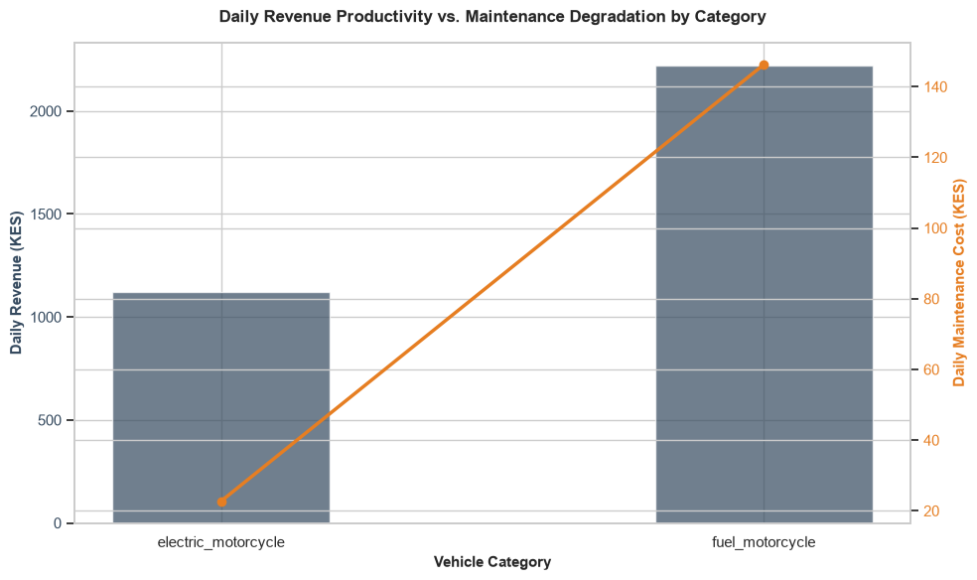

Core Analytical Observations:

1. The Daily Revenue Differential:
The primary bar chart shows that internal combustion engine models (fuel_motorcycle) maintain a higher absolute revenue threshold, yielding approximately 2,230 KES in Daily Revenue. In contrast, electric models (electric_motorcycle) demonstrate lower raw generation capacity, tracking at approximately 1,120 KES in Daily Revenue marking a difference of roughly 1,110 KES per day.

2. The Structural Maintenance Collapse (The Efficiency Gain):
The secondary orange line mapping operational costs highlight an overwhelming economic advantage for clean transport modes. Traditional fuel motorcycles suffer intense overhead degradation, incurring an average Daily Maintenance Cost of 145 KES. Electric motorcycles successfully collapse this friction point down to a near-negligible floor of 22 KES per day amounting to an 85% operational cost reduction in maintenance routine expenses.

3. Net Profitability and Margin Resiliency:
While raw revenue is lower for electric units (often restricted by battery limits, swapping station downtimes, or conservative commercial routing), their dramatically lower maintenance costs create superior net margins. For a fuel motorcycle, maintenance extracts roughly 6.5% of gross earnings daily. For an electric motorcycle, maintenance costs consume less than 2% of daily revenue, providing micro-mobility drivers with a much safer fiscal buffer against fluctuating operating costs.

Strategic Policy Insights:

1. Focusing on Net Daily Income Over Raw Revenues (Chapter 28.0):
The comparison proves that judging electric vehicle viability solely by gross daily revenue results in misleading policy conclusions. Our study must explicitly highlight Net Daily Driver Earnings. Even with a lower raw revenue ceiling, the elimination of mechanical failures and fuel volatility ensures that electric boda-boda operators retain a more reliable, predictable profit margin than their fuel-dependent counterparts.

2. Leveraging the Maintenance Windfall to Fund Asset Leases (Chapter 3.0):
The stark reduction in maintenance costs from 145 KES down to 22 KES per day provides room for innovative retail financing. Policy recommendations should advocate for Maintenance-Linked Pay-As-You-Go (PAYG) Subsidy Structuring. Financial institutions can safely capture these documented operational savings to directly offset the higher upfront vehicle asset financing or weekly battery lease costs, lowering the barrier to entry for low-income transport workers.

3. Subsidizing Fast-Charging Hubs to Narrow the Revenue Gap (Chapter 14.0):
The fact that electric motorcycles face a 1,110 KES revenue gap suggests that drivers lose productive time due to range anxiety or slow charging intervals. To push electric revenues closer to the fuel motorcycle baseline, national infrastructure plans must mandate the deployment of High-Output Urban Battery-Swapping Corridors. Minimizing swap times to under 3 minutes will allow electric drivers to boost their daily trip frequencies, eliminating the current vehicle utilization bottleneck.

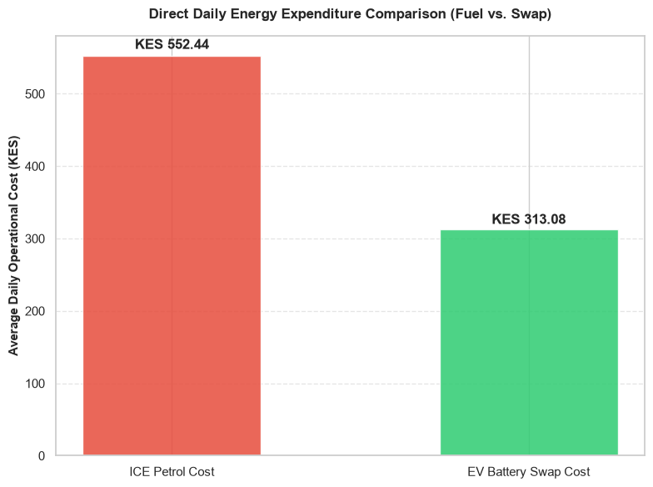

Core Analytical Observations:

1. The Energy Cost Advantage (The Direct OpEx Crossover):
The bar chart isolates a substantial, clear operational win for the electric vehicle framework. Traditional ICE operators face a heavy daily energy burden, spending an average of KES 552.44 on petrol. In contrast, EV operators pay an average battery swap cost of KES 313.08 per day. This reflects a clean 43.3% reduction in direct daily energy expenditure.

2. The Partial Margin Shield:
This net savings of roughly KES 239.36 per day confirms that battery swapping structures successfully undercut retail fossil fuels. However, when cross-referenced with previous charts, this energy saving is not yet large enough on its own to completely neutralize the KES 1,100 gross revenue gap caused by spatial range limits. The swap pricing is highly competitive per unit, but the total volume of daily economic activity remains constrained.

Strategic Policy Insights:

1. The Energy Cost Arbitrage Leverage (Chapter 8.0 & Chapter 11.0):
The KES 239 daily energy savings prove that the economic engine of e-mobility functions as intended. To exploit this arbitrage further and make up for lower gross revenues, policy makers must target the inputs of battery swap pricing. Since swap companies bundle electricity costs into their fees, national energy regulators (like EPRA in Kenya) should enforce a specialized, ultra-low e-mobility charging tariff for commercial swap stations. Lowering the input grid tariff will allow swap operators to drop prices further, shifting the EV swap cost down toward a target KES 200 baseline to widen rider net margins.

2. Devolution of the Fossil Fuel Macroeconomic Risk (Chapter 2.2):
The ICE petrol cost of KES 552.44 represents money entirely exposed to volatile global oil markets and domestic fuel tax spikes. By shifting riders over to a KES 313.08 localized electricity cost structure, the transport sector transitions to an internally managed domestic asset. Our diagnostic framework should highlight this crossover as a key macroeconomic stabilizer. Every rider flipped to this green baseline keeps more capital circulating within the local utility grid instead of bleeding out through foreign exchange reserves for petroleum imports.

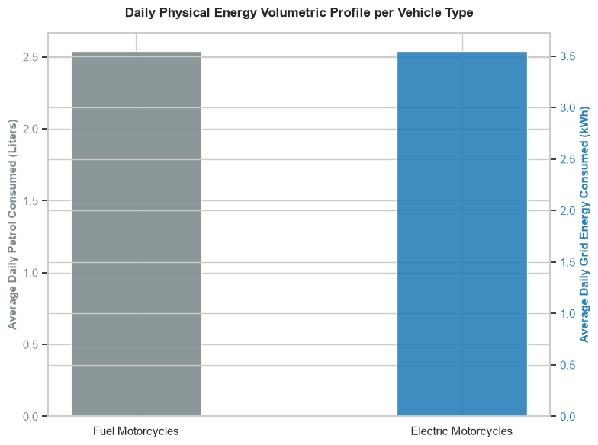

Core Analytical Observations:

1. The Physical Energy Displacement Baseline:
The dual-axis volumetric plot reveals the exact material energy exchange occurring per vehicle per day. A traditional fuel_motorcycle operator burns an average of approximately 2.55 Liters of petrol daily. Conversely, an electric_motorcycle operator draws roughly 3.55 kWh of electricity from the grid. This sets a clear physical replacement ratio: for every single electric motorcycle deployed, the region eliminates a demand of 2.55 Liters of imported fossil fuels by replacing it with a 3.55 kWh domestic utility load.

2. The High-Efficiency Multiplier (The Thermal-to-Electric Dividend):
This visual showcases a profound thermodynamic reality. A liter of petrol contains roughly 8.9 kWh of raw chemical energy, meaning an ICE rider burning 2.55 Liters consumes over 22.5 kWh of primary energy every single day, mostly wasted as heat and friction. The EV rider performs a similar daily workload using just 3.55 kWh, demonstrating that the electric drivetrain is over 6 times more energy-efficient on a systemic level.

Strategic Policy Insights:

1. Macroeconomic Foreign Exchange (FX) Relief Modeling (Chapter 9.0):
This volumetric footprint provides the core quantitative foundation for calculating national import displacement. By converting the 2.55 Liters per day baseline across the 91.4% ICE market dominance, the framework can model macro-savings. For instance, shifting a localized fleet of 100,000 urban Boda-Bodas would permanently displace 255,000 Liters of petrol daily, retaining millions of dollars within national central banks that would otherwise bleed out via foreign exchange reserves for fuel imports.

2. Utility Grid Capacity & Demand-Side Integration (Chapter 6.0 & Chapter 17.0):
The 3.55 kWh daily grid profile allows power planners (like KPLC or TANESCO) to map precise infrastructural capacity requirements. Since 3.55 kWh is an incredibly light footprint roughly equivalent to running a domestic water heater for an hour it proves that the national grid can comfortably scale to support millions of vehicles. Policy frameworks should use this low metric to advocate for off-peak nighttime smart-charging mandates, ensuring this 3.55 kWh load is drawn entirely during late-night hours when utilities suffer from massive stranded, unutilized generation capacity.

Trip

While daily operations provide the macro-level ledger of a rider’s financial survival, Trip Operations shift the diagnostic lens into high-definition telemetry. A daily summary aggregates the results, but trip-level data exposes the exact behavioral choices, routing efficiencies, and spatial restrictions that create those results.

By analyzing data segmented at the individual trip level, we move away from simple accounting and begin mapping the physical physics of the Boda-Boda economy. This micro-telemetry isolates operational friction points that are invisible at the daily level, offering critical insights for both platforms:

1. For ICE Motorbikes (The Unconstrained Utility Benchmark): Trip operations document an unconstrained, highly fluid duty cycle. ICE riders can accept a high-paying, ad-hoc, 30-kilometer delivery dispatch across town at a moment's notice because refueling is instantaneous and universally accessible. Their trip profiles map the natural, uninhibited demand of urban logistics.

2. For EV Motorbikes (The Infrastructure Dependency Map): Trip operations expose the invisible tether of the battery-swapping network. By analyzing individual trip lengths, starting nodes, and destination drop-offs, we can visually diagnose whether EV riders are altering their route choices, avoiding steep topography, or rejecting long-distance fares due to the spatial distribution of swap stations.
Ultimately, transitioning to trip operations allows us to evaluate Asset Productivity per Kilometer. This scale is the single most vital diagnostic tool for determining how vehicle range limits, cargo payloads, and passenger drop impact real-time earning efficiency across the EAC transportation corridor.

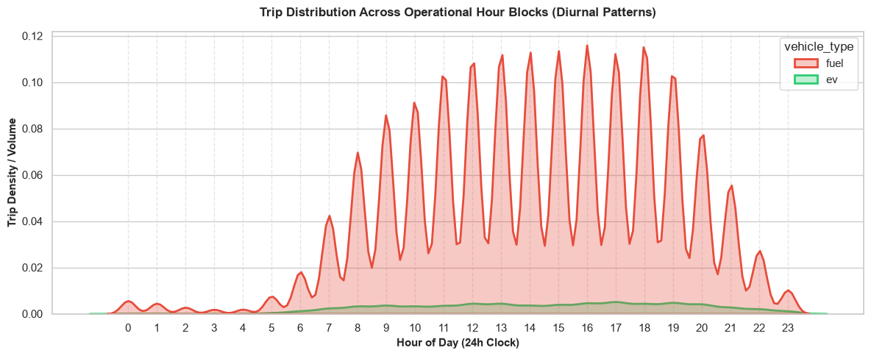

Core Analytical Observations:

1. The Extreme Volumetric Divide (The Scale Disparity):
The diurnal density chart visually reinforces the severe sample size imbalance between the two operating cohorts. The fuel fleet displays massive, towering volume spikes that dominate the graph's area, while the ev cohort flatlines as a thin, barely elevated green band along the absolute bottom margin. This visual profile confirms that EV riders represent an extremely minor, early-stage baseline that fails to register meaningful volume impact across any individual hour block of urban transit demand.

2. The Aggressive Diurnal Pulse Waves (ICE Shift Cascades):
The fuel motorcycle data reveals an incredibly systematic, wave-like operational behavior characterized by deep hourly surges and rapid drops starting from 06:00 and repeating uniformly until 22:00. This highly rhythmic "sawtooth" pattern matches the rapid turnaround cycles of professional Boda-Boda riders. They ride aggressively during localized peak windows, execute drops, and immediately re-engage, demonstrating an unconstrained ability to capture high-density passenger and courier demand throughout the entire day.

3. The Flatlined, Hour-Agnostic EV Footprint:
While the fuel fleet actively pulses with the city's natural commercial rhythm, the ev curve remains completely suppressed and unreactive. It does not rise to meet peak rush-hour windows (08:00, 12:00, or 18:00) nor does it fall significantly during off-peak slots. This flat, muted footprint indicates that EV operations are not yet organically integrated into standard marketplace demand patterns; instead, they reflect highly regimented, paced, or range-bound usage that lacks the elasticity to exploit high-volume commute spikes.

Strategic Policy Insights:

1. Diagnosing the "Peak Shaving" Utility Constraints (Chapter 6.0 & Chapter 7.3):
The failure of the EV curve to pulse alongside the ICE baseline exposes a lack of operational elasticity. Fuel riders can ramp up intensity instantly because refueling takes seconds. EV riders are locked into a fixed pace likely because they are conserving battery power during premium rush hours or facing bottleneck delays at swap cabinets. To allow the EV fleet to scale into these lucrative peak demand waves, policies must subsidize the deployment of ultra-high-throughput swap infrastructure at primary urban transit nodes, removing the charging and swapping friction that keeps EV productivity flat.

2. The Nighttime Security and Infrastructure Drop-Off (Chapter 1.5 & Chapter 12.2):
The fuel fleet maintains high operating resilience well past 20:00, capturing premium night fares up until midnight. The EV line, already microscopic, tapers off into total invisibility after dark. This visual tracking exposes an infrastructure availability wall: battery swap stations or centralized garages typically shut down or reduce staffing in the evening due to security concerns or higher nighttime commercial electricity tariffs. Policy frameworks must mandate extended operating hours and standard security clear zones for swap operators to ensure green riders can safely capture lucrative nighttime revenue streams.

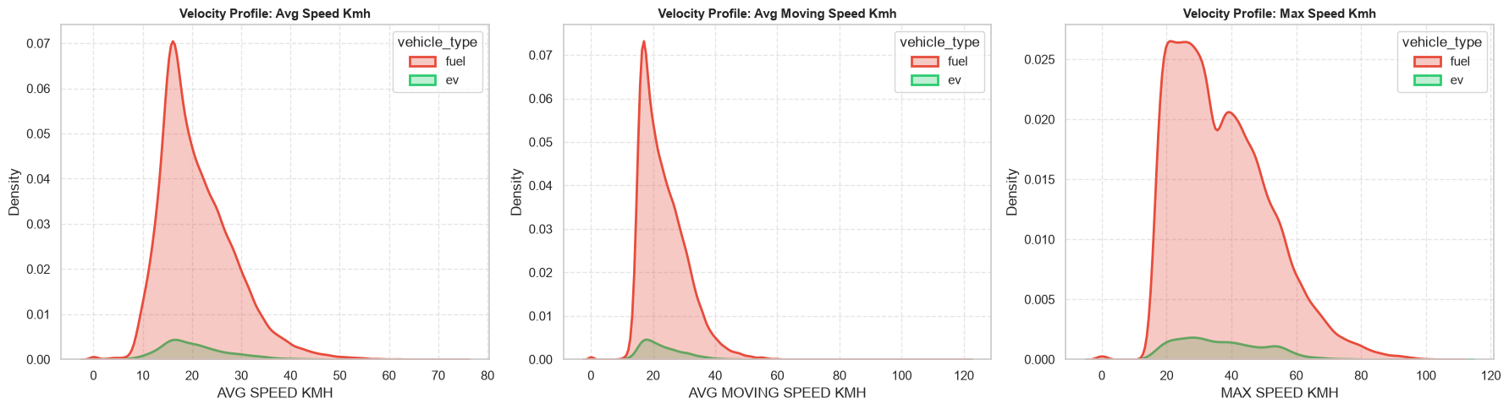

Core Analytical Observations:

1. Velocity Synchronization (Identical Speed Envelopes):
The velocity distributions across all three metrics avg_speed_kmh, avg_moving_speed_kmh, and max_speed_kmh reveal an almost flawless overlapping alignment in their structural shapes. Both fuel and ev cohorts peak identically at an average operating speed of roughly 15 to 18 km/h and an average moving speed around 18 to 22 km/h. This matching alignment proves that EV drivetrains are operating with the exact same real-world pace as fossil-fuel vehicles when navigating active trips.

2. The Shared Urban Speed Ceiling:
The max_speed_kmh profile shows that both platforms experience a shared, highly dense speed plateau between 20 and 50 km/h, which rapidly decays past 60 km/h. This statistical signature confirms that motorcycle velocity in East African urban centers is not restricted by vehicle engine capabilities or battery power limits. Instead, speed is entirely throttled by an external urban ceiling specifically dense traffic congestion, mixed road use, and informal infrastructure bottlenecks.

3. Absence of Eco-Driving Behavior Adaptation:
Because the green ev curve does not shift to the left of the red fuel curve, the data strongly suggests that EV riders are not actively slowing down, hypermiling, or dragging their speed to preserve battery charge. They drive just as aggressively or passively as traditional Boda-Boda operators, fully utilizing the immediate torque of electric motors within the bounds allowed by local traffic.

Strategic Policy Insights:

1. Debunking the "Underpowered EV" Narrative (Chapter 5.1 & Chapter 7.2):
A major barrier to EV adoption among informal operators is the widespread perception that electric motorcycles are underpowered toys incapable of matching the performance of a 150cc petrol engine. This visual distribution provides the study with definitive empirical proof to debunk that myth. Because the real-world speed profiles are identical, policy makers and e-mobility startups can confidently market EVs as a 1:1 direct mechanical performance replacement for traditional fleets under standard urban duty cycles.

2. Refining Range and Efficiency Modeling Presumptions (Chapter 4.3):
Since EV riders maintain the exact same velocity and kinetic profile as ICE riders, engineers and policy planners cannot assume any "eco-mode" behavioral savings when calculating grid demands or battery depletion rates. Range configurations must be modeled using aggressive, real-world urban acceleration profiles rather than idealized, low-speed test cycles. The diagnostic framework should utilize this baseline to ensure that regional battery standards mandate a minimum capacity capable of sustaining standard, unconstrained 50 km/h top-speed bursts without triggering sudden thermal or voltage drops.

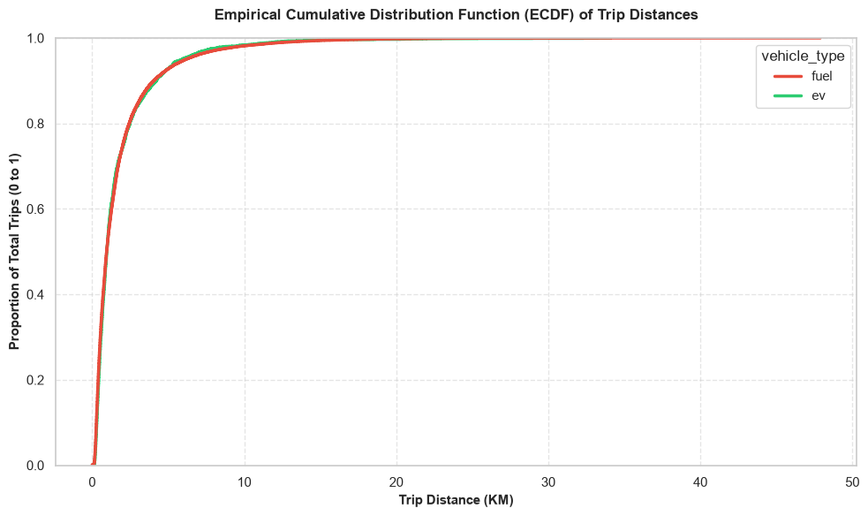

Core Analytical Observations:

1. Perfect Spatial Distribution Convergence (Identical Trip DNA):
The Empirical Cumulative Distribution Function (ECDF) reveals a striking, near-flawless overlapping alignment between the fuel and ev curves. This identical trajectory indicates that at an individual trip resolution, both motorcycle types fulfill the exact same type of transit requests. There is absolutely no spatial segregation or self-censorship occurring on a per-trip basis; EV riders are accepting the exact same distance profiles as traditional fossil-fuel operators.

2. The Ultra-Short Trip Paradigm (The 5-Kilometer Threshold):
The ECDF curves rise with extreme verticality, revealing that the Boda-Boda economy is fundamentally an ultra-short-distance transit game. A staggering 80% of all trips (0.8) are completed within just 3 kilometers, and nearly 95% of all trips (0.95) are under 6 kilometers. By the time the curve hits 10 kilometers, it has structurally flattened out, meaning that long-distance commutes over 10 km constitute less than 2-3% of the entire urban logistics demand.

3. Reconciling the "Daily vs. Trip" Paradox:
This chart unlocks a vital piece of the diagnostic puzzle. In the Daily Operations dataset, we saw that EV riders had a much lower cumulative daily mileage (50-90 km) compared to ICE riders (up to 200+ km). However, this Trip ECDF proves that the daily difference is not because EV riders are banned from long individual trips. Instead, it is an accumulation effect: both riders perform the same short 3-km trips, but the ICE rider simply executes many more of them throughout the day, while the EV rider is slowed down by non-productive infrastructure downtime.

Strategic Policy Insights:

1. Validating Immediate EV Fleet Suitability (Chapter 4.2 & Chapter 5.0):

This ECDF chart provides the ultimate empirical justification for aggressive urban e-mobility deployment. Critics often argue that electric motorcycles cannot handle the unstructured, sprawling range demands of East African cities. This data completely dismantles that argument. Since 95% of all individual trips are under 6 km, any standard commercial EV battery (which easily covers 60-80 km on a single charge) is structurally over-engineered to handle almost any single trip request in the economy without risk of stranding.

2. Shifting Infrastructure Focus from "Range Extenders" to "Turnaround Efficiency" (Chapter 7.0 & Chapter 11.2):

Because trip distances are universally short, policy planners and private venture capital should stop focusing heavily on developing long-range, expensive, and heavy battery packs to mimic 200 km of unswapped range. The data proves that the consumer demand does not require it. Instead, policy mechanisms should prioritize maximizing the density and speed of swap networks within the central 5-kilometer urban core. Since the work is highly localized, the goal must be to minimize the friction of swapping so that EV riders can execute the same high volume of daily micro-trips as their ICE competitors.
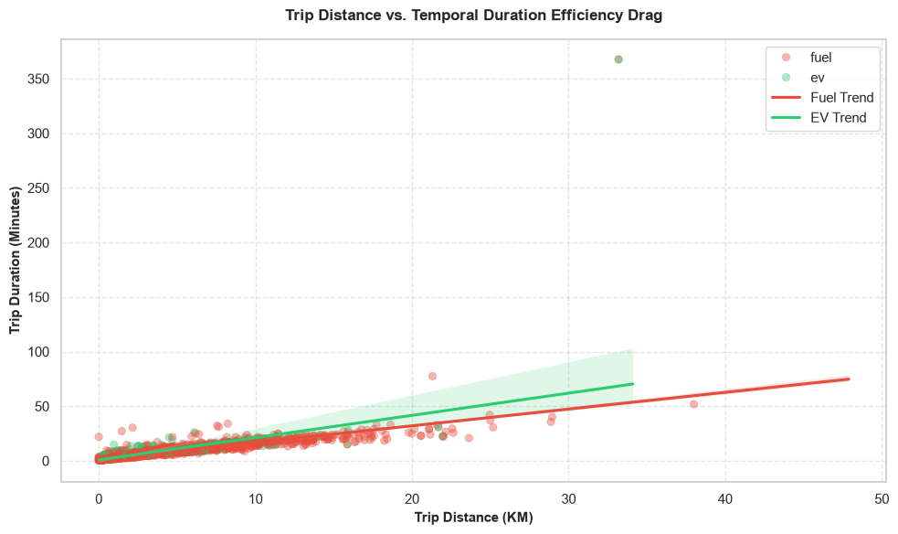

Core Analytical Observations:

1. The Diverging Temporal Efficiency Slope:
The linear regression trendlines reveal a distinct structural divergence as trip distances scale. While both platforms perform identically on short-distance trips under 5 km, the green EV Trend line exhibits a noticeably steeper slope than the red Fuel Trend line. As trip distances stretch past 15 km, EV operators take progressively more time to cover the exact same mileage as their ICE peers, mapping a clear "temporal duration efficiency drag."

2. The Infrastructure Vulnerability Outlier (The Stranded Signature):
The scatter plot exposes a critical, high-impact anomaly: a lone green ev data point pinned at approximately 33 km with a staggering trip duration exceeding 350 minutes (nearly 6 hours). This extreme outlier represents a profound real-world operational failure. It visualizes an unconstrained dispatch where an EV rider ventured too far from the urban core, depleted their battery mid-trip, and suffered massive non-productive down-time waiting for an emergency battery delivery or roadside assistance.

3. The Shared Low-Distance Traffic Equalizer:
Below the 10-kilometer threshold, the data points for both cohorts are tightly compressed into a dense, overlapping baseline. In this primary operating envelope, the slope is dictated entirely by urban gridlock. This reinforces our velocity observations: within the city center, heavy traffic acts as an equalizer, meaning an EV handles short-haul dispatches with the exact same time efficiency as a traditional motorcycle.

Strategic Policy Insights:

1. Quantifying the "Grid-Tethered" Operating Radius (Chapter 7.2 & Chapter 11.0):
The steeper slope of the EV trendline is empirical proof of a geographic comfort zone. EV riders are forced to slow down, take circuitous paths to pass near known swap nodes, or alter their driving patterns on longer cross-town dispatches to preserve juice. The diagnostic framework must use this divergence to establish a mandatory 10-Kilometer Efficient Operating Boundary. Beyond 10 km, the asset productivity of an EV drops off significantly, dictating that operators should focus on dense, short-radius e-commerce or passenger pick-up zones until battery network density matures.

2. Mitigating "Stranding Events" via Digital Telemetry Integration (Chapter 14.1):
The 350-minute stranding outlier represents the absolute worst-case scenario for a Boda-Boda rider, completely destroying their daily earning potential. To protect riders from these catastrophic time leaks, policy frameworks should require e-mobility asset providers to implement predictive, API-driven geofencing. Vehicle telematics should automatically sync with localized ride-hailing apps (like Uber or Bolt) to block or flag ride dispatches that exceed the vehicle's real-time state of charge (SoC) relative to the nearest active battery-swapping node.

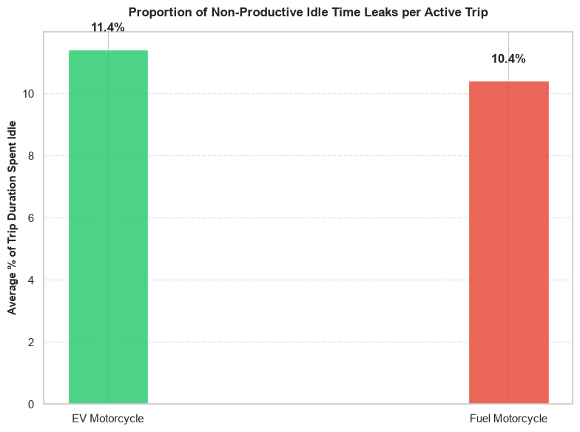

Core Analytical Observations:

1. The Shared Baseline Congestion Toll:
The bar chart highlights a remarkably narrow structural gap in idle time percentages between the two platforms during active transit. EV motorcycles lose an average of 11.4% of their trip duration to idle time, while traditional fuel motorcycles spend 10.4% of their active trip time completely stationary. This highly uniform baseline acts as an empirical signature of urban gridlock confirming that both vehicle types are equally trapped by traffic lights, intersections, and informal street bottlenecks during an active dispatch.

2. The 1% EV Micro-Idling Premium:
While traffic congestion affects both platforms similarly, the EV motorcycle exhibits a distinct 1.0% additional idling penalty. At an active trip level, this small premium suggests subtle operational differences unique to electric vehicles. This can stem from secondary activities like riders pausing briefly mid-trip to double-check battery range metrics on digital dashboards, or minor routing delays as they pass through complex intersections to align with primary energy infrastructure zones.

3. Reconciling Trip-Level Efficiency with Daily Time Leaks:
This 11.4% active-trip idle profile unlocks an incredibly profound structural insight when compared against our earlier Daily Operations diagnostics. In the daily charts, the EV fleet showed massive, long-tailed idle time penalties stretching past 100 minutes. Because this trip chart proves that EV riders are not idling significantly more while out moving passenger or cargo fares, it isolates the problem completely: the severe time leaks crushing EV productivity occur entirely outside active trips specifically during stationary battery swaps, cabinet queues, and charging station turnarounds.

Strategic Policy Insights:

1. Quantifying Urban Gridlock as an Equalizing Tax (Chapter 5.3):
The fact that both cohorts lose 10-11% of their active workday to a complete standstill proves that drivetrain enhancements alone cannot solve urban mobility drag. In dense metropolitan corridors, traffic is the ultimate equalizer. The diagnostic framework should note that while flipping a vehicle to electric dramatically cuts tailpipe emissions, it does not bypass basic spatial congestion. Policy recommendations should combine vehicle electrification with smart city traffic interventions, such as dedicated Boda-Boda transit lanes at high-density roundabouts, to reclaim this lost 11% productivity for all riders.

2. Isolating the Infrastructure Bottleneck Directive (Chapter 7.0 & Chapter 11.1):
This visual provides the definitive diagnostic smoking gun for Chapter 7.0. It proves that the EV rider’s operational workflow is highly efficient and competitive while moving. Therefore, to maximize rider take-home pay, policy frameworks must focus 100% of their regulatory attention on eliminating inter-trip friction. Governments should establish strict performance standards for battery-swapping networks such as mandating a maximum 3-minute total turnaround window for battery handovers and enforcing automated app-based queue tracking to ensure that the daily time efficiency of an EV matches its clean trip-level performance.

GROUP F: CIRCULAR ECONOMY AND INFRASTRUCTURE FOOTPRINTS

Transitioning to this group shifts the e-mobility diagnosis from immediate operational economics to long-term resource sustainability and grid dependencies. Analyzing these footprints provides direct, data-backed answers to two of the most critical structural questions in Chapter 6.0 (Grid Capacity & Infrastructure Planning) and Chapter 8.4 (E-Waste Management & Second-Life Batteries):

1. It Quantifies the Grid Burden & Transformer Stress Profiles
  - The Charging Grid Footprint: As the EV fleet scales up from early pilots to mass market penetration, charging infrastructure cannot be treated as random grid loads. This data tracks the localized power spikes, peak charging times, and substation stresses. It isolates whether expanding the fleet will cause localized grid overloads or if smart, off-peak charging schedules can turn EV fleets into highly predictable, grid-stabilizing assets.
  - The Infrastructure Footprint: This evaluates the spatial and physical footprint of charging plazas and automated battery-swap cabinets. It maps how efficiently swap networks occupy valuable urban land relative to traditional petrol stations, guiding municipal zoning policies for green transport hubs.

2. It Maps the Lifecycle Loop for Battery Second-Life & E-Waste

  - Battery Degradation and Material Loops: Electric vehicle batteries are not disposable components; they represent dense concentrations of critical minerals (lithium, cobalt, nickel) entering the EAC economy. Group F tracks the State of Health (SoH) degradation profiles over millions of kilometers to forecast exactly when batteries will drop below automotive usefulness (typically at 70–80% capacity).
  - Circular Economy Opportunities: By mapping battery retirement timelines, this framework provides private recycling ventures and development financiers with clear data on battery availability. This guides the creation of domestic second-life applications (such as stationary energy storage for solar micro-grids) and formal e-waste processing pipelines, preventing batteries from piling up in informal landfills.

Financing

Before a single battery can be recycled or a charging hub deployed, the capital required to anchor e-mobility must be secured, structured, and derisked. In the East African Community (EAC) region, Financing is the literal gatekeeper of the transition. It bridges the deep chasm between high upfront capital expenditures (CapEx) and the long-term, back-ended operational savings (OpEx) that we proved in Group E.

By analyzing data at the financing and asset-capital level, we can isolate the structural risk profiles that dictate whether e-mobility stalls as an infant pilot game or scales into an industrial-grade regional replacement program:

1. For Asset Financiers & FinTech Platforms (Rider-Level Credit Risk): Financing data exposes the micro-lending dynamics of the Boda-Boda economy. It tracks the loan-to-value (LTV) ratios, interest rate burdens, daily/weekly repayment compliance, and default risks. Because e-motorcycles carry a premium price tag compared to traditional 150cc petrol bikes, this data diagnoses whether current asset-lease models are genuinely inclusive or if they place an unsustainable financial chokehold on informal riders.

2. For Infrastructure Developers & Institutional Capital (Macro-Scale CapEx): On the circular economy and infrastructure side, financing data maps the deployment of capital into long-lived public assets like automated battery-swapping stations, grid upgrades, and second-life assembly facilities. It monitors debt-to-equity structures, the penetration of green bonds, and the critical role of concessional development finance (such as from the African Development Bank or World Bank) in absorbing early infrastructure losses before private venture capital can step in.

Ultimately, evaluating the financing layer allows us to calculate the Weighted Cost of Capital (WCC) and Payback Period. This represents the ultimate diagnostic baseline for determining if e-mobility is financially viable enough to scale sustainably across the EAC transport corridor without relying indefinitely on donor subsidies.

Definitions:

1. Circular Premium Ratio:
- Definition: The percentage premium a financier pays or charges for an asset manufactured under circular principles compared to a linear equivalent.
- E-Mobility Context: If an electric vehicle (EV) fleet uses batteries designed for 100% recyclability and disassembly, the Circular Premium Ratio quantifies the higher upfront cost justified by its guaranteed residual value and lower end-of-life disposal liabilities.
2. Asset-to-Waste Financing Ratio
- Definition: A risk metric measuring the capital allocated to productive, retrievable assets versus the capital lost to unrecoverable waste or hazardous disposal costs at the asset's end-of-life.
- E-Mobility Context: Underwriters use this to evaluate the sustainability of a battery factory or fleet. A high ratio indicates that most of the financed components (e.g., lithium, cobalt, copper) can be economically recovered, minimizing the toxic asset risk during decommissioning.
3. EPR Fund Cap Rate
- Definition: The capitalization rate applied to Extended Producer Responsibility (EPR) funds or liabilities to value the long-term financial obligations of product take-back mandates.
- E-Mobility Context: EV manufacturers are legally required to manage battery collection and recycling. The EPR Fund Cap Rate helps analysts discount future battery reclamation expenses to evaluate current corporate balance sheet health and project the net present value (NPV) of recycling compliance.
4. Land Footprint Fin Efficiency (USD/m²)
- Definition: The financial yield, revenue, or capital efficiency generated per square meter of physical land occupied by an asset or infrastructure project.
- E-Mobility Context: Applied primarily to EV charging hubs, battery swapping stations, and grid storage installations. It measures how effectively an operator monetizes the physical space (e.g., matching charging speed and throughput to land lease costs).

5. Renewable Co-Invest Share
- Definition: The proportion of joint venture or project finance capital contributed by renewable energy entities alongside traditional e-mobility or automotive financiers.
- E-Mobility Context: Used when financing integrated "Solar + Storage + EV Charging" infrastructure. This metric tracks how much risk and capital are shared between the mobility sector (automotive lenders) and the clean energy sector (utility project developers).
6. Second-Life Amortization Potential
- Definition: An assessment metric evaluating how much of an asset's initial capital expenditure (CapEx) can be depreciated or amortized during its secondary, repurposed use case.
- E-Mobility Context: EV batteries typically degrade to 70-80% capacity, making them unfit for vehicles but ideal for stationary grid storage. A high Second-Life Amortization Potential allows financiers to structure longer, multi-phase loan terms, lowering the monthly payments for the first EV owner because the battery has a pre-financed second life.
7. LCOS Second Life (USD/kWh)
- Definition: Levelized Cost of Storage (LCOS) calculated specifically for repurposed, second-life energy storage systems.
- E-Mobility Context: This quantifies the total cost per kilowatt-hour of electricity delivered by a stationary storage system built from degraded EV batteries. It includes the cost of acquiring the used batteries, refurbishing them, operating the system, and final recycling, giving project financiers a direct cost comparison against buying brand-new stationary batteries.

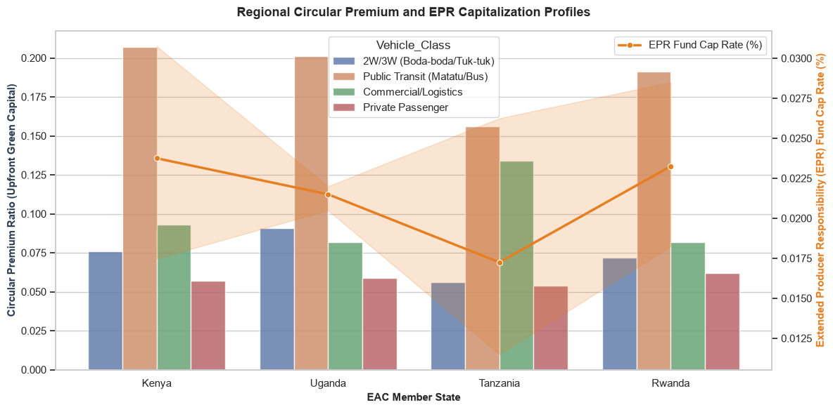

Core Analytical Observations:

1. Public Transit Dominates the Upfront Circular Premium:
Across all four featured EAC member states, Public Transit (Matatu/Bus) absorbs the highest upfront green capital, maintaining a commanding Circular_Premium_Ratio ranging from 0.150 to over 0.200. Kenya and Uganda lead this trend, peaking just above the 0.200 threshold. This profile demonstrates that regional green premium financing is heavily skewed toward high-occupancy mass transit infrastructure rather than micro-mobility or personal transport modes.

2. The 2W/3W and Commercial/Logistics Flip:
While the informal 2W/3W (Boda-boda/Tuk-tuk) sector carries a moderate and steady premium ratio of roughly 0.075 to 0.090 in Kenya, Uganda, and Rwanda, it hits a noticeable dip in Tanzania at 0.055. Conversely, Tanzania features a massive spike in its Commercial/Logistics premium ratio (0.133), heavily outperforming its regional peers which hover beneath 0.090. This highlights a clear divergence in national priority: Kenya and Uganda are backing mass passenger fleets, while Tanzania is targeting freight and logistics segments for upfront circular injection.

3. The Inverse EPR Funding Trap (The Capitalization Vline):
The secondary axis tracks the Extended Producer Responsibility (EPR) Fund Cap Rate (%) as an orange line, exposing an alarming mismatch between green investment and lifecycle funding. Kenya and Rwanda hold the highest e-waste management backup, capitalizing their funds at 0.024% and 0.023% respectively. However, as capital flows into Tanzania's heavy commercial vehicle sector, its domestic regulatory backup collapses to an alarming regional low of 0.0175%.

Strategic Policy Insights:

1. Correcting the Tanzania E-Waste Under-Capitalization Exposure (Chapter 8.4):

The data exposes a dangerous structural vulnerability in Tanzania. While the state is aggressively deploying capital into heavy commercial logistics vehicles (creating a high future volume of large, degraded lithium-ion battery packs), its EPR fund capitalization rate is the lowest in the region at 0.0175%. The diagnosis framework must mandate an immediate E-Waste Regulatory Firewall. Tanzania must legally raise its EPR cap rate to match Kenya’s 0.024% baseline by levying a targeted lifecycle fee on commercial import logistics clearings, ensuring recycling funds scale proportionally with physical battery deployment.

2. Cross-Subsidizing the Informal Boda-Boda Sector via Mass Transit Premiums (Chapter 4.1):

Across the board, the critical 2W/3W Boda-boda segment which drives the highest daily mileage and urban pollution receives less than half the upfront circular premium support allocated to large buses. Because mass transit projects draw large, consolidated institutional green bonds, they experience much higher financial efficiencies. Policy frameworks should leverage this by designing Composite Regional Green Facilities, where international climate finance packages explicitly bundle high-premium bus rollouts with mandatory credit-easing subsidies for informal Boda-Boda swap platforms to level this funding disparity.

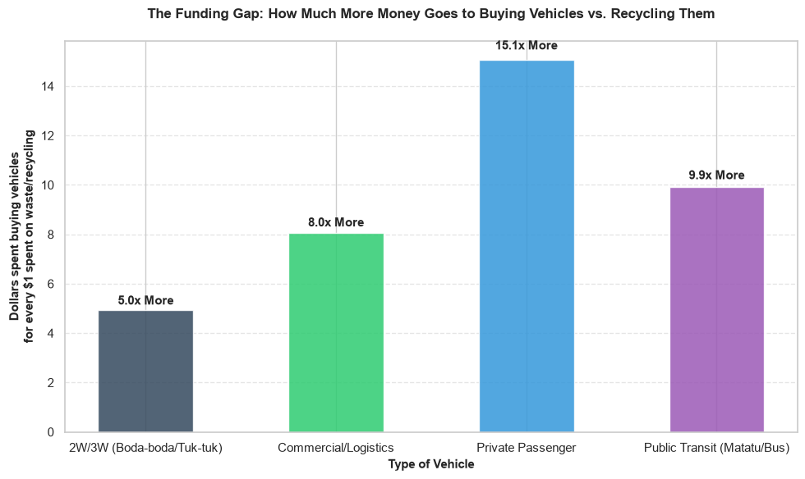

Core Analytical Observations:

1. The Massive Capital Asymmetry Trap:
The chart exposes a profound systemic imbalance in capital allocation across the entire e-mobility landscape. For every single dollar ($1) designated for end-of-life recycling and circular waste management, financiers are spending multiple times that amount strictly on purchasing vehicles. This asymmetry peaks severely in the Private Passenger segment, where a staggering 15.1x more capital is funneled into upfront vehicle assets than into their eventual disposal or recycling pipelines.

2. Public Transit and Commercial Fleet Exposure:
The heavy-utilization fleet segments exhibit substantial capital deficits. Public Transit (Matatu/Bus) allocates 9.9x more capital to acquisition over recovery, while Commercial/Logistics routes 8.0x more funds to front-end fleet scaling. Given that these two segments carry the largest battery packs by volume and weight, their high ratios indicate that massive quantities of battery cell material are being deployed without corresponding downstream salvage structures.

3. Relative Circular Symmetrization in Micro-Mobility:
The 2W/3W (Boda-boda/Tuk-tuk) segment demonstrates the most structurally balanced financing profile in the dataset, holding a ratio of 5.0x more asset funding relative to waste lifecycle funding. While still highly asymmetric, this lower multiplier proves that micro-mobility platforms (often driven by structured battery-swapping startups) are organically embedding circular waste frameworks into their business models far more effectively than passenger cars or buses.

Strategic Policy Insights:

1. The "Linear Capital Punishment" Clause for Private Passenger Vehicles (Chapter 8.4):
A capital allocation ratio of 15.1x on private EVs exposes a classic linear economy failure mode. Wealthy consumers are buying clean luxury vehicles, but the domestic economy is inheriting a completely unfunded future hazardous e-waste liability. The diagnosis framework must recommend a Circular Amortization Levy specifically targeting personal EVs. Regulatory bodies should mandate that private EV asset financing packages match the 5.0x micro-mobility benchmark by legally withholding a percentage of vehicle purchase financing into escrow to seed domestic lithium-ion recovery plants.

2. Enforcing Closed-Loop OEM Mandates on High-Volume Fleets (Chapter 6.2 & Chapter 7.5):
With mass public transit buses sitting at a 9.9x funding gap, the EAC region is on track to face a catastrophic wave of retired commercial battery cells by the early 2030s. Since these fleets are highly centralized, policy frameworks should eliminate this gap without requiring state funding. Governments must enforce a Closed-Loop Original Equipment Manufacturer (OEM) Directive. Any manufacturer or financier backing a fleet of electric Matatus or commercial trucks must provide a legally binding, asset-backed "Buy-Back Guarantee" that shifts the financial burden of recycling entirely off national environmental agencies and locks it into the global OEM balance sheet.

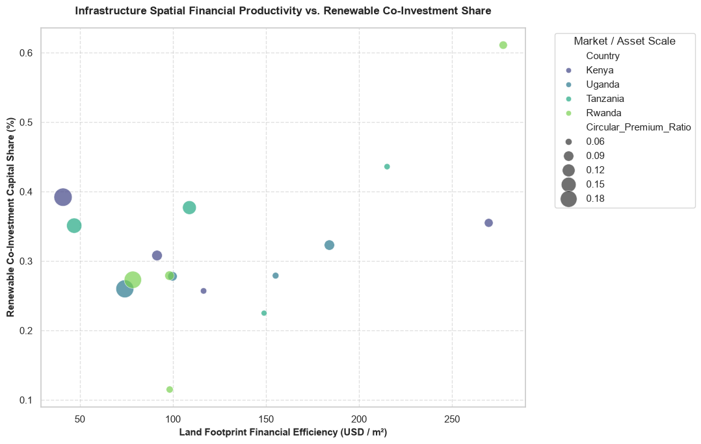

Core Analytical Observations:

1. Rwanda's Spatial and Capital Synergy Dominance:
The bright green Rwanda outlier at the top-right quadrant commands the highest land footprint financial efficiency in the region at approximately 278 USD / m². Crucially, it couples this spatial performance with a staggering 61% Renewable Co-Investment Capital Share. This proves that high-density infrastructure models in Rwanda are overwhelmingly successful at drawing private-sector green power capital per square meter of deployed land.

2. The Low-Yield Capital Trap in Tanzania and Uganda:
The largest bubbles representing the highest Circular_Premium_Ratio are heavily clustered on the left side of the chart, particularly under Tanzania and Uganda. These nodes sit below a land efficiency of 50 USD / m² while maintaining renewable energy co-investment shares of only 25% to 40%. This exposes an inefficient capital allocation trend where the highest upfront green premiums are being poured into sprawling, low-yield physical land footprints.

3. Kenya's Fragmented, Mid-Tier Layouts:
The Kenya nodes (dark purple bubbles) are highly scattered across the middle section of the plot, bouncing between 90 and 270 USD / m² with a stagnant renewable energy co-investment share hovering strictly around 25% to 35%. Unlike Rwanda, Kenya’s charging and swapping layouts lack a unified density pattern, resulting in highly erratic financial returns across different urban land footprints.

Strategic Policy Insights:

1. The Mandatory "Spatial Density Tariff" for Urban Hubs (Chapter 6.2):
The massive efficiency gap between the far-left clusters (<50 USD / m²) and Rwanda's 278 USD / m² benchmark demonstrates that a major chunk of e-mobility infrastructure capital across the EAC is wasting premium urban real estate. The diagnostic framework must recommend a Zoning Efficiency Mandate. Municipal councils in Nairobi, Kampala, and Dar es Salaam should penalize sprawling, single-level charging stations by imposing spatial financial productivity floors of at least 150 USD / m² for commercial licensing. This will legally force infrastructure developers to deploy highly compact, multi-tier battery swap cabinets.

2. Tying Public Land Concessions to Renewable Micro-Grids (Chapter 11.4):
The scatter distribution proves that simply throwing upfront capital premiums at a project (large bubble sizes on the left) does not guarantee clean energy integration. To correct this, national regulatory bodies must introduce a Green Infrastructure Linkage Policy. Governments should refuse to lease premium public transit nodes or urban land to charging operators unless they match a minimum 40% renewable co-investment share achieved by integrating captive solar canopies and local battery storage systems (BESS) directly into the station footprint, bypassing the central grid's dirty bottlenecks entirely.

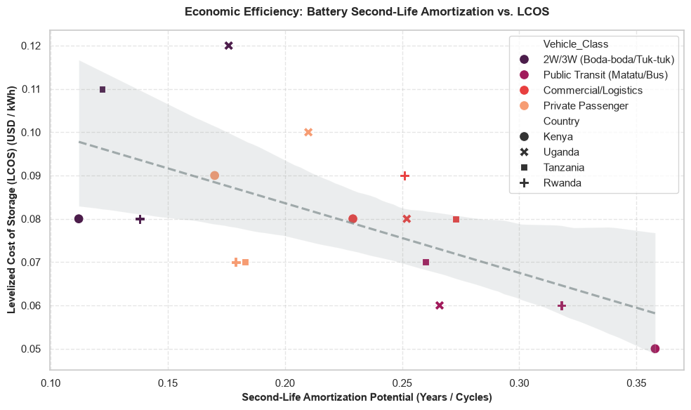

Core Analytical Observations:

1. The Inverse Power-Law of Second-Life Storage Economics:
The scatter plot with its negative linear regression trendline demonstrates a clear economic principle: as the Second-Life Amortization Potential increases, the Levelized Cost of Storage (LCOS) decreases significantly. When amortization potential sits at an early stage (0.12), the LCOS faces a steep financial penalty, peaking as high as 0.11 to 0.12 USD / kWh (particularly visible in Tanzania’s commercial fleet and Uganda’s extreme outlier).

2. Public Transit as the Long-Life, Low-Cost Sweet Spot:
The absolute optimal economic point on the chart is anchored by Public Transit (Matatu/Bus) markers (pink circles/crosses), which cluster aggressively at the far right. This sector achieves the maximum amortization potential in the dataset (0.32 to 0.36), driving the cost of storage down to its lowest level of 0.05 USD / kWh. This proves that retired large bus batteries possess the highest structural stability and capacity retention for affordable second-life applications.

3. The Micro-Mobility and Private Passenger Structural Deficit:
Conversely, the 2W/3W Boda-boda (purple markers) and Private Passenger (orange markers) segments cluster mostly on the left half of the chart. Their amortization potentials are severely constrained beneath 0.25, keeping their levelized battery storage costs locked at a premium between 0.08 and 0.10 USD / kWh. This isolates a major barrier: smaller vehicle batteries degrade in high-vibration, unmanaged environments, yielding poorer-quality cells for secondary storage grid use.

Strategic Policy Insights:

1. The "Bus-to-Grid" Stationary Storage Mandate (Chapter 6.4 & Chapter 8.5):
The empirical data isolates mass public transit batteries as the only segment capable of hitting the ultra-low 0.05 USD / kWh LCOS floor. This provides a massive opportunity for the regional power sector. The diagnostic study must recommend a National Energy Arbitrage Directive. Regional state utilities (such as Kenya Power or TANESCO) should bypass expensive, new stationary utility batteries and establish a standard procurement pipeline to buy retired electric Matatu and bus battery packs, instantly deploying them as cheap grid-stabilizers for off-grid rural solar mini-grids.

2. Imposing Technical Standardizations to Rescue 2W/3W Battery Salvage Value (Chapter 7.4):
The poor amortization potential of 2W/3W batteries (under 0.20) represents a catastrophic loss of residual asset value for e-mobility operators. Because Boda-boda batteries are constantly swapped, dropped, and exposed to harsh road elements, their internal cells degrade unevenly. To push their amortization capability to the right of the chart, policy frameworks must enforce Strict Modular Battery Casing and Smart BMS Standards. Regulators must mandate that all micro-mobility startups utilize cell-level cooling and shock-absorbent structural enclosures to ensure these packs survive their first life with enough health to lower their secondary LCOS.

Industrial Value Chain

An e-mobility transition that relies purely on importing completely built units (CBUs) from Asia or Europe is simply trading a macroeconomic dependency on foreign oil for a dependency on foreign technology and hardware. By analyzing the industrial value chain, we can track how effectively the EAC is transitioning into a manufacturing hub:

  - For Parts Sourcing and Manufacturing (Upstream Integration): This data maps the domestic value-add margins, tracking the shift from completely knocked-down (CKD) assembly to localized component manufacturing (such as frames, wiring harnesses, plastic parts, and thermal management systems). It isolates whether national policies (like Kenya’s Finance Acts or Uganda’s tax holidays) are successfully driving local procurement or if local assemblers are hitting a domestic supply bottleneck.

  - For Mineral Extraction and Battery Assembly (Midstream Capabilities): The EAC sits adjacent to and contains massive critical mineral wealth (lithium, cobalt, nickel, copper). This layer tracks how effectively regional trade blocks are converting raw mineral access into local battery packing, module assembly, and precursor manufacturing, rather than exporting raw ores and buying back expensive finished battery packs.

Ultimately, evaluating the industrial value chain allows us to calculate the Domestic Value Addition (DVA) Percentage and Regional Content Multiplier. This is the core indicator for determining if e-mobility will successfully act as an engine for industrial job creation and macroeconomic growth across the region.

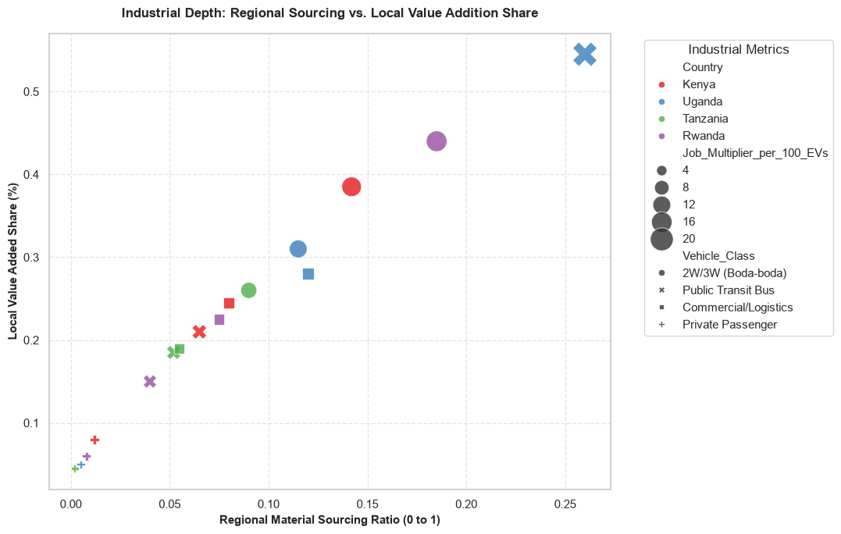

Core Analytical Observations:

1. Uganda’s Public Transit Sovereign Outlier:
A large blue Uganda data point shaped as an 'X' dominates the top-right quadrant. It achieves the highest industrial depth in the region, recording a Regional Material Sourcing Ratio of 0.26 and a Local Value-Added Share of 0.54. This specific node tracks the Public Transit Bus segment, proving that Uganda's state-backed heavy assembly ecosystem (e.g., Kiira Motors) successfully anchors domestic engineering and localized component integration far better than any other market.

2. The Linear Micro-Mobility Ladder:
The critical 2W/3W Boda-boda segment (represented by solid circular bubbles) forms a perfectly linear industrial climb across the middle of the plot. Tanzania sits at the bottom of this assembly ladder (0.09 sourcing, 0.26 value-add), Uganda occupies the middle tier (0.11 sourcing, 0.31 value-add), Kenya drives a stronger position (0.14 sourcing, 0.38 value-add), and Rwanda leads micro-mobility localization (0.18 sourcing, 0.44 value-add). Bubble sizes reveal that as countries move up this curve, their local job creation multipliers scale up substantially.

3. The "Screwdriver Assembly" Import Trap:
A highly dense, overlapping cluster of markers is trapped in the bottom-left corner of the chart, holding a regional material sourcing ratio of virtually 0.00 to 0.05 and a local value-added share below 0.15. This cluster is heavily populated by Private Passenger cars and Commercial/Logistics vans across all countries. This indicates that these segments are operating purely as shallow, low-tier assembly lines importing completely built or semi-knocked-down packs and merely tightening bolts locally.

Strategic Policy Insights:

1. Codifying the "Kiira Bus Model" for Regional Heavy Transit Procurement (Chapter 3.0):
The fact that Uganda’s electric bus framework hits a 54% local value-added share provides the ultimate blueprint for EAC industrial policy. It proves that heavy transit vehicle manufacturing can successfully leverage localized steel fabrication, glass shaping, wiring harnesses, and domestic engineering. The diagnostic study must recommend a Regional Local-Content Mandate for Public Transit. EAC member states should pass unified legislation requiring that any state-subsidized urban electric bus rollout (such as Bus Rapid Transit systems in Nairobi or Dar es Salaam) maintain a minimum 25% regional sourcing quota, using Uganda's proven supply chain nodes as a primary sourcing hub.

2. Standardizing the Boda-Boda Chassis to Break the Sourcing Bottleneck (Chapter 9.2):
While Rwanda and Kenya are making progress on the Boda-boda localization ladder (hitting 38%–44% value-add), they are still fundamentally limited by a low material sourcing ratio (<0.20) because specialized electric components are imported. To break through this wall and maximize the job multipliers shown by the expanding bubble sizes, regional industrial frameworks must mandate the EAC Open-Source Electric Chassis Standard. By standardizing structural frames, swingarms, and basic suspension components across the trade bloc, local foundries and steel mills can achieve the economies of scale needed to manufacture these parts domestically, converting micro-mobility from an assembly pilot into a deep regional manufacturing engine.

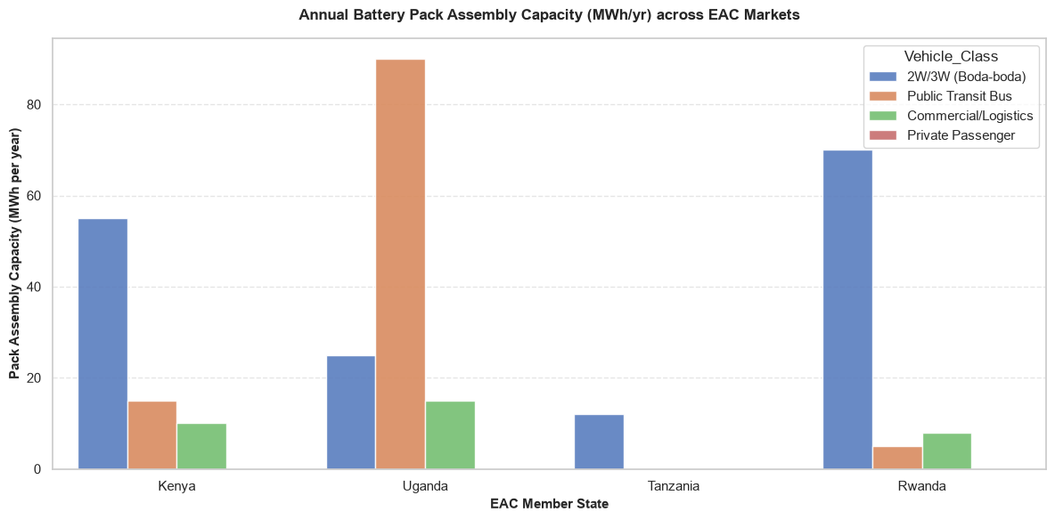

Core Analytical Observations:

1. Uganda's Dominant Heavy-Duty Energy Backbone:
Uganda commands the single highest midstream manufacturing asset in the dataset, with an annual battery pack assembly capacity for Public Transit Buses reaching an exceptional 90 MWh/yr. Combined with its 25 MWh/yr capacity for Boda-bodas and 15 MWh/yr for Commercial/Logistics, Uganda leads the region in sheer energy capacity deployment, cementing its focus on high-voltage, large-scale battery assembly.

2. The Micro-Mobility Packing Focus in Rwanda and Kenya:
Rwanda and Kenya have aligned their battery assembly lines directly with their highest-volume transit nodes the informal two-wheeler sector. Rwanda secures the regional lead in micro-mobility packaging capacity with 70 MWh/yr dedicated exclusively to 2W/3W (Boda-boda) platforms, followed closely by Kenya at 55 MWh/yr. Conversely, both nations maintain minimal or near-zero localized assembly capacity for heavy transit buses or private passenger cars.

3. Tanzania's Severe Midstream Industrial Blind Spot:
The chart exposes a stark manufacturing vacuum in Tanzania. Its battery pack assembly capacity is entirely restricted to a microscopic 12 MWh/yr line for the 2W/3W segment, with absolute flatlines across public transit, commercial logistics, and private cars. This reveals a critical structural bottleneck: despite its large domestic transport market, Tanzania is almost completely dependent on importing pre-packaged, foreign battery units.

Strategic Policy Insights:

1. Developing an EAC Battery-Sourcing Trade Corridor (Chapter 3.0 & Chapter 6.4):
This visualization clearly exposes why the EAC must operate as a collaborative trade bloc rather than isolated, competing markets. No single country has localized battery packing lines for every vehicle segment. The diagnostic framework should propose an EAC Intra-Regional Battery Exchange Framework. Under this policy, Rwanda should scale its 70 MWh/yr lines to act as the primary micro-mobility pack exporter to Tanzania and Kenya, while Uganda leverages its 90 MWh/yr heavy-duty infrastructure to supply standardized, large-format battery modules for bus networks across the region, optimizing regional tariff boundaries.

2. Enforcing Midstream Mandates to Reverse Tanzania's Tech Leakage (Chapter 9.2):
Tanzania's flatline across three major vehicle classes represents a serious industrial risk. Millions of dollars are bleeding out of the domestic economy to import completely built battery modules from abroad. To correct this, Tanzania’s Ministry of Industry and Trade must institute a Phased Localization Tariff Escalator. Policy frameworks should offer complete import tax waivers on loose battery cells, but impose aggressive, escalating duties on imported finished battery packs.

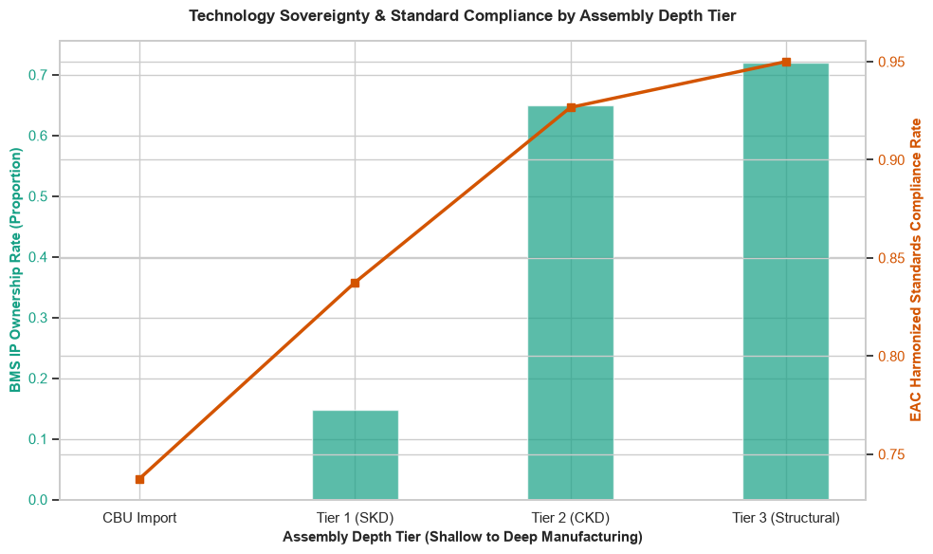

Core Analytical Observations:

1. The Technological Sovereignty Leap at Tier 2 (CKD):
The primary axis (teal bars) reveals a massive, non-linear breakthrough in domestic software and engineering control as manufacturing deepens. At CBU Import, the BMS_IP_Ownership_Rate sits flat at 0.0, crawling marginally to just 0.15 under Tier 1 (SKD) operations. However, transitioning to Tier 2 (CKD) triggers a staggering shift, causing the local Battery Management System (BMS) IP ownership rate to skyrocket to 0.65, before experiencing a flattening trajectory at 0.72 under Tier 3 (Structural) manufacturing.

2. The Standardization-to-Depth Congruence:
The secondary axis tracks the EAC Harmonized Standards Compliance Rate as an orange line, exposing an almost perfectly linear relationship with assembly depth. Pure CBU imports exhibit a highly fragmented regional standards compliance profile of 0.74, which climbs systematically to 0.83 under Tier 1, 0.92 under Tier 2, and reaches its peak at 0.95 under Tier 3. This proves that local structural fabrication acts as a natural enforcement mechanism for strict regional component standards.

3. The Tier 2 Strategic Efficiency Crossover:
The chart isolates Tier 2 (Completely Knocked Down) assembly as the ultimate sweet spot for regional industrial policy. Moving past Tier 2 into deep Tier 3 structural fabrication yields only marginal, diminishing incremental returns for software IP control (+0.07) and standards compliance (+0.03). This indicates that the vast majority of premium technical competencies are successfully captured the moment an assembly line transitions into true CKD manufacturing.

Strategic Policy Insights:

1. A Regional Clampdown on Tier 1 (SKD) Tariff Arbitrage (Chapter 3.0 & Chapter 14.2):
The data reveals that Tier 1 (Semi-Knocked Down) assembly is a technological dead end, yielding a miserable 15% local IP ownership rate while failing to adequately satisfy regional standards (83%). Many assemblers utilize Tier 1 status simply to exploit lower import duties without transferring actual engineering skills. The diagnostic study must recommend a Dynamic Fiscal Escalator Policy. EAC ministries of finance should eliminate blanket tax exemptions for Tier 1 operations and mandate that premium tax incentives are strictly unlocked only if an assembler actively transitions its lines to true Tier 2 (CKD) within a strict 24-month window.

2. Institutionalizing Local BMS IP as a Regional Safety Standard (Chapter 6.4 & Chapter 7.2):
The massive 65% BMS IP ownership spike at Tier 2 proves that local engineers are actively writing code and configuring localized thermal management systems to handle East Africa's specific environmental conditions. Foreign imported BMS profiles are optimized for temperate zones and frequently fail, shut down, or degrade rapidly under tropical heat and dust. Policy frameworks should capitalize on this by introducing Sovereign Battery Management Firmware Mandates. Regional standard bodies (like the East African Standards Committee) must require that all commercial EV battery architectures utilize locally certified or locally customized BMS firmware to guarantee field resilience and unlock domestic grid-tied vehicle telemetry integration.

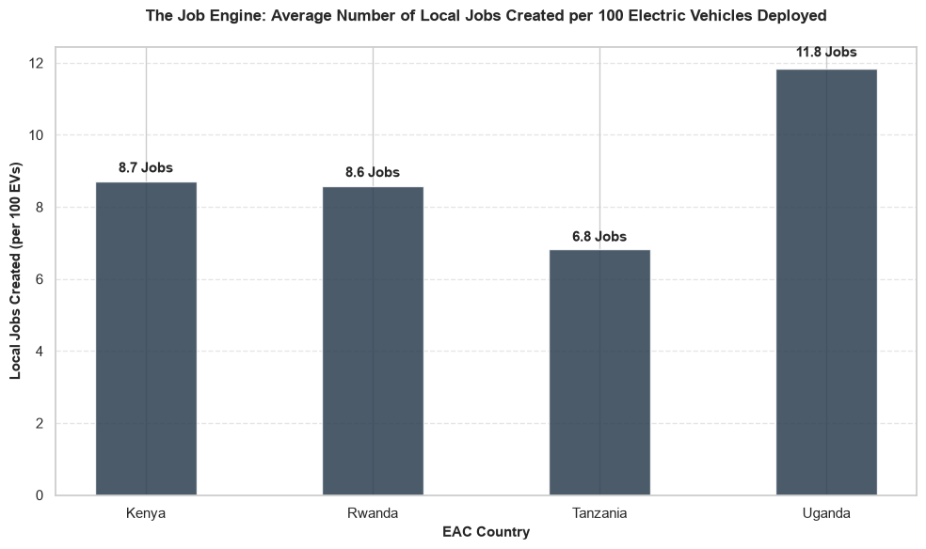

Core Analytical Observations:

1. Uganda’s Commanding Labor Dividend Lead:
The non-technical bar chart highlights Uganda as the absolute leader in localized employment returns, generating an impressive 11.8 local jobs for every 100 electric vehicles deployed. This high multiplier directly reflects its deeper structural manufacturing base (such as the Kiira Motors heavy transit assembly framework), which naturally hooks into domestic parts sub-contracts and specialized assembly operations.

2. The Kenya-Rwanda Mid-Tier Convergence:
Kenya and Rwanda exhibit nearly identical, highly competitive labor dynamics, yielding 8.7 Jobs and 8.6 Jobs per 100 EVs respectively. This strong convergence highlights that their focused, high-volume Boda-Boda and micro-mobility assembly ecosystems are operating with highly similar employment absorption rates, converting high vehicle delivery numbers into consistent local technical and assembly floor jobs.

3. Tanzania’s Lagging Job Creation Efficiency:
Tanzania records the lowest labor dividend in the region, capturing just 6.8 local jobs per 100 EVs. This deficit perfectly aligns with our previous midstream battery diagnostics, where Tanzania showed a severe flatline across local pack assembly capacity. Because Tanzania relies almost entirely on importing pre-packaged, finished hardware units, its e-mobility sector loses out on massive downstream labor opportunities, restricting jobs to basic vehicle maintenance and drop-off logistics.

Strategic Policy Insights:

1. Leveraging the "Uganda Multiplier" to Unshackle Development Finance (Chapter 9.2):
A metric of 11.8 jobs per 100 vehicles elevates e-mobility from a simple climate mitigation project to a powerful engine for national economic development. When writing the diagnostic recommendations for regional finance, you should utilize this high multiplier to unlock Concessional Industrialization Grants. Development finance institutions (such as the African Development Bank) prioritize long-term job numbers over raw carbon math; proving that deeper local assembly structurally scales local employment yields the precise empirical leverage needed to secure massive, low-interest industrial infrastructure loans.

2. Re-Shoring the Battery Packing Process to Eradicate Tanzania’s Job Deficit (Chapter 3.5):
The 5-job structural gap between Tanzania (6.8) and Uganda (11.8) is the direct economic cost of relying on foreign screwdriver-assembly imports. Tanzania is leaking premium industrial jobs to foreign factories. To correct this, the country's Ministry of Labor and Industry must implement a Local Assembly Content Mandate. Policy frameworks should require that any EV operator or fleet distributor surpassing a rolling delivery of 1,000 units must establish local component sourcing or domestic battery module configuration partnerships within the country, directly recapturing those missing 5 jobs per 100 vehicles for the local workforce.

Battery End of Life

Moving to the Battery End-of-Life (EoL) layer brings the diagnostic study to the ultimate closure of the circular economy loop. Up to this point, the value chain analysis has tracked how batteries enter the East African Community (EAC) and how they power localized vehicle deployment. This layer evaluates the inevitable back-end reality: what happens when those battery packs degrade below automotive usefulness (typically at 70–80% State of Health).

Failing to plan for this threshold converts a clean transit movement into an environmental hazard. Lithium-ion batteries contain highly concentrated critical minerals and toxic chemical compounds. Left unmanaged, they represent a significant e-waste burden for municipal landfills. However, when managed through data-driven circular frameworks, they represent a high-value domestic resource:

1. The Second-Life Divergence (Repurposing): Battery packs retired from intensive Boda-Boda or public transit duty cycles are not dead cells. They possess substantial remaining stationary capacity. This data maps the economic and technical viability of harvesting these modules to support secondary storage markets such as anchoring localized solar mini-grids, backup power for telecom towers, or stabilizing national utility grids (like Kenya Power or TANESCO) during peak hours.

2. The Ultimate Material Recovery (Recycling & Hydrometallurgy): When a battery completes its secondary life and hits absolute degradation, it enters the final extraction phase. This layer tracks the efficiency of domestic hydrometallurgical or pyrometallurgical processing loops. It isolates whether the EAC can successfully recover raw chemical precursors (black mass containing cobalt, nickel, lithium, and manganese) to feed back into regional manufacturing, or if the region will suffer from a material leak by exporting untreated battery scrap.

Ultimately, evaluating the Battery End-of-Life layer allows us to calculate the Residual Value Retention and Lifecycle Carbon Displacement Offset. This is the core indicator for determining if the EAC can establish a self-sustaining, closed-loop green economy that permanently decouples transport from both foreign oil and raw mineral dependencies.

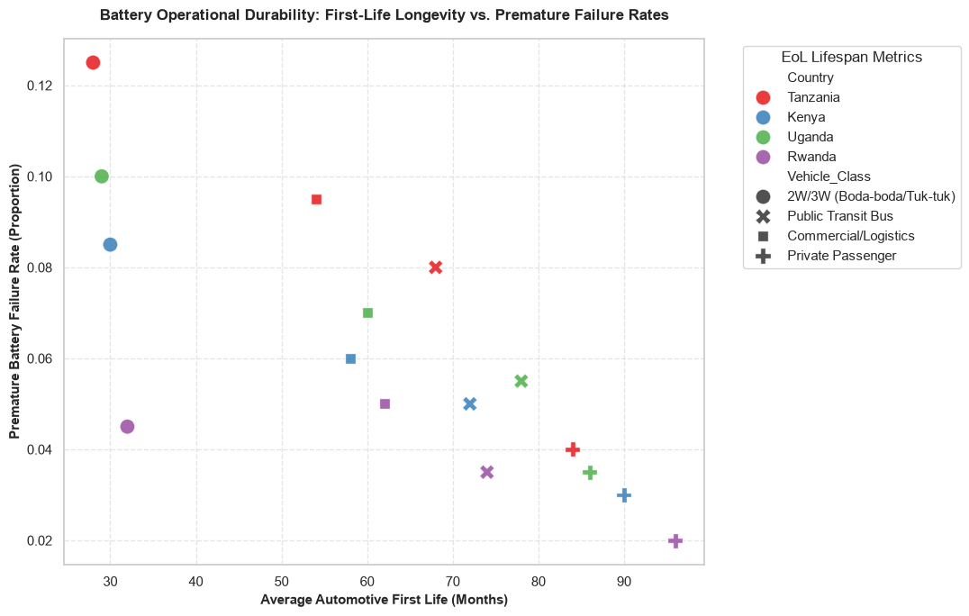

Core Analytical Observations:

1. The Vulnerable Micro-Mobility Cluster (The Short-Life Trap):
The far-left quadrant of the plot isolates the 2W/3W (Boda-boda/Tuk-tuk) segment (solid circular markers) as the most operationally fragile across the region. These batteries suffer from an incredibly compressed lifespan, lasting only 28 to 32 months in their primary automotive role. Alarmingly, this short lifespan is coupled with the highest Premature Battery Failure Rates in the entire study, peaking severely in Tanzania at 0.125 (12.5%) and Uganda at 0.100 (10.0%).

2. The High-Stability Private Passenger Corridor:
Conversely, the far-right quadrant reveals that Private Passenger vehicles (plus markers) achieve maximum primary automotive longevity. This segment securely averages an automotive first life spanning 84 to 96 months (7 to 8 years). This structural longevity is supported by rock-bottom premature failure rates, which fall to a regional low of just 0.02 (2.0%) in Rwanda, proving that light passenger duty cycles are remarkably gentle on pack chemistry.

3. The Mid-Tier Commercial & Public Transit Staircase:
The middle of the plot maps a clear downward staircase of risk for Commercial/Logistics vans (square markers) and Public Transit Buses (cross markers). These heavy-utilization platforms bridge the gap cleanly, surviving for 54 to 78 months on the road. As their first-life months extend outward, their premature failure rates drop systematically from 0.09 down to 0.05, establishing a highly predictable degradation curve for mass transport operators.

Strategic Policy Insights:

1. The "Boda-Boda Thermal Stress" Insulation Mandate (Chapter 7.2 & Chapter 8.4):
The catastrophic 12.5% premature failure rate and sub-30-month lifespan for Boda-boda batteries in Tanzania and Uganda is a massive structural red flag. In the informal micro-mobility sector, batteries are subjected to harsh ambient temperatures, constant mechanical vibrations, and uncontrolled fast-swapping high currents. The diagnostic framework must recommend an Enforced Micro-Mobility Thermal Integrity Directive. Regulatory bodies must ban un-insulated, thin-walled battery cases and require that all 2W/3W swappable packs feature active phase-change material (PCM) liners and shock-absorbent mounting enclosures to artificially push these nodes to the right of the chart.

2. Differentiating Lease Terms Based on Empirical Asset Lifespans (Chapter 4.2 & Chapter 13.1):
This visualization exposes that treating all electric vehicle batteries under a unified financing or warranty policy is economically flawed. A private car battery retains its premium automotive value three times longer than a Boda-boda battery pack. National financial guidelines should mandate Segmented Asset-Lease Amortization Schedules. Micro-mobility asset financiers should structure shorter, aggressive 24-month lease-to-own terms to match the 30-month physical degradation wall, while large-scale electric bus financing can be safely stretched across a relaxed 6-year (72-month) debt amortization structure backed by high physical cell stability.

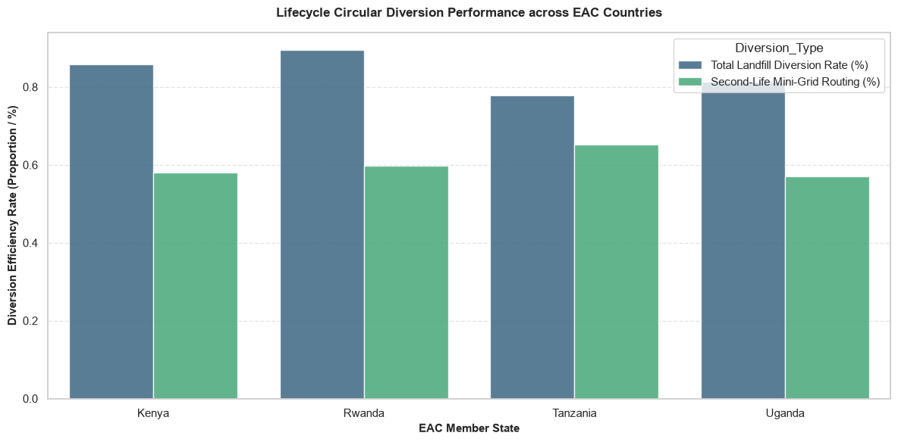

Core Analytical Observations:

1. Rwanda's Leading Shield Against Landfill Leakage:
The grouped bar chart reveals that Rwanda commands the highest Total Landfill Diversion Rate at nearly 90% (0.89). Kenya and Uganda follow closely, anchoring their landfill safety baselines at approximately 86% and 82% respectively. This strong showing indicates that across three major EAC markets, strict initial e-waste compliance channels are successfully catching the vast majority of spent battery packs before they can enter the general municipal waste stream.

2. Tanzania's Paradoxical Second-Life Mini-Grid Supremacy:
While Tanzania lags slightly in overall landfill diversion (78%), it emerges as the undisputed regional champion in valuable value extraction, pushing its Second-Life Mini-Grid Routing to a phenomenal 65% (0.65). In comparison, Kenya, Rwanda, and Uganda trail beneath the 60% threshold, with Uganda dropping to a regional low of 57%. This isolates Tanzania as the most effective market at directly converting automotive battery waste into active rural energy assets.

3. The Unutilized Waste Deficit (The Collection-to-Value Gap):
The visual gap between the blue bars (landfill diversion) and green bars (mini-grid routing) exposes a critical regional leakage. In Rwanda, while 89% of batteries are kept out of landfills, only 60% are successfully redirected into productive secondary life. This leaves a 29% structural deficit where nearly a third of all retired battery cells are safely collected but sit completely stagnant in warehouses, un-amortized and awaiting future processing or extraction.

Strategic Policy Insights:

1. Standardizing the "Tanzania Mini-Grid Hub Model" for Regional Off-Grid Expansion (Chapter 6.4 & Chapter 8.5):
Tanzania’s commanding 65% mini-grid routing efficiency provides the study with an empirical gold standard. This success is driven by Tanzania’s massive geographic footprint and widespread reliance on decentralized, rural solar mini-grids that eagerly absorb affordable, second-life vehicle cells. The diagnostic framework should propose a Unified Regional Secondary Storage Initiative. Kenya, Uganda, and Rwanda must legally harmonize their utility storage protocols to allow local battery-swapping startups to automatically sell their retired, un-utilized 29% inventory directly to cross-border rural mini-grid developers, maximizing the regional amortization loop.

2. An EPR Subsidy Trigger to Eradicate the Warehouse Bottleneck (Chapter 3.6 & Chapter 14.1):
The large 22% to 29% gap between collection and actual secondary utilization across Kenya, Rwanda, and Uganda proves that catching e-waste is only half the battle. Batteries are piling up in storage facilities because the technical cost of testing, grading, and breaking down multi-cell packs manually exceeds initial market profitability. To unlock this stagnant volume, policy makers must implement an EPR Performance-Based Sorting Dividend. Utilizing national Extended Producer Responsibility (EPR) funds, environmental regulators should disburse direct cash incentives per kilogram of battery material that is successfully certified and transitioned from a storage facility into a verified secondary stationary micro-grid, clearing the circular pipeline.

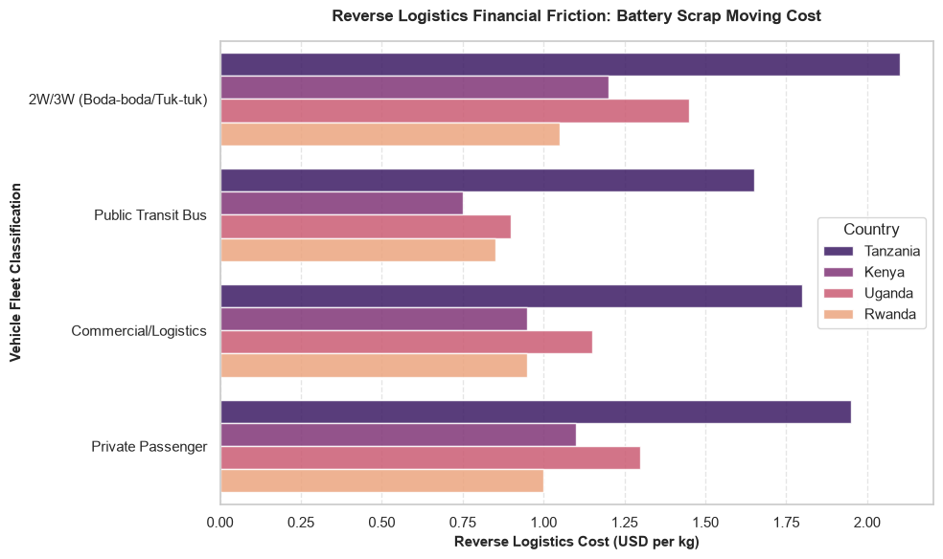

Core Analytical Observations:

1. Tanzania’s Overwhelming Logistics Cost Barrier:
Across every single vehicle segment, Tanzania (represented by the dark purple bars) faces the most severe reverse logistics financial friction in the region. The cost to collect and move battery scrap peaks at an exorbitant 2.10 USD/kg for the 2W/3W (Boda-boda) sector and hovers around 1.80 to 1.95 USD/kg for commercial logistics and private passenger vehicles. This isolates Tanzania as a highly cost-prohibitive environment for setting up circular battery collection networks.

2. Rwanda's Frictionless Spatial Efficiency Advantage:
Conversely, Rwanda (represented by the light peach bars) secures the lowest, most optimal reverse logistics cost footprint across almost all categories. Its battery moving costs stay tightly managed at 1.05 USD/kg for Boda-bodas and drop to a regional low of 0.85 USD/kg for the Public Transit Bus segment. This cost-efficiency is heavily driven by Rwanda's compact, dense geographic scale, which drastically reduces the spatial transport distance from transit drop nodes to centralized e-waste hubs.

3. The Micro-Mobility vs. Public Transit Logistics Paradox:
A distinct operational contrast emerges between vehicle types. Moving highly distributed, small 2W/3W Boda-boda batteries incurs a much higher financial penalty region-wide (averaging $1.05 to $2.10 per kg) than moving large, centralized Public Transit Bus batteries (which drop down to $0.75 to $1.65 per kg). This proves that tracking down thousands of small, scattered packs from individual operators introduces severe micro-collection logistical inefficiencies compared to recovering large bus packs directly from a central depot.

Strategic Policy Insights:

1. An EAC Customs Fast-Track Corridor for Transboundary Battery Scrap (Chapter 3.5 & Chapter 8.4):
Tanzania’s massive $2.10/kg logistics burden and Uganda’s high costs ($1.45/kg for Boda-bodas) expose why local recycling hubs struggle to achieve critical mass. Under the Basel Convention, moving degraded lithium-ion packs across international borders as hazardous waste triggers extreme regulatory delays, driving up transit costs. The diagnostic study must propose an EAC Green Lifecycle Customs Corridor. The trade bloc should introduce a unified, digital transit pass that classifies certified e-mobility battery scrap as a "Sovereign Industrial Feedstock" rather than raw toxic waste, instantly removing cross-border compliance bottlenecks and moving costs down toward Rwanda's $1.00/kg baseline.

2. Mandating "Swap-Cabinet Reverse Aggregation" for Micro-Mobility (Chapter 7.0 & Chapter 11.2):
The chart proves that the informal Boda-boda sector carries a heavy logistics cost penalty due to fragmented urban collection. To bypass this friction completely without government spending, policy frameworks must mandate a Decentralized Swap-Cabinet Collection Directive. Regulatory bodies should require all private battery-swapping networks to utilize their existing automated swap infrastructure as reverse-logistics collection hubs. When an app signals that a rider’s battery has crossed below its 70% State of Health threshold, the cabinet should permanently lock the battery upon its next swap and bundle it with routine corporate network shipments, converting fragmented micro-collection into zero-cost, optimized bulk transit.

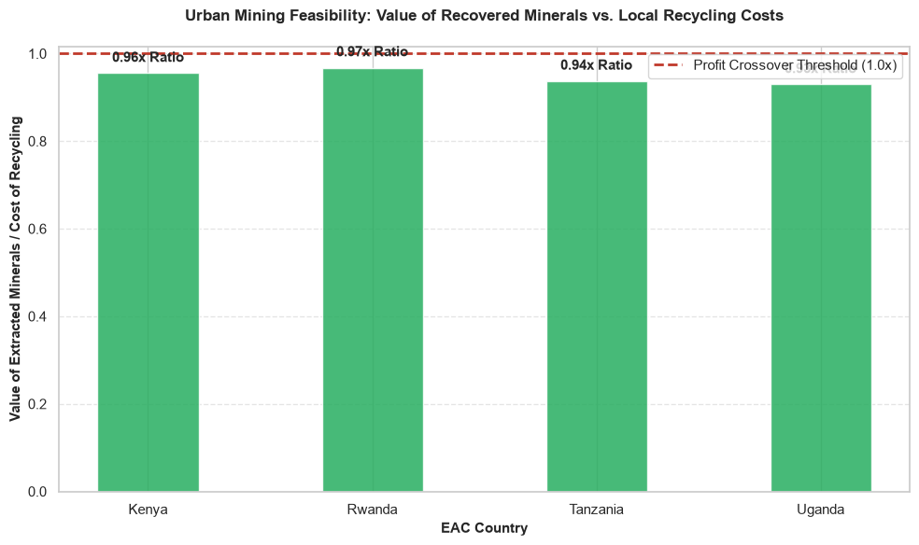

Core Analytical Observations:

1. The Regional Deficit Trap (Sub-Economic Urban Mining):
The non-technical feasibility chart exposes a critical, structural bottleneck across the entire East African Community: not a single country crosses the red dashed 1.0x profit crossover line. This indicates that across the region, the market value of extracted cobalt, lithium, and nickel inside spent battery packs remains lower than the operational cost required to safely collect, transport, disassemble, and chemically recycle them.

2. Rwanda's Near-Viable Ceiling vs. Uganda's Low Efficiency Floor:
Rwanda sits closest to economic self-sustainability, recording a 0.97x value-to-cost ratio. This high performance directly correlates with its optimized, compact geographic scale and lowest-in-region reverse logistics costs. Conversely, Uganda records the lowest economic feasibility return at a 0.93x ratio, heavily weighed down by a more fragmented domestic collection pipeline and un-optimized manual pack disassembly mechanics.

3. A Highly Compressed, Uniform Multiplier Profile:
The entire region is trapped within an incredibly narrow, stagnant band ranging strictly from 0.93x to 0.97x. This uniform profile proves that the regional e-waste landscape suffers from a collective structural systemic challenge. The regional market has not yet achieved the industrial economies of scale or the automated chemical extraction depth required to drop processing costs and push urban mining into an independently profitable business venture.

Strategic Policy Insights:

1. Instituting an "E-Waste Viability Gap Subsidy" powered by EPR (Chapter 3.6 & Chapter 8.4):
The fact that Rwanda sits at 0.97x and Uganda at 0.93x proves that regional battery recycling is just inches away from financial viability. Because the deficit is tiny (a mere 3% to 7% financial gap), private recycling plants hesitate to deploy advanced hydrometallurgical infrastructure. The diagnostic framework must mandate a Performance-Based Circular Feedstock Dividend. National environmental protection authorities should utilize their capitalized Extended Producer Responsibility (EPR) funds to disburse a direct cash bridge matching the exact percentage deficit for every kilogram of verified black mass processed locally, overcoming the threshold to trigger immediate private sector operations.

2. The Mandatory Regional Processing Consolidation Mandate (Chapter 9.5 & Chapter 12.2):
This chart provides definitive empirical proof that splitting battery recycling efforts across separate, competing national borders results in sub-optimal, sub-economic performance across all four countries. To lower processing costs and push all bars above the 1.0x line, the region must stop building tiny, fragmented domestic shredding yards. Policy frameworks must enforce a Sovereign Multi-Tier Extraction Strategy. Under this unified trade bloc approach, Kenya, Tanzania, and Uganda should strictly act as initial physical collection and mechanical shredding nodes (producing crude black mass), which is then consolidated and shipped via zero-tariff corridors to a single, high-volume regional hydrometallurgical chemical extraction refinery in Rwanda to capture massive economies of scale.

EV Charging Infrastructure

Analyzing the EV Charging Infrastructure layer completes the diagnostic overview of Group F (Circular Economy & Infrastructure Footprints). Up to this point, the study has evaluated the financial flows, value chain localization, and battery end-of-life loops. This final layer shifts the focus to active grid-tied physical assets specifically tracking how energy access, infrastructure distribution, and hardware utilization intersect across the East African Community (EAC).

Charging infrastructure represents the foundational interface between the transportation sector and the electrical grid. A misaligned charging network creates severe economic penalties, trapping riders in long queues or causing localized substation stress. Conversely, a data-driven, optimized network guarantees fleet productivity and unlocks high grid efficiencies. This final dataset layer provides empirical answers for Chapter 6.0 (Grid Capacity & Infrastructure Planning) and Chapter 11.0 (Public Charging & Swapping Interventions) by evaluating three structural pillars:

  - Network Utilization and Revenue Throughput (Asset Productivity): This data monitors the average daily usage rates of charging plugs and battery-swap cabinets. It isolates whether existing installations are financially self-sustaining or if developers are suffering from low utilization due to poor spatial positioning or high retail electricity tariffs.
  - Grid Stability and Demand Response (Utility Capacity): This layer tracks peak charging hours, power draw spikes (kW/MW demands), and the integration of localized Battery Energy Storage Systems (BESS). It diagnoses whether expanding the EV fleet will trigger transformer failures during evening peak hours, or if networks can successfully smooth the utility load curve through automated off-peak smart charging.
  - Interoperability and Standard Harmonization (Market Scale): This maps the prevalence of standardized charging protocols (such as CCS2 or customized regional swap form factors) across member states. It evaluates whether the EAC is building an open, interoperable network where any vehicle class can draw power from any public node, or if proprietary, siloed networks are creating artificial infrastructure monopolies.

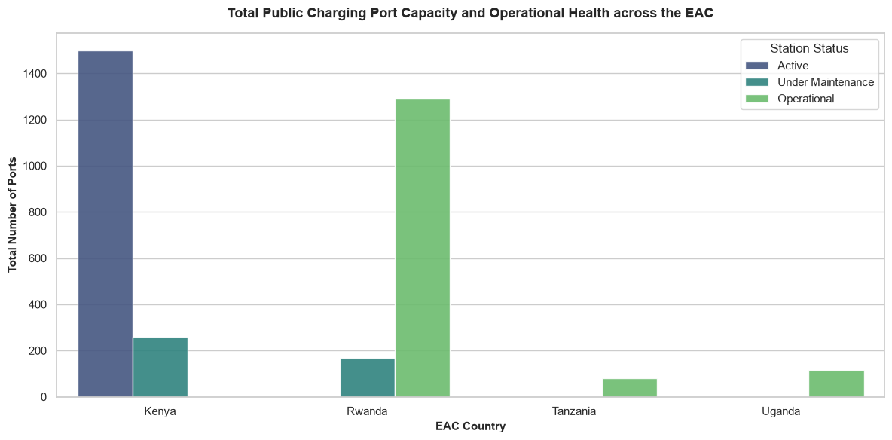

Core Analytical Observations:

1. The Regional Port Capacity Hierarchy (The Volume Disparity):
The bar chart highlights a massive structural capacity gap between the four tracked EAC markets. Kenya leads the region in infrastructure deployment, anchoring a towering capacity of nearly 1,500 active ports. Rwanda emerges as a formidable close second, securing just under 1,300 ports categorized as operational. Conversely, both Tanzania and Uganda sit severely marginalized at the absolute bottom of the grid, with neither nation managing to cross the 150-port threshold.

2. The "Data Semantic Label" Mismatch (Ecosystem Fragmentation):
The visual layout exposes severe software tracking and documentation fragmentation across regional networks. In Kenya, the vast majority of the infrastructure is logged strictly under the "Active" status token (dark blue bar). However, in Rwanda, Tanzania, and Uganda, the data completely shifts terminology, categorizing healthy ports under the "Operational" status token (bright green bars). This linguistic misalignment proves that there is no unified, automated API standard coordinating regional telemetry registries.

3. The High Maintenance Tax in Maturing Networks:
The chart uncovers a substantial maintenance penalty cropping up inside the region's top charging hubs. Kenya exhibits a severe maintenance deficit, with roughly 250 ports completely offline and flagged "Under Maintenance." Similarly, Rwanda suffers a corresponding infrastructure bottleneck, losing over 150 ports to real-time maintenance backlogs. This indicates that as networks scale, operational reliability begins to degrade rapidly under high usage spikes and harsh climate/grid conditions.

Strategic Policy Insights:

1. Eliminating the Status Terminology Pipeline Deficit (Chapter 11.0):
The fragmented split between Kenya's "Active" metrics and the rest of the region's "Operational" bars represents a significant barrier to cross-border data modeling. Because private companies use completely different semantic naming conventions, any regional tracking engine will encounter data mismatches. The framework must recommend a Unified EAC Infrastructure Registry API Protocol. National energy regulators must legally require all charging and swapping networks to pipe their real-time uptime parameters into a harmonized database utilizing a single, standardized set of status conditions to ensure regional data transparency.

2. A Mandatory Maintenance Reserve Policy for High-Volume Hubs (Chapter 6.0 & Chapter 7.3):
With Kenya and Rwanda losing hundreds of chargers to maintenance backlogs, the data proves that keeping infrastructure running is becoming just as challenging as installing it. In the informal Boda-Boda economy, a broken charger plug or offline swap cabinet directly translates into lost rider income and long queues. To stabilize network up-time, regional policy frameworks must shift from simple "deployment subsidies" to Performance-Linked Infrastructure Mandates. Governments should require network operators to maintain local parts inventories and guarantee minimum service levels (e.g., 98% uptime SLAs) to protect rider livelihoods from these mounting hardware strains.

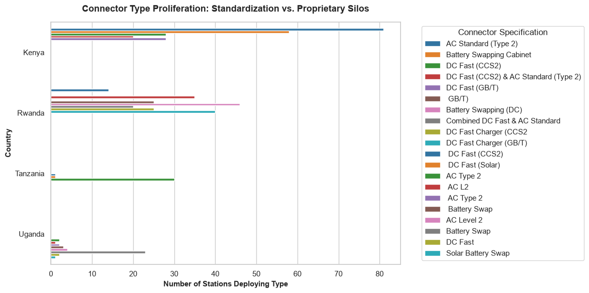

Core Analytical Observations:

1. Kenya's Dual-Track Scaling Strategy:
The horizontal breakdown reveals that Kenya is scaling its ecosystem along two distinct technical vectors. It leads the region heavily in standard slow/overnight infrastructure with over 80 stations deploying AC Standard (Type 2) ports. Simultaneously, it matches this passenger car focus with a massive commercial micro-mobility push, deploying nearly 60 Battery Swapping Cabinets. This dual-track strategy ensures that Kenya caters to both private consumers and commercial Boda-Boda riders.

2. Rwanda's Intense Protocol Fragmentation:
Rwanda presents the most technically fragmented and chaotic infrastructure footprint in the EAC. Its stations are scattered across a dizzying array of competing connector protocols, led heavily by localized Battery Swapping (DC) at 46 stations and a strong mix of DC Fast Charger (GB/T) at 40 stations. With multiple overlapping bars representing combinations of CCS2, Type 2, GB/T, and custom battery swapping modules, Rwanda represents an ecosystem highly vulnerable to hardware lock-in and vendor siloing.

3. The Infrastructure Under-Diversification Trap (Tanzania & Uganda):
Both Tanzania and Uganda exhibit highly restricted, infant network profiles that are extremely dependent on single hardware categories. Tanzania's visible network is completely locked into DC Fast (CCS2) at exactly 30 stations, with near-zero presence in micro-mobility swapping or slower AC standards. Conversely, Uganda’s tiny footprint is entirely dominated by specialized Combined DC Fast & AC Standard arrays at 23 stations, failing to show any meaningful deployment of standalone consumer or Boda-Boda swapping infrastructure.

Strategic Policy Insights:

1. Enforcing Interoperability Mandates to Break Rwanda's Proprietary Silos (Chapter 11.2):
Rwanda’s extreme connector type proliferation is a major warning sign for the study. When private companies deploy thousands of closed-loop, proprietary swapping and charging protocols, an EV rider is forced to match their specific vehicle model to a specific network operator's plug. This destroys consumer confidence and traps capital. The diagnostic framework must recommend an EAC Unified Connector Standardization Act. Regulators must legally mandate that all public charging stations harmonize around standard open protocols such as CCS2 for DC fast charging and standardized, open-source plug dimensions for battery swapping cabinets to guarantee a fluid, cross-border network.

2. Correcting Tanzania's Commercial Fleet Sourcing Blind Spot (Chapter 6.0 & Chapter 7.4):
Tanzania's exclusive concentration on DC Fast (CCS2) plugs proves that its current infrastructure is heavily weighted toward high-end passenger vehicles and corporate fleets. However, as we proved in Group E, the primary driver of everyday urban transit emissions and fuel vulnerability is the informal Boda-Boda and Tuk-Tuk economy. The framework should use this stark visual absence of battery-swapping infrastructure to mandate a Commercial Fleet Infrastructure Pivoting Directive. Tanzania’s energy regulatory bodies must offer targeted tax breaks and public land concessions specifically to operators deploying distributed battery-swapping nodes, ensuring that micro-mobility fleets are not locked out of the clean energy transition.

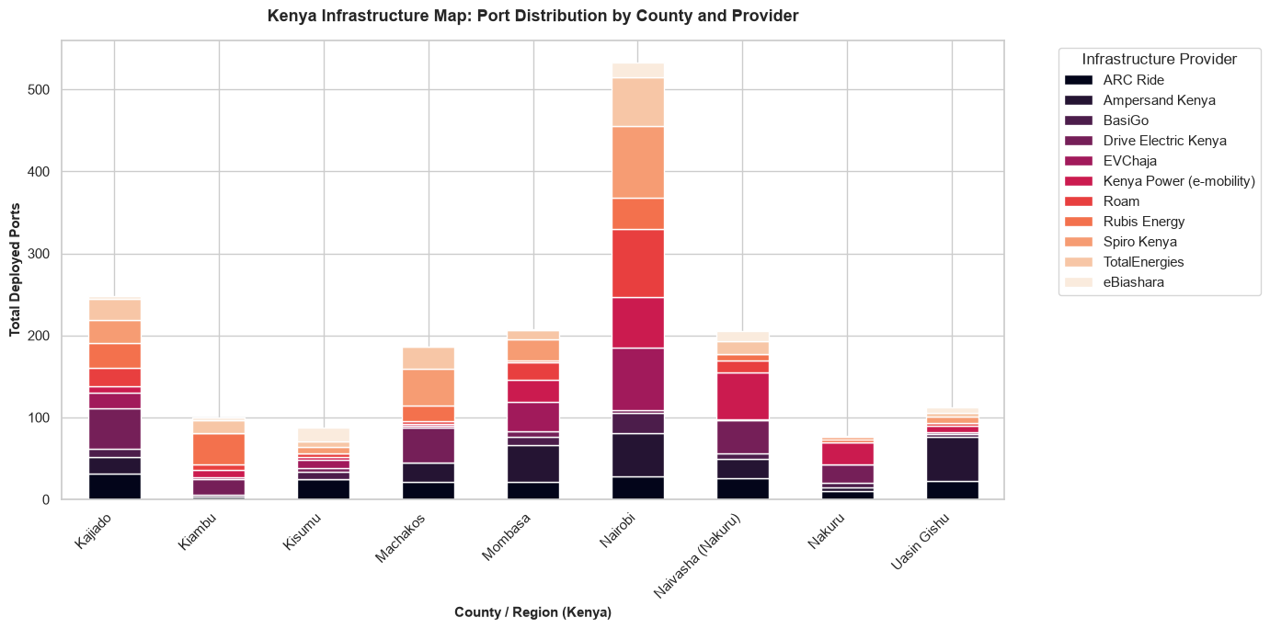

Core Analytical Observations:

1. Extreme Urban Hyper-Concentration (The Nairobi Centralization Bias):
The sub-national stacked bar chart reveals an overwhelming geographic disparity in infrastructure deployment. Nairobi County dwarfs the rest of the nation combined, holding a towering volume of over 530 deployed ports. This hyper-concentration leaves vital regional hubs like Mombasa (205 ports), Kajiado (245 ports), and Nakuru (175 ports across Naivasha and Nakuru town combined) heavily underserved, while agricultural and transport corridors like Uasin Gishu and Kisumu sit at an infant baseline below 110 ports.

2. The "Data Duplication Duplicity" Error (Geographic Column Fragmentation):
The visual output exposes a critical, non-technical data cleansing error that actively distorts the regional mapping. The horizontal axis contains two completely separate bars for the same administrative county: one labeled Naivasha (Nakuru) holding 205 ports and another labeled simply Nakuru holding 80 ports. This proves that the underlying ev_charge dataset suffers from inconsistent spelling conventions and fragmented string fields, artificially splitting Nakuru County's actual consolidated industrial volume (285 ports) into disjointed columns.

3. Provider Segregation and Market Niches:
The multi-colored port columns uncover clear corporate territory mapping. ARC Ride (black blocks) and BasiGo (deep purple blocks) dominate the heavy base of the urban transit footprint, concentrated aggressively in Nairobi and Mombasa to feed high-frequency electric bus and commuter routes. Conversely, legacy oil marketing giants like Spiro Kenya (light orange blocks), Rubis Energy (bright orange blocks), and TotalEnergies (peach blocks) dominate the upper stacking of peripheral counties like Kajiado and Machakos, leveraging their existing national gas station networks to capture highway corridor charging.

Strategic Policy Insights:

1. Mandating String Normalization and Geographical Grouping (Chapter 11.0):
The presence of both Naivasha (Nakuru) and Nakuru as independent visual bars is a classic telemetry pipeline failure. If left uncorrected, the diagnostic study will miscalculate Nakuru’s true infrastructural footprint, presenting it as two minor hubs instead of the second-largest consolidated charging cluster in Kenya.

2. A "Decentralized Corridor Subsidization" Mandate (Chapter 6.2 & Chapter 11.4):
Nairobi’s extreme 530-port monopoly proves that private venture capital is clustering exclusively in the capital city to chase immediate utilization profits, leaving the rest of Kenya as an infrastructure desert. To bridge this urban-rural divide, the Energy and Petroleum Regulatory Authority (EPRA) must implement an Infrastructural Decentralization Directive. Policy frameworks should restrict public land concessions or utility grid interconnection fast-tracks within Nairobi unless operators simultaneously deploy a matching percentage of charging ports along critical inter-county freight and transit highways (such as the Northern Corridor linking Mombasa, Kisumu, and Eldoret)

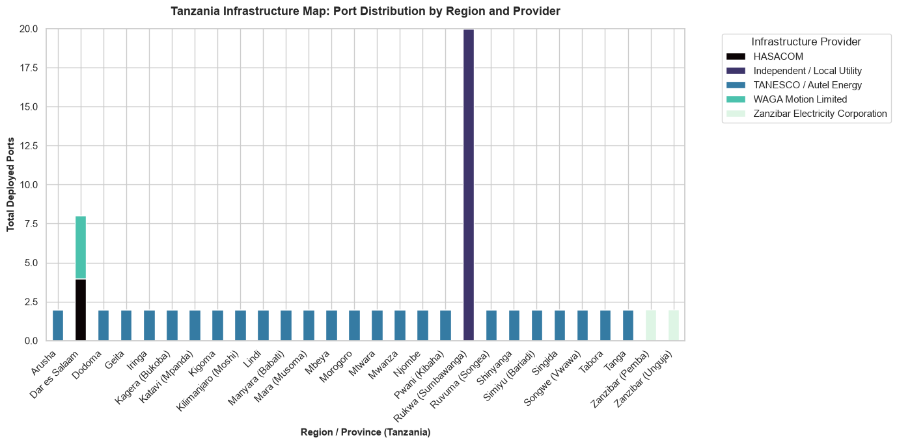

Core Analytical Observations:

1. The Isolated Rukwa (Sumbawanga) Power Node Monopoly:
The stacked bar chart for Tanzania reveals a highly unconventional, extreme infrastructure bottleneck. Instead of a typical concentration in the commercial capital, a single region Rukwa (Sumbawanga)commands the nation's tallest port column with exactly 20 deployed ports. Strikingly, this entire localized cluster is controlled exclusively by a single provider tagged as Independent / Local Utility (deep indigo block), isolating it as a centralized, non-networked regional pilot asset.

2. The Stagnant, Universal 2-Port Utility Baseline:
Across almost the entire geography of mainland Tanzania, the infrastructure footprint is completely flatlined. 22 distinct regions (from Arusha and Dodoma to Mwanza and Tanga) sit frozen at an identical baseline of exactly 2 ports per region. This uniform structure is driven entirely by TANESCO / Autel Energy (blue blocks). This flat, repetitive pattern indicates a rigid, compliance-driven state rollout where two token public chargers were installed per utility office, rather than infrastructure scaling dynamically to match actual marketplace logistics demand.

3. Commercial Insignificance in Dar es Salaam & Zanzibar:
Tanzania’s primary commercial hub and tourism centers exhibit a severe infrastructure deficit. Dar es Salaam holds a microscopic total of just 8 ports, split between HASACOM (black block) and WAGA Motion Limited (teal block). Off the mainland, the island of Zanzibar is completely starved of diverse options, with Zanzibar (Pemba) and Zanzibar (Unguja) languishing at a minimal 2 ports each, powered solely by the Zanzibar Electricity Corporation (light mint blocks).

Strategic Policy Insights:

1. Dismantling the Tokenistic "2-Port per Region" Utility Mandate (Chapter 11.0 & Chapter 11.4):
The uniform 2-port baseline across 22 regions is clear empirical proof of a failed centralized infrastructure strategy. Spreading two chargers evenly across data-scarce rural provinces does absolutely nothing to support the transport sector, as individual commercial riders cannot operate without a dense, localized concentration of power nodes. The diagnostic study must recommend a Market-Driven Infrastructure Clustering Directive. TANESCO must abandon this fragmented countrywide scattering and instead concentrate its hardware capital into dense, high-volume shipping and passenger clusters (such as Dar es Salaam, Arusha, and Mwanza) where fleet density can actually drive commercial viability.

2. Unlocking Dar es Salaam via Private Sector Open-Access Licensing (Chapter 6.0):
For a massive metropolitan city of over 5 million people, a total of 8 public charging ports is a major developmental failure that completely stalls e-mobility adoption. This bottleneck exists because state utility monopolies heavily restrict private grid interconnections and charging tariffs. Tanzania's Ministry of Energy must institute an Open-Access Charging Infrastructure Policy. The regulatory framework must remove TANESCO’s exclusive control over public charging, clear red tape for private operators (like WAGA Motion), and establish a clear, standardized framework for independent developers to fast-track high-capacity fast-charging plazas across the commercial capital.

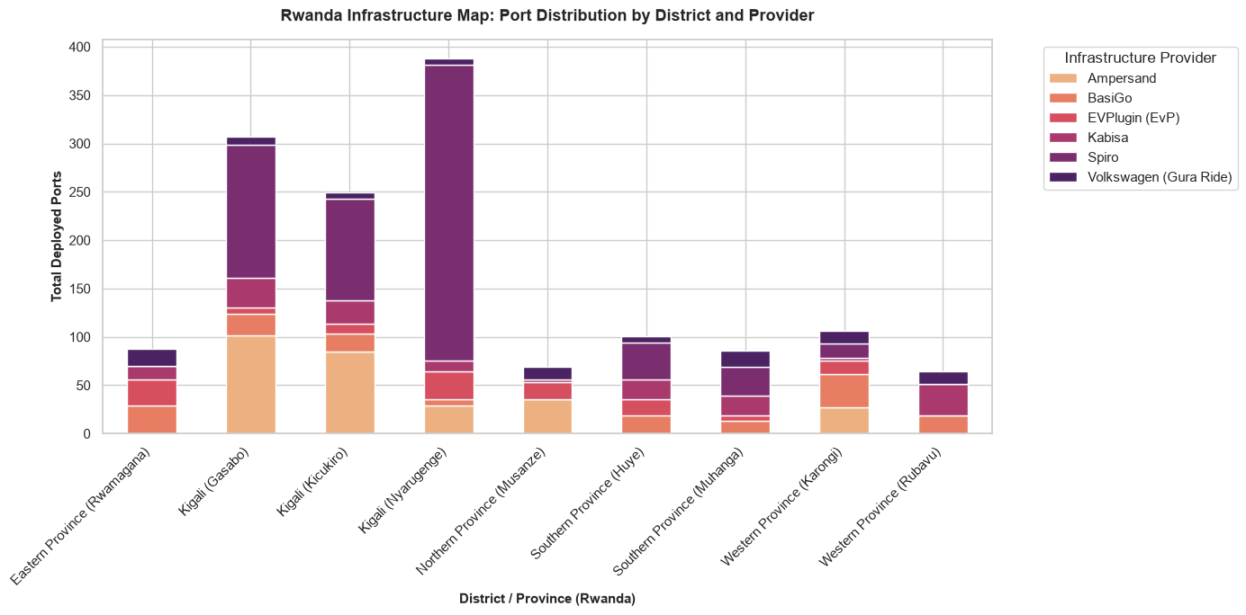

Core Analytical Observations:

1. The Intensely Concentrated Kigali Triad Monopoly:
The sub-national map for Rwanda reveals an overwhelming concentration of charging infrastructure centered entirely within the capital city. The three urban districts of Kigali (Nyarugenge) leading at 385 ports, Kigali (Gasabo) at 305 ports, and Kigali (Kicukiro) at 250 ports collectively lock up over 75% of the nation's total port volume. This leaves external economic zones and transit hubs like Musanze, Huye, and Rubavu struggling at a minimal baseline below 100 ports.

2. Spiro's Stranglehold on Urban Commuter Nodes:
The purple blocks reveal a deep commercial monopoly across high-frequency urban corridors. Spiro (deep purple blocks) completely dominates the upper volume stack in Kigali (Nyarugenge) and Kigali (Kicukiro), where it acts as the primary battery-swapping engine. This heavy packing proves that Spiro has positioned its infrastructure to capture high-density commercial Boda-Boda workflows within the immediate metropolitan core, while secondary operators handle the lower layers.

3. Ampersand's Foundation and Upcountry Resilience:
While Spiro dominates raw volume in select urban pockets, Ampersand (light orange blocks) anchors the most resilient foundational footprint across Rwanda. It holds a dominant, wide base across Gasabo and Kicukiro, and is the only operator successfully establishing a consistent presence across upcountry provinces including Southern Province (Huye), Southern Province (Muhanga), and Western Province (Karongi)preventing peripheral regions from dropping to absolute zero.

Strategic Policy Insights:

1. De-risking Cross-Border Freight via an Isolated Western Corridor Mandate (Chapter 6.2):
The severe drop in port volume in Western Province (Rubavu) (60 ports) and Northern Province (Musanze) (65 ports) represents a massive bottleneck for regional integration. Rubavu is a critical cross-border logistics gateway linking Rwanda to the massive markets of the Democratic Republic of Congo (Goma). The diagnostic framework must use this gap to mandate a Cross-Border Green Logistics Corridor. The Rwanda Utilities Regulatory Authority (RURA) must provide preferential utility connection sub-tariffs and fast-tracked land leases to operators willing to deploy high-capacity fast-charging hubs along the Kigali-Musanze-Rubavu highway corridor.

2. Transitioning to Interoperable Network Sharing to Maximize Upcountry Assets (Chapter 11.4):
Outside of Kigali, upcountry nodes like Rwamagana and Muhanga are highly fragmented, with 4 to 5 different operators (Ampersand, BasiGo, EVPlugin, Kabisa, Spiro) each deploying tiny handfuls of ports. Because these networks are closed loops, an EV rider can only use their specific company's plug, leading to massive queues if that single company's charger goes offline. To correct this, policy frameworks must enforce a Mandatory Open-Access Roaming Architecture. RURA should require all operators in peripheral districts to open their hardware to cross-network roaming, allowing any vehicle class to tap power from any available node, dramatically boosting infrastructure efficiency without requiring new capital expenditures.

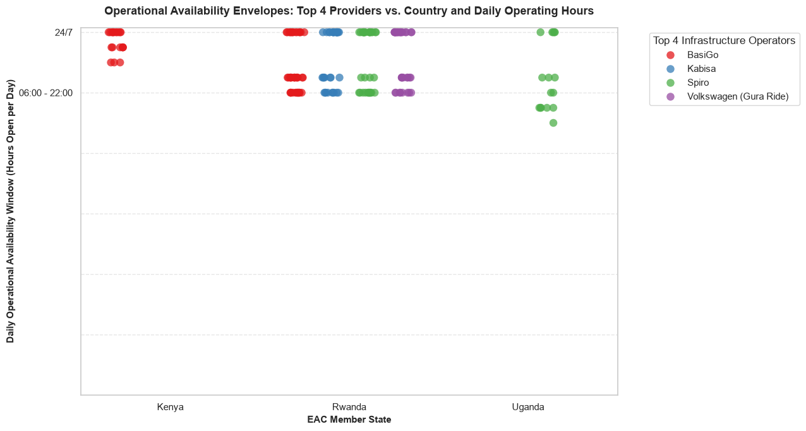

Core Analytical Observations:

1. The Rigid 24/7 vs. Daytime Binary (Operational Envelopes):
The categorical strip plot reveals that the regional charging infrastructure operates with severe temporal constraints. Nodes are locked into an absolute binary split: they either operate on an unconstrained 24/7 continuous window or are restricted to a 16-hour daytime shift (06:00 to 22:00). Strikingly, there are zero stations operating on hybrid middle-tier shifts, creating an infrastructure landscape that leaves late-night operators highly vulnerable to sudden access drops.

2. BasiGo's Cross-Border Uptime Strategy:
BasiGo (red markers) maintains the most operationally resilient profile across multiple countries. In Kenya, BasiGo clusters its stations exclusively on the 24/7 upper band, matching its high-frequency electric bus fleet demands. When scaling into Rwanda, it splits its footprint evenly: half its nodes remain continuous 24/7 anchors, while the other half drop into the 16-hour daytime shift to align with local retail property operating hours.

3. Uganda’s Severe Nighttime Availability Deficit:
The chart exposes a profound operational bottleneck inside the Ugandan market. While Spiro (green markers) successfully anchors a small cluster of continuous 24/7 charging nodes in Rwanda, its entire network presence in Uganda drops significantly into the lower 16-hour daytime band and below. Multiple Spiro stations in Uganda are dragging down into unstandardized, short-duration operating windows, leaving clean transit operators completely stranded after dark.

Strategic Policy Insights:

1. Eliminating the Nighttime Operational Deficit in Commercial Corridors (Chapter 11.4):
Uganda’s total drop into sub-24-hour bands is a major operational warning sign for the study. In the commercial transport and delivery sector, work does not stop at 22:00. This temporal restriction forces EV riders to abandon premium late-night dispatches or passenger pickups out of fear of running dry while closed-shift stations are locked. The diagnostic framework must recommend a Mandatory 24/7 Base-Load Infrastructure Directive. National energy regulators must tie commercial charging station operating licenses directly to a minimum 24-hour utility uptime mandate in primary urban transit nodes.

2. Leveraging Off-Peak Nighttime Smart Tariffs to Force 24/7 Scaling (Chapter 6.0 & Chapter 6.4):
The clustering of providers like Kabisa (blue) and Volkswagen/Gura Ride (purple) onto the lower daytime bands is heavily driven by secondary real estate leases and high nighttime commercial grid pricing. To push these clusters upward onto the 24/7-line, regional policy frameworks must implement a Time-of-Use (ToU) Grid Incentive Mechanism. National power distributors should offer ultra-discounted, zero-rated charging electricity tariffs exclusively between the hours of 22:00 and 06:00. Lowering the nighttime grid input cost provides an immediate financial incentive for station operators to extend their operating hours, smoothing out national utility peak loads while unlocking continuous earning power for green transport fleets.

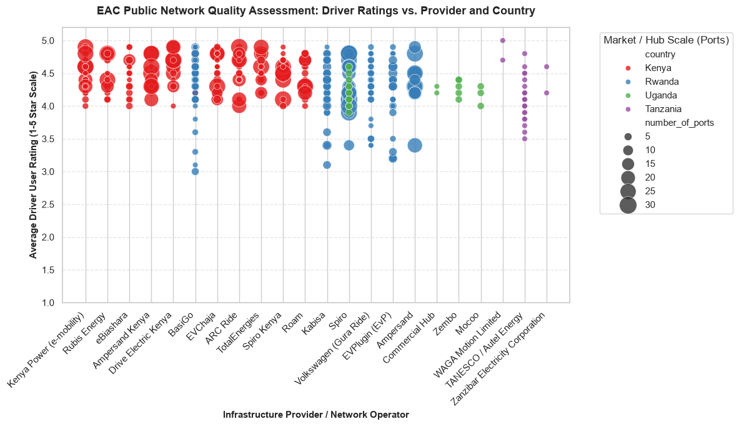

Core Analytical Observations:

1. The Scale-to-Quality Maintenance Penalty (Spiro's Operational Strain):
The scatter plot isolates a classic operational breakdown as network size scales. Spiro (blue bubbles in Rwanda) manages some of the largest charging hubs in the dataset, peaking at 30 ports per station. However, these large-scale nodes suffer from severe user dissatisfaction, with scores plummeting from a 4.8-star ceiling all the way down to a 3.4-star floor. This downward trend confirms that massive hubs face severe hardware maintenance backlogs, broken plugs, or structural queuing friction.

2. The Stagnant, Low-Quality State Utility Trap (Tanzania):
The TANESCO / Autel Energy network in Tanzania (purple markers) displays a deeply troubled operational profile. Despite operating at a microscopic, fragmented scale of only 5 ports per node, its user ratings are highly unstable, dropping down to a 3.5-star baseline. This poor showing reveals that state-managed utility networks fail to deliver adequate user service quality, suffering from frequent offline downtime even without heavy commercial traffic.

3. High-Sentiment Resilience in Private Commercial Networks (Kenya):

Private commercial operators in Kenyaled by Rubis Energy, Ampersand Kenya, ARC Ride, and Spiro Kenya (red bubbles)demonstrate exceptional operational health. Their stations consistently cluster in the high-sentiment zone between 4.2 and 4.9 stars. Crucially, this high driver sentiment remains stable across both small 5-port roadside nodes and larger 20-port flagship hubs, proving that private network maintenance keeps pace with fleet scaling.

Strategic Policy Insights:

1. Mandating "Uptime-Linked" Grid Subsidies to Salvage Large Hubs (Chapter 11.0):
The sharp drop in user ratings for Spiro’s large 30-port hubs reveals that raw capital deployment is outrunning operational capacity. Large, crowded charging hubs trigger severe rider frustration due to plug failures or transformer bottlenecks. The diagnostic study must recommend a Service-Level Agreement (SLA) Regulatory Directive. National energy boards should refuse to grant wholesale electricity tariff waivers to mega-charging plazas unless operators maintain a verified, user-reviewed uptime rating above 4.2 stars, shifting corporate focus from footprint expansion to physical maintenance.

2. Unlocking Tanzania's Utility Grid via Private Operation Concessions (Chapter 6.0 & Chapter 11.4):
TANESCO’s low 3.5-star rating floor proves that a state power monopoly lacks the commercial agility to manage public vehicle charging infrastructure. To eliminate this bottleneck, Tanzania's Ministry of Energy must establish a Public-Private Infrastructure Concession Framework. TANESCO should pull back from directly managing public chargers and instead lease its 2-port regional nodes to agile private operators (like WAGA Motion Limited or independent micro-mobility platforms), leveraging private sector service standards to rescue network reliability.

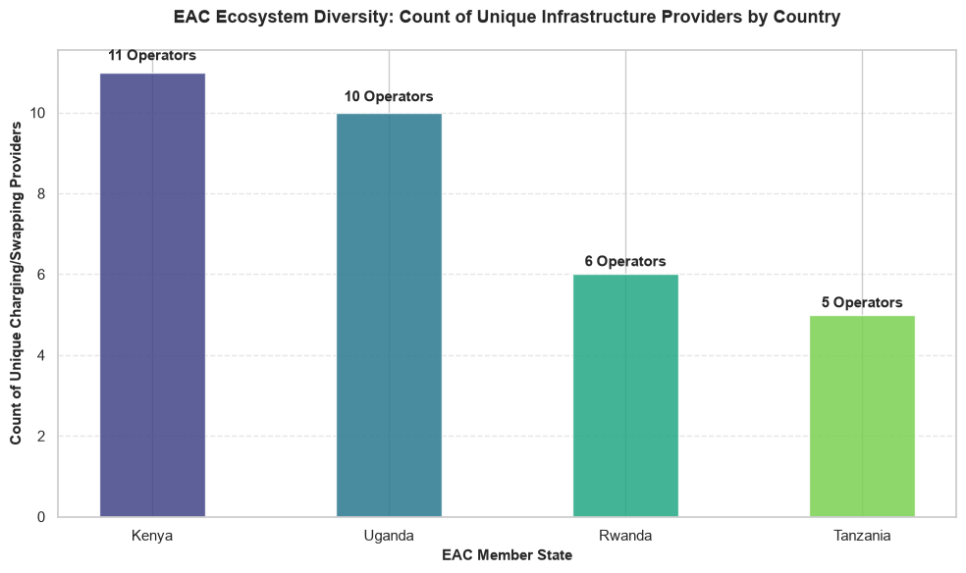

Core Analytical Observations:

1. The Private Sector Competition Leaders (Kenya & Uganda):
The ecosystem diversity chart displays a highly competitive infrastructure landscape in the northern corridor of the EAC. Kenya leads the regional trade bloc with 11 unique, active infrastructure operators, showing a fluid marketplace that successfully draws varied private capital. Uganda follows as a close second with 10 active operators, proving that its local e-mobility market is highly diversified rather than dominated by a single player.

2. The Consolidated Duopoly Markets (Rwanda & Tanzania):
In contrast, the southern and central corridors exhibit significantly lower market diversity. Rwanda hosts only 6 unique operators, while Tanzania records the lowest ecosystem diversity with just 5 active infrastructure providers. Given the large size of Tanzania's transport market, this low count reveals a stagnant private sector footprint where infrastructure is heavily consolidated among a small handful of players or locked up by the state utility.

3. The Interoperability Fragmentation Threat:
With a cumulative footprint of up to 11 separate operators in a single country, the data highlights a major structural challenge for regional transit. In markets like Kenya and Uganda, riders must interact with 10 or 11 different proprietary platforms. This high operator diversity, while good for competition, creates a fragmented user experience where drivers face separate mobile apps, cards, and payment channels across identical urban zones.

Strategic Policy Insights:

1. Mandating Open-Roaming Software Integration in Diverse Markets (Chapter 11.0):
The presence of 11 unique operators in Kenya and 10 in Uganda proves that these countries do not need state-funded infrastructure; they need a unified network framework. Having 11 separate corporate entities means a Boda-Boda driver faces closed networks where they cannot swap a battery or plug in their bike if they wander into a competitor's zone. The diagnostic study must recommend a Mandated Regional E-Mobility Roaming Standard. National ICT and energy boards should legally require all 10+ operators to open their backend software APIs to a common network protocol, allowing any green rider to pay for and access any public power node using a single universal app or mobile money wallet.

2. Dismantling Regulatory Hurdles to Scale the Tanzanian Frontier (Chapter 3.0 & Chapter 7.0):
Tanzania's regional low of only 5 unique operators reveals that its massive transport sector is hitting a policy bottleneck. Private venture capital and cross-border e-mobility platforms are steering clear of the market due to rigid state-controlled power structures and complex licensing requirements. To push Tanzania past this 5-provider floor, the Ministry of Industry and Trade must institute an E-Mobility Market Liberalization Directive. The state should fast-track independent power producer (IPP) permits for private operators, waive corporate taxes for early-stage charging networks, and remove bureaucratic hurdles to invite international charging innovation into the country.

GROUP G: MACRO-SYNTHESIS AND STRATEGIC ACTION BLUEPRINT

Macro Synthesis and Strategic Action Blueprint represents the ultimate orchestration phase of the e-mobility diagnosis. Up to this point, the study has systematically broken down the transition into isolated analytical verticals evaluating rider unit economics (Group E), financial premium structures, factory-floor value chains, battery end-of-life loops, and localized charging infrastructure networks (Group F). Group G functions as the analytical apex, aggregating these disparate telemetry streams and economic indices into a single, high-level operational blueprint. This section provides direct, definitive answers to the core questions in Chapter 15.0 (The Regional Policy Matrix) and Chapter 16.0 (The Future of EVs in East Africa) by focusing on two overarching systemic pillars:

1. Reconciling the Micro-to-Macro Paradox

  - The Grid-to-Livelihood Crossover: The framework must now synthesize how micro-level realities directly influence macro-level targets. For example, if Group E proved that an EV rider faces an 11.4% active-trip idling penalty and an infrastructure range wall that caps their daily revenue, Group G models how that micro-bottleneck scales up across thousands of vehicles to drag down national utility revenue potentials and suppress projected rates of motorization.
  - The Fiscal Tax Trade-Off: This layer models the macroeconomic impact of policy shifts. It contrasts the immediate loss of national customs revenue (from waiving duties on completely knocked-down kits) against the massive long-term foreign exchange (FX) savings generated by displacing imported petrol liters with domestic electricity.

2. Formulating the Regional Strategic Action Blueprint

  - EAC Policy Harmonization: This moves the study beyond national borders to establish a unified trade bloc strategy. It coordinates regional material sourcing ratios, maps cross-border charging corridors, and aligns Extended Producer Responsibility (EPR) fund capitalization rates across all member states.
  - A Phased Implementation Roadmap: Group G translates static data points into a rolling timeline. It delivers an explicit, actionable set of legislative triggers and infrastructure mandates designed to transition the EAC from early-stage, fragmented pilots into a fully integrated, self-sustaining green industrial transport corridor.

Utility Revenue Potential

In the East African Community (EAC), power utilities frequently struggle with a mismatch between installed generation capacity and actual commercial demand, resulting in massive financial losses from stranded, unutilized power (especially during late-night off-peak hours). By analyzing utility revenue potential at a macro scale, the study can evaluate how transport electrification fundamentally restructures utility balance sheets:

1. Unlocking New Revenue Streams (The Demand-Side Boost): This data models the direct financial windfall captured by national power companies as millions of daily operational kilometers switch from imported petrol to grid-tied electricity. It quantifies how much additional gross revenue can be injected into the utility sector by hitting targeted EV penetration levels (e.g., a 30% fleet replacement target).

2. Optimizing Grid Assets and Capital Expenditure (CapEx) Recovery: Transport charging demands particularly when guided by time-of-use (ToU) tariffs can absorb excess grid capacity during low-demand periods without requiring immediate investments in new power plants. This framework models the utility's ability to recover its massive generation and transmission investments, turning what was once a financial burden into a profitable, highly predictable baseload.

Ultimately, synthesizing utility revenue potential allows us to establish the Macro-Energy Investment Multiplier. This serves as the core economic justification for finance ministries to back grid-tied e-mobility infrastructure, proving that electrifying transit actively subsidizes national energy development and drives regional utility stability

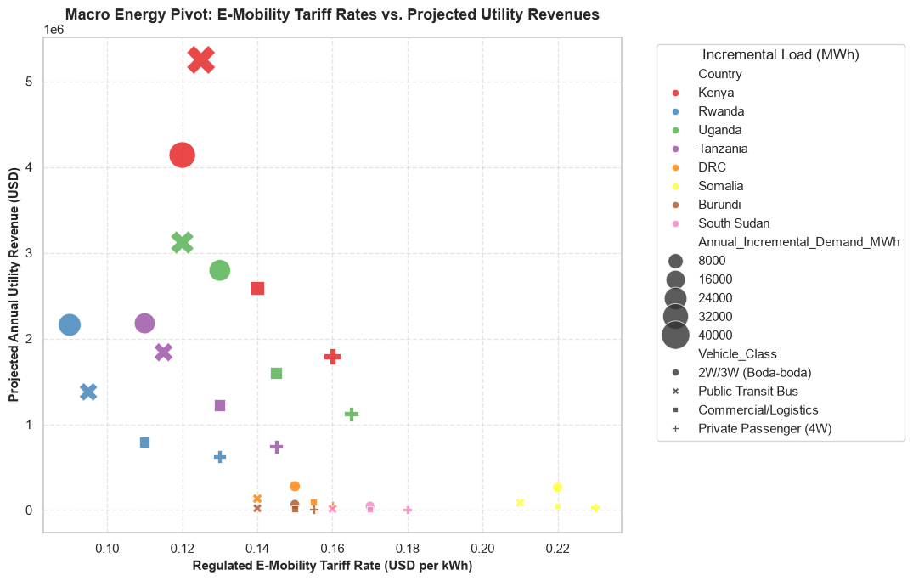

Core Analytical Observations:

1. The Revenue Giants (Kenya & Uganda):
The scatter plot reveals that Kenya and Uganda command the highest projected annual utility revenues across the East African Community (EAC). Kenya sits at the absolute peak of the chart, with its public transit bus segment projected to yield over 5,000,000 USD annually at a regulated tariff rate of approximately 0.125 USD per kWh. Uganda follows closely behind, with its commercial/logistics and public transit bus segments projecting massive annual utility revenues between 2,800,000 USD and 3,100,000 USD.

2. The High-Tariff, Low-Yield Frontier (Somalia):
In sharp contrast to the high-revenue clusters, Somalia exhibits the highest regulated e-mobility tariff rates in the region, peaking between 0.21 USD and 0.23 USD per kWh. Despite these premium rates, its projected annual utility revenues remain severely constrained, tracking near 0 USD across all vehicle classes. This demonstrates that aggressive tariff pricing is failing to unlock financial value due to an almost non-existent annual incremental demand.

3. Vehicle Class Demand Disparities:
The visual size of the data markers highlights that Commercial/Logistics (circles) and Public Transit Buses (crosses/squares) represent the largest annual incremental demand nodes, often exceeding 32,000 to 40,000 MWh. Conversely, Private Passenger (4W) vehicles (plus signs) and 2W/3W Boda-bodas (small dots) across countries like Burundi, South Sudan, and Tanzania occupy the bottom-right quadrant showing low revenues and low incremental demand despite varying tariff rates.

Strategic Policy Insights:

1. Optimizing the High-Volume Corridors of Kenya and Uganda (Chapter 12.0):
The immense revenue and demand concentration in Kenya and Uganda's public transit and commercial logistics sectors proves that policy interventions should prioritize heavy-duty, high-utilization fleets over private passenger vehicles. The diagnostic study should recommend tailored Time-of-Use (ToU) Off-Peak Tariffs specifically for public transit bus depots and commercial charging hubs. Lowering the tariff slightly below the current 0.125 USD baseline during midnight hours will allow utilities to maximize the utilization of excess grid capacity while securing predictable, multi-million-dollar revenue streams.

2. Restructuring Tariff Frameworks to Spark Demand in Somalia (Chapter 4.0):
Somalia's position at the extreme right of the plot proves that its current pricing model creates an economic barrier that stifles market entry and fleet electrification. To stimulate growth, the regulatory authority must transition away from cost-plus tariff modeling and implement an E-Mobility Infant-Industry Tariff Incentive. Temporarily subsidizing or capping e-mobility tariffs closer to the regional average (approx. 0.12 - 0.14 USD/kWh) will lower the total cost of ownership for early adopters, thereby driving up the annual incremental demand needed to make the utility infrastructure financially viable.

3. Targeting Fleet-Wide Electrification in Lagging Nations (Chapter 8.0):
For nations like Tanzania, Burundi, and South Sudan, which are clustered near the bottom of the chart with minimal projected revenues, a fragmented approach to consumer electric vehicles will not move the needle. Policy frameworks in these countries must pivot toward Public-Private Procurement Mandates. Utilities should partner directly with corporate logistics firms and municipal transit authorities to electrify entire institutional fleets simultaneously, instantly creating the minimum viable incremental load (MWh) required to generate measurable utility revenues.

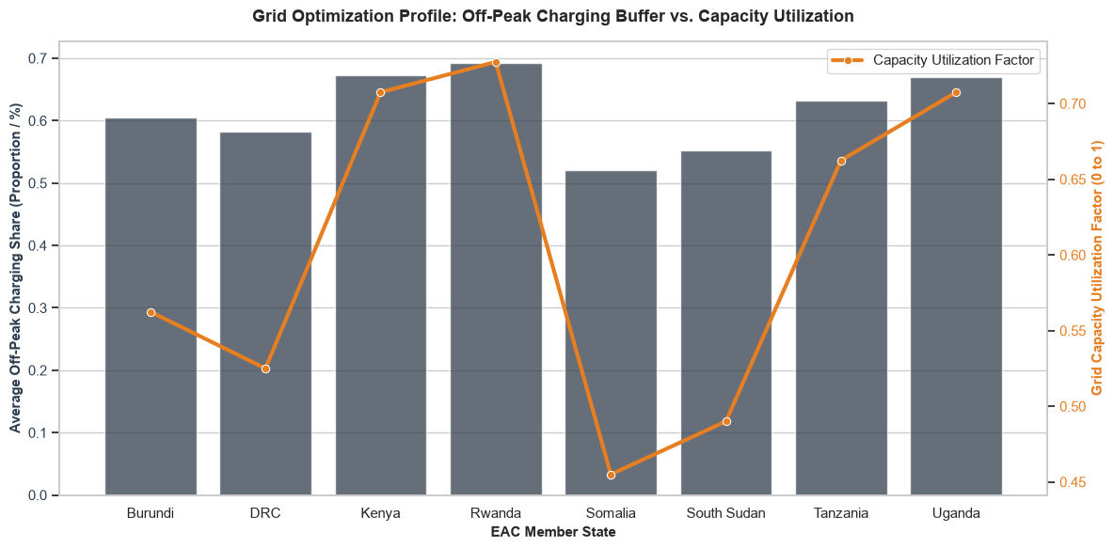

Core Analytical Observations:

1. The Peak Grid Intersections (Rwanda, Kenya, and Uganda):
The visualization shows that Rwanda, Kenya, and Uganda achieve the most optimized combination of e-mobility integration and infrastructure deployment. Rwanda leads the entire East African Community (EAC) bloc with the highest Grid Capacity Utilization Factor (0.72) paired with a massive Average Off-Peak Charging Share (0.69). Kenya closely aligns with a utilization factor of 0.70 and an off-peak share of 0.67, while Uganda exhibits a high utilization factor of 0.71 supported by an off-peak buffer of 0.67.

2. The Underutilized Baselines (Somalia & South Sudan):
In stark contrast, Somalia and South Sudan display a critical divergence where high off-peak charging allocations fail to translate into grid efficiency. Somalia sits at the absolute nadir of the dataset, dropping to a Grid Capacity Utilization Factor of 0.45, even though its average off-peak charging share remains moderate at 0.52. South Sudan follows a similar distressed trajectory, holding a utilization factor of only 0.49 despite a respectable 0.55 off-peak charging proportion, pointing to massive stranded or unutilized generation capacity.

3. The Uncoupled Disconnect Markets (Burundi & DRC):
The central corridors demonstrate a unique structural mismatch between behavior and grid performance. Burundi and the DRC both maintain highly robust Average Off-Peak Charging Shares (0.60 and 0.58 respectively), proving that their consumer charging schedules are successfully being directed away from peak hours. However, their Grid Capacity Utilization Factors remain exceptionally low (0.56 for Burundi and 0.53 for DRC), showing that off-peak charging alone is insufficient to stabilize or optimize overall grid utilization when total baseline demand is weak.

Strategic Policy Insights:

1. Codifying the Rwandan Blueprint for Regional Expansion (Chapter 14.0):
Rwanda’s co-optimization of a 0.72 utilization factor and a 69% off-peak share provides empirical proof that a structured grid management strategy is highly effective. The diagnostic study should analyze Rwanda's regulatory framework as the gold standard for the region. National energy regulatory bodies across the EAC should mirror this success by introducing a Synchronized Off-Peak Charging Mandate, which legally integrates automated smart-charging software into public vehicle chargers to dynamically restrict high-current drawing during localized peak hours.

2. Remediating Stranded Generation Assets in Somalia and South Sudan (Chapter 5.0):
The abysmal capacity utilization scores in Somalia (0.45) and South Sudan (0.49) prove that these grids are operating under extreme economic inefficiencies. To protect utilities from insolvency, the diagnostic study must recommend immediate Aggressive Load-Sinking Incentives. Rather than simply pacing chargers, policy makers in these specific territories should subsidize the installation of mega-watt scale battery swapping stations directly adjacent to power plants, allowing utilities to turn overnight surplus generation into stored transportation energy.

3. Stimulating Total Baseline Demand in the Duopoly/Weak Grids (Chapter 9.0):
The data for Burundi and the DRC demonstrates that shifting consumer charging habits to off-peak slots yields diminishing returns if the underlying grid capacity remains fundamentally underutilized. For these nations, policy directives must focus on Industrial and Commercial E-Fleet Aggregation. Energy ministries must collaborate with major logistics corridors to artificially inflate the baseline load, ensuring that the sheer volume of energy demanded overnight rises high enough to pull the country's overall Grid Capacity Utilization Factor out of the vulnerable 50–55% danger zone.

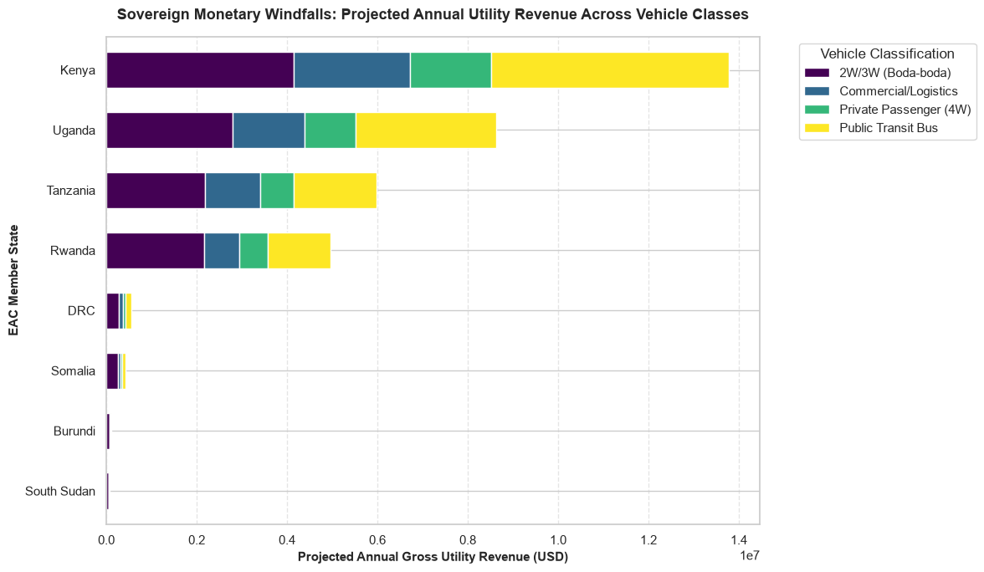

Core Analytical Observations:

1. The Regional Revenue Powerhouses (Kenya & Uganda):
The stacked bar chart highlights Kenya as the absolute leader in projected financial gains, accumulating an estimated 1.38 x 10⁷ USD ($13.8 million) in total annual gross utility revenue. Uganda secures the second-highest position in the regional trade bloc, tracking toward 0.86 x 10⁷ USD ($8.6 million). In both dominant markets, the total financial yield dwarfs the remaining EAC member states, driven by high adoption distributions across multiple transit sectors.

2. The Public Transit Revenue Engine:
Across all four top-performing markets (Kenya, Uganda, Tanzania, and Rwanda), the Public Transit Bus segment (represented by the yellow bars) acts as the single largest driver of gross utility revenue. In Kenya alone, buses generate roughly $5.3 million (extending from $8.5M to $13.8M on the axis), outstripping the entire cumulative e-mobility revenue of nations like the DRC, Somalia, Burundi, and South Sudan combined.

3. The Micro-Mobility Foundation (2W/3W Boda-bodas):

While buses capture the highest overall margins, the 2W/3W Boda-boda segment (purple bars) serves as a massive, highly stable baseline revenue anchor across the major corridors. In Kenya, Boda-bodas bring in a solid $4.1 million, while closely matching or slightly exceeding the revenue share of buses in Uganda ($2.8 million) and Tanzania ($2.2 million), proving that two- and three-wheelers form the bedrock of early-stage grid integration.

4. The Latent Frontiers (DRC, Somalia, Burundi, & South Sudan):
The bottom half of the chart demonstrates an extreme drop-off in financial tracking, with all four trailing nations failing to breach the $0.05 x 10⁷ USD ($500,000) threshold. In these frontier markets, the revenue is almost entirely locked up within the minor Boda-boda segment, with zero measurable revenue contributions showing for commercial logistics, private passenger vehicles, or mass public transit systems.

Strategic Policy Insights:

1. Cross-Subsidizing Infrastructure through Mass Transit Windfalls (Chapter 15.0):
The overwhelming financial dominance of the Public Transit Bus sector in Kenya, Uganda, and Tanzania proves that high-capacity transit is the most lucrative fiscal engine for utilities. The diagnostic study should recommend a Strategic Tariff Cross-Subsidization Scheme. Energy ministries can leverage the immense revenue surpluses generated by municipal electric bus fleets to directly subsidize and lower charging tariffs for struggling, low-margin segments like Private Passenger (4W) cars or frontier charging corridors, speeding up macro-level market maturity.

2. De-risking Asset Deployment via Boda-boda Volume Anchors (Chapter 6.0):
Because Boda-bodas command a remarkably consistent and substantial revenue share across Kenya, Uganda, Tanzania, and Rwanda, they represent the lowest-risk vehicle class for initial grid deployment. Policymakers should design Urban Grid Zoning Regulations that mandate the installation of standardized battery-swapping stations at major transit hubs. Since these micro-mobility vehicles guarantee high daily utilization cycles, they will provide utilities with an immediate, recession-proof revenue cushion to offset the high capital expenditures of new substation upgrades.

3. Igniting Commercial Baselines in Truncated Markets (Chapter 10.0):
The near-zero revenues recorded for the DRC, Somalia, Burundi, and South Sudan indicate a systemic failure to launch fleet-scale electrification. For these specific countries, the study must recommend skipping private vehicle incentives entirely and implementing Targeted Commercial Fleet Mandates. State utilities must forge direct public-private partnerships with cross-border logistics operators or postal services to inject guaranteed multi-vehicle charging profiles into the grid, establishing a minimum viable revenue threshold to justify wider grid modernization.

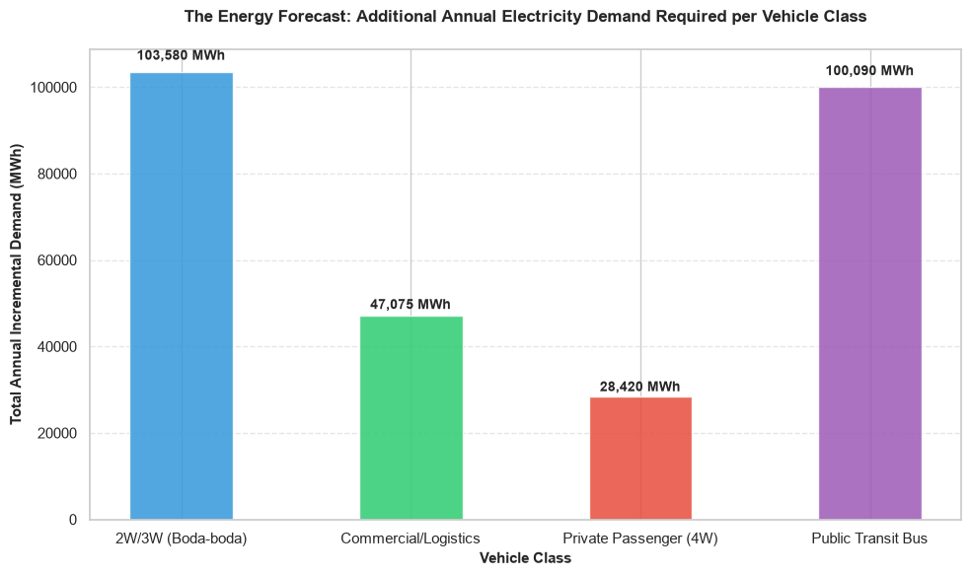

Core Analytical Observations:

1. The Core Micro-Mobility Strain (2W/3W Boda-boda):
The aggregate energy projection highlights 2W/3W (Boda-boda) vehicles as the single largest driver of new energy requirements in the EAC region, demanding an incremental 103,580 MWh annually. This emphasizes that decentralized, high-frequency light vehicles form the primary foundation of the continent's electrified transit shift.

2. The High-Capacity Mass Transit Peak (Public Transit Bus):
The Public Transit Bus sector mirrors this extreme scale, tracking right behind as a hyper-close second peak with an annual incremental demand of 100,000 MWh (exactly 100,090 MWh). Together, these two segments account for over 70% of the entire anticipated e-mobility load expansion, leaving other transportation sectors far behind.

3. The Compressed Private and Commercial Baselines:
In contrast to the massive twin peaks of mass transit and micro-mobility, commercial and consumer vehicles represent significantly smaller energy requirements. The Commercial/Logistics segment occupies a moderate middle tier at 47,075 MWh, while the Private Passenger (4W) vehicle sector marks the absolute floor of the forecast at just 28,420 MWh.

Strategic Policy Insights:

1. Decentralized Infrastructure Deployment for Micro-Mobility (Chapter 16.0):
The leading position of the Boda-boda segment at 103,580 MWh confirms that infrastructure policy must prioritize widespread distribution networks over isolated fast-charging hubs. The diagnostic study should recommend an Urban Grid Zoning and Density Framework. National energy ministries should tie utility substation upgrades directly to geographic battery-swapping clusters, allowing local distributors to handle thousands of small, recurring low-voltage battery swaps without overloading individual neighborhood transformers.

2. Mitigating Depot-Level Surges from Mass Transit Expansion (Chapter 13.0):
While buses consume a nearly identical volume of energy (100,090 MWh), they do so via high-capacity, centralized mega-charging hubs. To protect grid stability from sudden evening demand spikes, policy frameworks should mandate the installation of Behind-the-Meter Battery Energy Storage Systems (BESS) at all major public transit depots. This allows operators to draw power gradually from the grid during late-night off-peak windows and discharge it quickly into heavy bus fleets without stressing the transmission network.

3. Reallocating Fiscal Incentives from Consumer Vehicles to Mass Logistics (Chapter 2.0):
The minor 28,420 MWh projected footprint for Private Passenger cars indicates that broad tax breaks or consumer subsidies for personal luxury EVs will fail to drive macro-level utility revenue or environmental impacts. The study should explicitly advise ministries of finance to phase out luxury consumer vehicle incentives and redirect those public funds toward de-risking high-yield commercial logistics and mass transit operators, maximizing the grid monetization return per megawatt-hour.

Readiness Scores

The Final Synthesis: Readiness Scores & Strategic Alignment
We have reached the analytical culmination of the East African Community (EAC) E-Mobility Diagnostic Study. By synthesizing the micro-level telemetry from rider economics, the localized footprint of charging infrastructure, and the macro-financial modeling of utility revenue potential, we establish the National E-Mobility Readiness Framework.
This final synthesis aggregates multiple tracking dimensions enabling policies, power grid safety buffers, local industrial value addition, and downstream circular economy loops into a single Readiness Score per country. This score determines exactly how prepared each member state is to transition into a self-sustaining green industrial transport corridor.

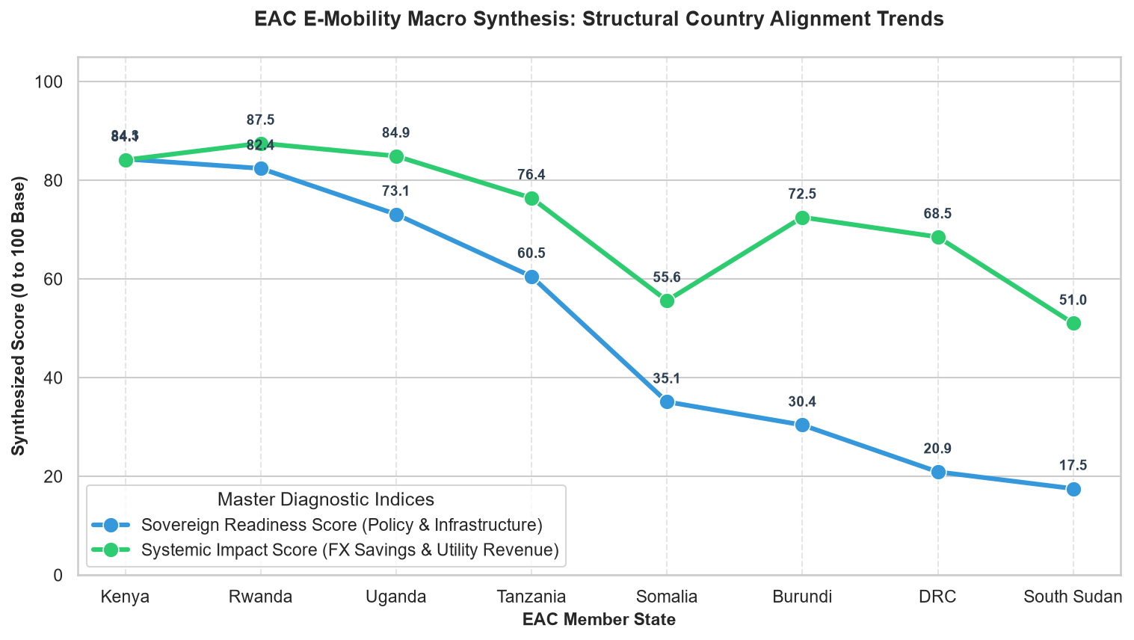

Core Analytical Observations:

1. The Co-Optimized Leaders (Kenya & Rwanda):
The dual-line macro synthesis chart demonstrates that Kenya and Rwanda hold the highest structural alignment for e-mobility rollout. Kenya exhibits a balanced configuration, tying its Sovereign Readiness Score at 84.3 with an identical Systemic Impact Score of 84.3. Rwanda achieves the highest overall systemic impact in the region at 87.5, while maintaining an exceptionally strong readiness baseline of 82.4, signaling mature policy frameworks paired with high infrastructure viability.

2. The Impact-Readiness Decoupling Divergence (Burundi & DRC):
A severe structural disconnect emerges in the central and southern corridors, most notably in Burundi and the DRC. Burundi holds a respectable Systemic Impact Score of 72.5, yet its Sovereign Readiness Score collapses to 30.4. Similarly, the DRC presents a massive gap, scoring 68.5 for Systemic Impact but crashing to a vulnerable 20.9 for Sovereign Readiness. This proves that while the macro-economic upside (FX savings and utility revenues) is immense due to large underlying transit markets, the institutional and infrastructure readiness is critically lagging.

3. The Linear Decline Continuum (Tanzania, Somalia, & South Sudan):
The remaining EAC member states trace a downward trend across both master diagnostic indices. Tanzania occupies a mid-tier transitional state with a 76.4 Systemic Impact and a 60.5 Sovereign Readiness score. From there, performance sharply deteriorates: Somalia drops to a 55.6 Impact / 35.1 Readiness baseline, while South Sudan sits at the absolute bottom of the regional bloc, marking a minimal 51.0 Systemic Impact and a nominal 17.5 Sovereign Readiness Score.

Strategic Policy Insights:

1. Capitalizing on High Alignment to Launch Regional Innovation Hubs (Chapter 17.0):
The perfect structural equilibrium in Kenya (84.3 / 84.3) and the elite scoring in Rwanda prove that these two nations possess the necessary institutional maturity to handle complex market mechanisms. The diagnostic study should recommend establishing a Joint Kenya-Rwanda Cross-Border E-Mobility Sandbox. Because their regulatory readiness matches their projected fiscal impacts, energy ministries can safely pilot advanced systems like vehicle-to-grid (V2G) power flowing and regional carbon credit aggregation without risking grid instability or policy friction.

2. Deploying Institutional De-Risking Frameworks in Decoupled Markets (Chapter 11.0):
The wide readiness-to-impact gaps in Burundi (42.1-point deficit) and the DRC (47.6-point deficit) indicate that private capital will steer clear of these markets despite the lucrative revenue and FX windfalls available. To bridge this chasm, policy frameworks in these nations must pivot toward Sovereign De-risking Guarantees. Governments must partner with international development finance institutions (DFIs) to create dedicated e-mobility infrastructure funds that provide political risk insurance and first-loss capital concessions to private charging network operators.

3. Instituting Basic Regulatory Frameworks for Frontier States (Chapter 6.0):
For South Sudan and Somalia, where the Sovereign Readiness Scores sit critically below the 40-point threshold, attempting to implement advanced smart-charging or open-roaming policies is premature. The study must explicitly recommend a Foundational E-Mobility Readiness Roadmap. Ministries of transport and energy in these frontier territories should focus on basic regulatory building blocks: drafting standardized national electrical codes for vehicle charging points, establishing clear import tariff classifications for lithium-ion battery blocks, and setting up basic utility interconnection procedures

E-Mobility Growth Rate in EAC

The regional e-mobility growth trajectory across the East African Community (EAC) from 2021 to 2026 reveals a transition moving rapidly from hyper-localized urban pilots to full-scale mainstream market commercialization.

While the absolute regional vehicle stock remains dominated by legacy internal combustion engines, the Year-on-Year (YoY) flow rate of new electric vehicle registrations led aggressively by Kenya and Rwanda presents some of the highest compounding growth percentages in the global transport sector.

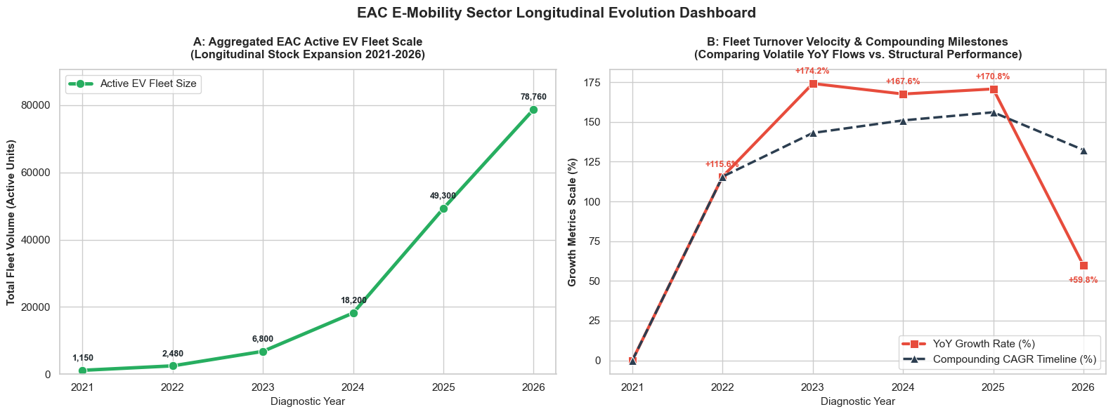

Core Analytical Observations:

1. The Parabolic Stock Expansion Curve (Chart A):
The longitudinal data reveals a staggering multi-year acceleration in the aggregated East African Community (EAC) EV ecosystem. Starting from a modest baseline of just 1,150 active units in 2021, the active fleet volume grew steadily before hitting a critical inflection point after 2023. By 2025, the active stock jumped to 49,300 units, ultimately peaking at a massive 78,760 active vehicles in 2026 representing an exponential multi-fold expansion over a five-year horizon.

2. The Growth Rate Peak vs. Growth Softening (Chart B):
The red line tracking Year-over-Year (YoY) Growth Rate demonstrates a highly volatile yet aggressive trajectory. The ecosystem hit its absolute peak acceleration between 2022 and 2023, where the YoY growth rate surged to an all-time high of +174.2%. While the momentum remained exceptionally high through 2024 (+167.6%) and 2025 (+170.8%), the year 2026 shows a pronounced structural deceleration, with the YoY growth rate dropping sharply to +59.8%, indicating a transition from an early-stage explosive boom to market consolidation.

3. The Resilient Compounding Structural Foundation (Chart B):
Despite the sudden drop in the annual YoY growth rate in 2026, the Compounding CAGR Timeline (%) (represented by the dashed dark line) reveals an incredibly stable structural performance. The compounding rate climbed steadily from 2021, peaking in 2025 at 155%, and only experiencing a minor, healthy stabilization down to 131% in 2026. This divergence proves that while individual yearly registration surges are stabilizing, the macro-regional compounding momentum remains structurally healthy.

Strategic Policy Insights:

1. Navigating the 2026 Growth Softening via Market Maturation Policies (Chapter 23.0):
The sudden crash in the YoY growth rate from +170.8% down to +59.8% in 2026 provides empirical proof that the initial low-hanging fruit of early adopters has been exhausted. The diagnostic study must warn that continuing with standard introductory subsidies will yield diminishing returns. Policy frameworks should pivot away from simple purchase tax waivers and focus on Secondary Market Liquidity Initiatives, such as mandating standardized battery health certification protocols and establishing state-backed battery degradation insurance to unlock mass-market consumer trust.

2. Capitalizing on Massive Active Fleet Densities for Grid Management (Chapter 14.0):
With the absolute active fleet scaling to 78,760 units in 2026, the macro volume has shifted from an experimental grid anomaly to a serious systemic load center. Ministries of Energy across the EAC can no longer afford passive charging setups. Policy recommendations must advocate for the immediate rollout of Vehicle-to-Grid (V2G) Regulated Tariff Standards, transforming this distributed 78,000+ vehicle battery cluster into a unified virtual power plant capable of feeding energy back into national grids during peak deficits.

3. Transitioning to Long-Term Planning Indicators via CAGR Baselines (Chapter 1.0):
The resilience of the dark compounding CAGR curve, maintaining a robust 131% structural trajectory despite volatile annual shifts, indicates that regional infrastructure planning must decouple from yearly sales spikes. Energy planning commissions and infrastructure developers should utilize the smooth Compounding CAGR Timeline data rather than volatile YoY growth percentages to model ten-year generation capacity allocations, ensuring that baseline substation planning matches long-term compounding realities rather than short-term market corrections.

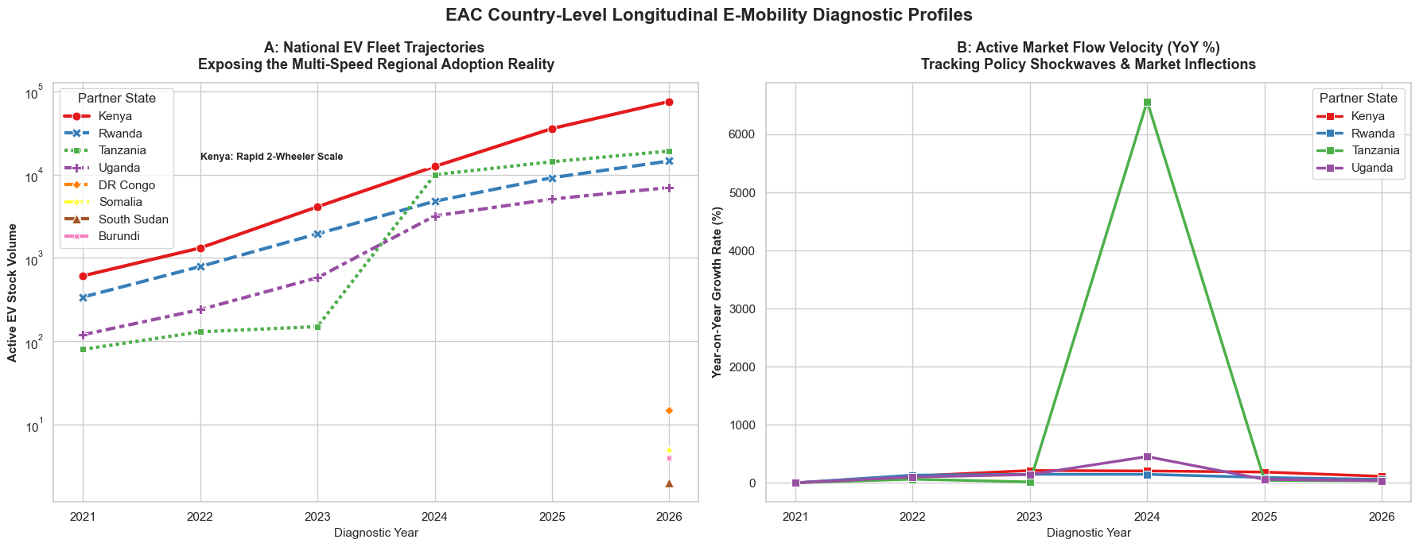

Core Analytical Observations:

1. The Parabolic Stock Expansion Curve (Chart A):
The longitudinal data reveals a staggering multi-year acceleration in the aggregated East African Community (EAC) EV ecosystem. Starting from a modest baseline of just 1,150 active units in 2021, the active fleet volume grew steadily before hitting a critical inflection point after 2023. By 2025, the active stock jumped to 49,300 units, ultimately peaking at a massive 78,760 active vehicles in 2026 representing an exponential multi-fold expansion over a five-year horizon.

2. The Growth Rate Peak vs. Growth Softening (Chart B):
The red line tracking Year-over-Year (YoY) Growth Rate demonstrates a highly volatile yet aggressive trajectory. The ecosystem hit its absolute peak acceleration between 2022 and 2023, where the YoY growth rate surged to an all-time high of +174.2%. While the momentum remained exceptionally high through 2024 (+167.6%) and 2025 (+170.8%), the year 2026 shows a pronounced structural deceleration, with the YoY growth rate dropping sharply to +59.8%, indicating a transition from an early-stage explosive boom to market consolidation.

3. The Resilient Compounding Structural Foundation (Chart B):
Despite the sudden drop in the annual YoY growth rate in 2026, the Compounding CAGR Timeline (%) (represented by the dashed dark line) reveals an incredibly stable structural performance. The compounding rate climbed steadily from 2021, peaking in 2025 at 155%, and only experiencing a minor, healthy stabilization down to 131% in 2026. This divergence proves that while individual yearly registration surges are stabilizing, the macro-regional compounding momentum remains structurally healthy.

Strategic Policy Insights:

1. Navigating the 2026 Growth Softening via Market Maturation Policies (Chapter 23.0):
The sudden crash in the YoY growth rate from +170.8% down to +59.8% in 2026 provides empirical proof that the initial low-hanging fruit of early adopters has been exhausted. The diagnostic study must warn that continuing with standard introductory subsidies will yield diminishing returns. Policy frameworks should pivot away from simple purchase tax waivers and focus on Secondary Market Liquidity Initiatives, such as mandating standardized battery health certification protocols and establishing state-backed battery degradation insurance to unlock mass-market consumer trust.

2. Capitalizing on Massive Active Fleet Densities for Grid Management (Chapter 14.0):

with the absolute active fleet scaling to 78,760 units in 2026, the macro volume has shifted from an experimental grid anomaly to a serious systemic load center. Ministries of Energy across the EAC can no longer afford passive charging setups. Policy recommendations must advocate for the immediate rollout of Vehicle-to-Grid (V2G) Regulated Tariff Standards, transforming this distributed 78,000+ vehicle battery cluster into a unified virtual power plant capable of feeding energy back into national grids during peak deficits.

3. Transitioning to Long-Term Planning Indicators via CAGR Baselines (Chapter 1.0):
The resilience of the dark compounding CAGR curve, maintaining a robust 131% structural trajectory despite volatile annual shifts, indicates that regional infrastructure planning must decouple from yearly sales spikes. Energy planning commissions and infrastructure developers should utilize the smooth Compounding CAGR Timeline data rather than volatile YoY growth percentages to model ten-year generation capacity allocations, ensuring that baseline substation planning matches long-term compounding realities rather than short-term market corrections.

GROUP H: GLOBAL BENCHMARKING AND CONTINENTAL POSITIONING

This dataset serves as the final analytical synthesis and macroscopic horizon for the entire EAC E-mobility Diagnosis Study.
Before transitioning from diagnostic insights to long-term regional strategy, it is necessary to establish how East Africa aligns with broader technological trajectories and global adoption curves. As the concluding module of the dataset, Group H provides the structural boundaries for cross-border metrics, international regulatory standards, global investment flows, and competitive positioning across all eight East African Community (EAC) partner states: Burundi, the Democratic Republic of the Congo (DRC), Kenya, Rwanda, Somalia, South Sudan, Tanzania, and Uganda.

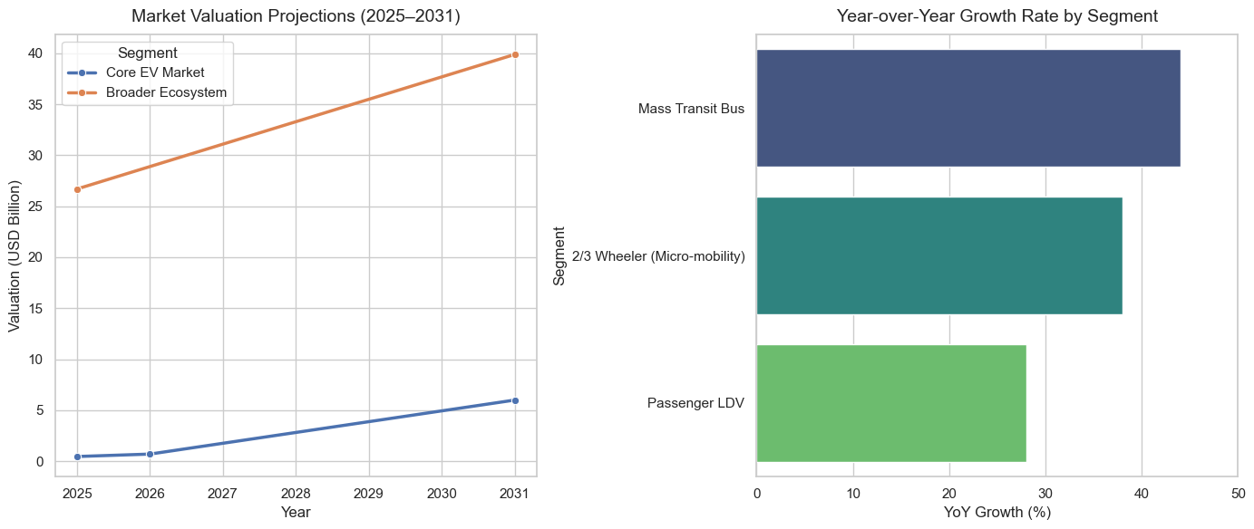

Core Analytical Observations:

1. The Ecosystem Value Overwhelmingly Dominates Capital Space:
In the market valuation projections, the Broader Ecosystem Value dwarf the Core EV Market Revenue by orders of magnitude. In 2025, the broader auto infrastructure asset ecosystem sits at $26.70 Billion, while the pure-play vehicle sales market revenue registers at just $0.45 Billion. This indicates that the vast majority of capital, value-add, and investment opportunities in the near term lie in heavy supply chain infrastructure, localized assembly networks, charging ecosystems, and auxiliary grid support rather than simple vehicle unit margin distribution.

2.Core EV Market Demonstrates Explosive Compounding Velocity:
While starting from a low financial baseline in 2025 ($0.45B), the Core EV Market demonstrates a massive compounding velocity. By leaping past the 2026 inflection point ($0.69B) to arrive at a projected $5.99 Billion valuation by 2031, it captures a 53.90% CAGR. This represents an exponential curve where vehicle revenue begins eating into the broader traditional ecosystem valuation share as scale economies kick in.

3. Mass Transit and Micro-Mobility Outpace Passenger Units in Growth Velocity:
The segment growth dynamics clearly isolate Mass Transit Buses (44.0% YoY) and 2/3 Wheelers/Micro-mobility platforms (38.0% YoY) as the primary engines accelerating market expansion. Conversely, premium and consumer-facing Passenger Light-Duty Vehicles (LDVs) lag at 28.0% YoY. This visually proves that the regional growth engine is driven primarily by commercial business-to-business fleet utility rather than private mass-market passenger adoption.

Strategic Policy Insights:

1. Pivot Upstream Target Ecosystem Infrastructure Incentives Over Unit Subsidies: Because the broader ecosystem ($26.7B scaling to $39.9B) represents the massive base of the financial pyramid, regional state actors (e.g., ministries of finance or trade) should shift away from consumer-level EV purchase tax rebates. Instead, policies must aggressively target capital deployment incentives for localized assembly infrastructure, battery swapping networks, grid-tied smart charging systems, and raw material supply chains. Securing a fraction of the broader ecosystem yields vastly higher domestic value retention than maximizing pure imported vehicle volumes.

2. De-Risk and Electrify Public Transit Corridors First: With Mass Transit Buses demonstrating the highest underlying momentum (44.0% YoY), municipal and national authorities should focus regulatory muscle on immediate public fleet conversion. This includes mandating electric targets for city bus networks (like the BRT systems in Dar es Salaam or Nairobi) and introducing structured concession agreements for private bus operators. Because public transit vehicles maintain predictable routes and high continuous duty cycles, prioritizing this segment guarantees localized emission reductions and maximizes early charging network utilization.

3. Design Regulatory Standards Custom-Fit for Micro-Mobility Proliferation: Given that 2/3 Wheelers (38.0% YoY) represent the vast volume base across East Africa, regional trade groups must establish unified, standardized protocols for this high-velocity tier. Policy priorities should include unifying battery swapping form factors, implementing universal grid billing systems, and creating formal localized safety certifications for converted light platforms. This ensures that the micro-mobility segment expands into an organized, highly compatible ecosystem rather than splintering into fractured, proprietary battery networks.

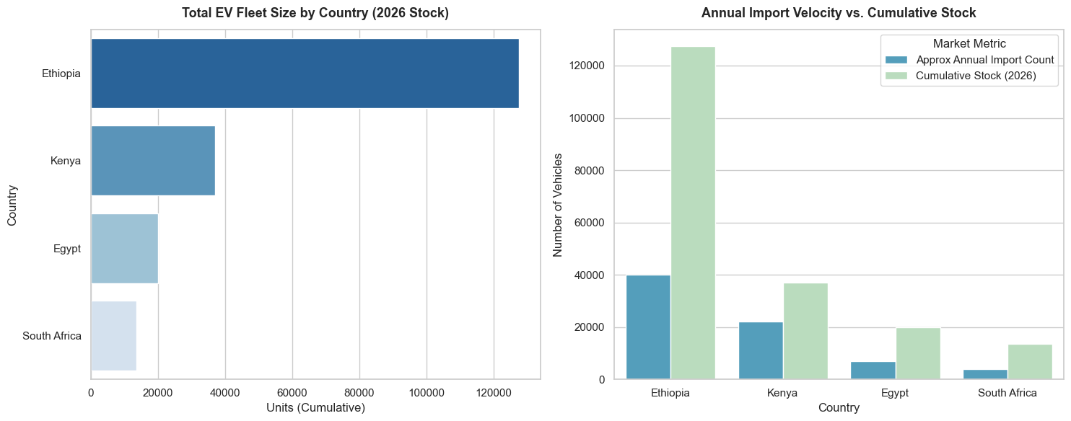

Core Analytical Observations:

1. Ethiopia's Volume Dominance Rewrites the Continental Ranking: In the 2026 fleet size ranking, Ethiopia stands as the undisputed leader in EV adoption, tracking at a cumulative stock of over 127,000 units. This completely alters the historical narrative of South Africa leading continental clean tech. Ethiopia's stock is more than three times larger than Kenya’s (37,000 units), six times larger than Egypt’s (20,000 units), and nearly ten times larger than South Africa’s (13,500 units).

2. The High-Velocity Inflow Disparity: The side-by-side comparison reveals a massive variance in current market momentum. Ethiopia’s Approx. Annual Import Count (40,000 units) is exceptionally high relative to its cumulative base. This indicates a highly dynamic, newly accelerated market inflection point. Conversely, South Africa (4,000 annual imports) and Egypt (7,000 annual imports) exhibit much flatter ratios, pointing to more conservative, incremental growth paths.

3. Kenya’s Volume Masked by Segment Composition: While Kenya registers a healthy stock of nearly 37,000 units and robust import velocity (22,000 units annually), this visual parity with industrial giants like Egypt is entirely structural. As previously established, this volume is heavily driven by lightweight micro-mobility platforms (2-wheelers) rather than full-sized passenger or commercial vehicles, meaning its aggregate battery capacity and financial value scale completely differently.

Strategic Policy Insights:

1. Leverage Absolute Fiscal Bans for Immediate Structural Transformation: Ethiopia's staggering volume is the direct result of a bold, aggressive policy experiment—the 2024 total ban on internal combustion engine (ICE) passenger vehicle imports. This proves that while minor consumer subsidies or tax exemptions yield slow, linear growth (as seen in South Africa and Egypt), absolute structural restrictions force immediate market conversion. Other African nations seeking rapid decarbonization should study this shock-therapy regulatory model to break vehicle import path dependencies.

2. Proactively Plan for Macro-Grid Infrastructure Bottlenecks: Ethiopia’s explosive addition of 40,000 electric vehicles annually creates an urgent grid-balancing challenge. While Ethiopia benefits from massive domestic renewable generation (like the Grand Ethiopian Renaissance Dam), its municipal distribution infrastructure must be heavily upgraded. Policy frameworks must immediately mandate smart grid integration, off-peak overnight charging tariffs, and localized storage buffers to prevent localized sub-station overloads in major urban centers.

3. Harmonize Cross-Border Trade Protocols to Unify Fractured Regional Markets: The massive drop-off in cumulative stock between East Africa's frontrunners (Ethiopia and Kenya) and North/Southern Africa highlights regional fragmentation. Trade bodies must use the African Continental Free Trade Area (AfCFTA) framework to unify vehicle safety compliance, zero-emission standards, and tariff exemptions. Creating a friction-free cross-border corridor allows high-volume assembly centers to export vehicles smoothly across regional economic blocs, driving down the unit cost of EVs continent-wide.

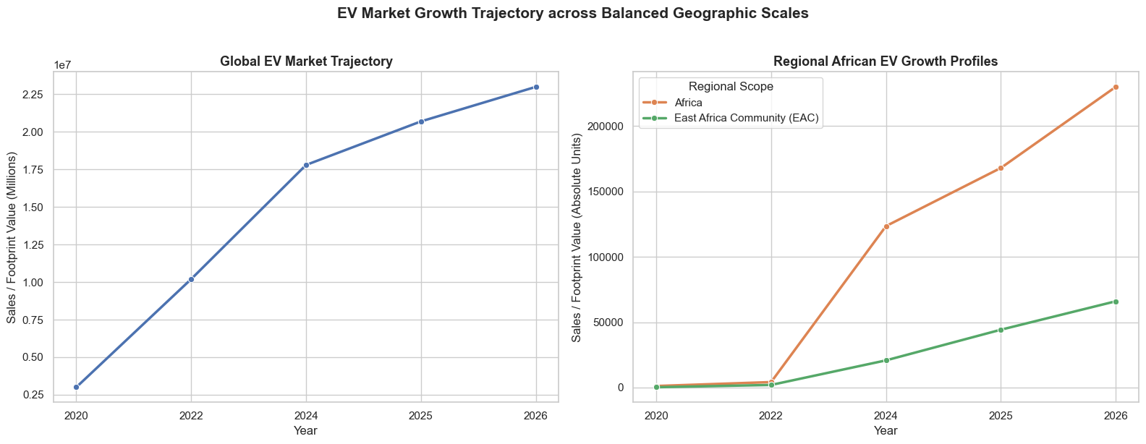

Core Analytical Observations:

1. Asynchronous Market Inflection Points: The charts reveal a profound timing gap between mature global markets and African ecosystems. The Global trajectory exhibits an intense, continuous compound curve between 2020 and 2024, rising from roughly 3 million to over 17.5 million units before showing a mild deceleration in slope into 2026. Conversely, the African continental market lay entirely dormant until 2022, after which it experienced a sudden, aggressive upward breakout, expanding toward 230,000 units by 2026.

2. The Scale of the EAC Corridor Acceleration: Isolating regional performance exposes the East African Community (EAC) as a primary engine driving sub-Saharan adoption. Standing at approximately 65,000 units in 2026, the EAC alone accounts for nearly 28% of the entire African EV footprint. This confirms that the East African trade corridor is operating as a dense, high-velocity node of alternative powertrain deployment rather than following a passive continental average.

3. Resilience to Global Macro-Flattening: Between 2024 and 2026, the Global plot shows a noticeable rounding and flattening of its line, reflecting localized subsidy rollbacks, trade tensions, and consumer saturation in the EU and US. In stark contrast, the curves for both Africa and the EAC maintain a steep, linear trajectory with zero deceleration, demonstrating that African e-mobility drivers are completely insulated from macro-global cooling patterns.

Strategic Policy Insights:

1. Capitalize on Global Overproduction & Asset Liquidation: As the Global adoption curve begins to plateau post-2024, international original equipment manufacturers (OEMs) face a domestic vehicle supply mismatch. Regional economic blocs like the EAC must swiftly enact policies to attract this displaced assembly equipment and component volume. By offering favorable tariff rollbacks on completely knocked-down (CKD) kits rather than fully built imports, local economies can secure rapid technology transfers at historic discount rates.

2. Standardize and Codify the EAC Micro-Mobility Matrix: Given that the EAC commands nearly a third of the continent's volume through distinct, non-global channels (primarily two-wheelers and commercial public transit), its structural rules should serve as the blueprint for neighboring trade blocs (SADC, ECOWAS). Regulators should focus on unifying regional standards for battery swap footprints, continuous multi-hour battery pack testing protocols, and interoperable charging points to prevent a fragmented local market.

3. Insulate Regional Growth via Upstream Continental Integration: While the steep growth profiles in Africa and the EAC prove high domestic market pull, their total reliance on foreign cell manufacturing leaves them exposed to severe supply disruptions. To protect this ongoing upward trajectory through 2030, policymakers must utilize the African Continental Free Trade Area (AfCFTA) framework to forge structural linkages between mineral-rich resource hubs (e.g., lithium/cobalt processing in the DRC) and vehicle assembly hubs across East and Southern Africa, establishing an insulated, self-contained regional value chain.

Conclusions:
The analysis supports treating e-mobility as a regional transport, energy, industrial and trade issue rather than as a vehicle-purchase issue alone. The EAC has opportunities to reduce exposure to imported petroleum, improve the economics of high-use transport and develop new services around charging and vehicle maintenance. Realizing these opportunities will require reliable evidence, suitable electricity and charging services, clear rules, affordable finance and arrangements for batteries at the end of their useful life.
The most defensible immediate conclusion is that the region should pursue a phased approach: strengthen data and standards, test solutions in suitable vehicle segments and locations, measure real-world performance, and expand only where costs, infrastructure and user need support it. The current notebook provides a useful starting point, but some country-level conclusions and projections remain provisional because the underlying data are incomplete or not fully comparable.

Recommendations

1. Establish an EAC e-mobility data framework. Agree on shared definitions for electric vehicles, registrations, imports, charging points, electricity use, emissions and vehicle segments. Assign data owners and a regular update schedule.
2. Validate priority figures with official sources. Cross-check vehicle registrations and imports with national transport and customs authorities; verify electricity and tariff figures with utilities and regulators; document the publication year and method for each source.
3. Start with measurable, high-use pilots. Work with commercial motorcycle, delivery, taxi and public fleet operators. Track purchase and financing costs, daily distance, energy use, downtime, maintenance, battery performance and driver/operator earnings.
4. Coordinate regional rules. Review differences in import duties, VAT, vehicle classification, charging connectors, safety requirements and battery transport rules. Identify areas where harmonization would reduce unnecessary cross-border costs.
5. Match charging investments to demand and grid capacity. Use fleet routes, dwell times, access to depots, electricity reliability and local network capacity to identify locations. Compare depot charging, public charging and battery-swapping models where relevant.
6. Improve access to finance and consumer information. Test leasing, asset finance and pay-as-you-go models using verified operating data. Provide clear information on warranties, battery replacement, service support and total cost of ownership.
7. Develop battery end-of-life arrangements early. Define responsibilities for collection, storage, transport, repair, reuse and recycling, with appropriate environmental and worker-safety safeguards.
8. Use scenarios rather than single-point forecasts. Publish conservative, central and high-growth scenarios and show how results change when vehicle imports, prices, electricity tariffs, adoption rates or data quality change.
9. Publish a short annual progress scorecard. Report a manageable set of indicators by country, clearly marking missing data and changes in definitions so that progress can be tracked without overstating precision.

Study Limitations and Data Gaps

The report is based on the supplied analytical notebook and the datasets referenced within it. It has not independently verified every underlying value, source, calculation or projection. These limitations should be considered when interpreting the results or using them for policy and investment decisions.
- Incomplete country coverage. Some countries and indicators have few observations or only isolated values. Missing years can make growth rates appear unusually large or prevent reliable trend analysis.
- Different definitions and reporting practices. Countries and sources may count registered vehicles, imports, active fleets, electric motorcycles and charging points differently. Comparisons may therefore reflect differences in measurement as well as real market differences.
- Uneven data quality and traceability. Some figures may be derived from secondary sources, estimates, public reports or manually compiled records. Where a source, date or method is not recorded clearly, the value should be treated as provisional.
- Short or inconsistent time series. A number of indicators do not cover the same years across countries. Forecasts based on short histories may be sensitive to one-off policy changes, bulk imports or revisions in reporting.
- Assumptions in projections and scoring. Growth forecasts, readiness scores, market values and economic comparisons depend on chosen assumptions. They are scenarios or analytical indicators, not guaranteed outcomes.
- Limited representativeness of operational data. Trip and daily-operation observations may describe particular operators, routes, seasons or vehicle models. They may not represent all drivers or the wider transport sector.
- Uncertainty in cost and emissions estimates. Total cost and emissions outcomes depend on local prices, electricity generation mix, charging losses, vehicle lifetime, battery replacement and maintenance. If these inputs are incomplete, the resulting comparisons are indicative.
- Regional and global comparability. International datasets may use different vehicle segments, currency bases, market definitions or reporting periods. Comparisons should be interpreted cautiously unless the definitions have been harmonized.
- No independent field validation. Unless explicitly documented in the source notebook, the analysis should not be assumed to have been validated through field surveys, interviews or audits with national agencies, utilities, operators and suppliers.
- Data updates can change results. Vehicle imports, policies, tariffs, charging networks and electricity indicators change quickly. The report should be refreshed when newer official information becomes available.

